Chapter 14 Quantitative Analysis in Budgeting

Answer – Exercise 1
(a)
In 2010 the four quarters will be numbers 5–8, consequently the trend figures for waste to be collected will be:
Quarter 1 (Q = 5): 2,000 + 25(5) = 2,125 tonnes
Quarter 2 (Q = 6): 2,000 + 25(6) = 2,150 tonnes
Quarter 3 (Q = 7): 2,000 + 25(7) = 2,175 tonnes
Quarter 4 (Q = 8): 2,000 + 25(8) = 2,200 tonnes
Seasonal adjustments are needed thus:
Quarter 1: 2,125 – 200 = 1,925
Quarter 2: 2,150 + 250 = 2,400
Quarter 3: 2,175 + 150 = 2,325
Quarter 4: 2,200 – 100 = 2,100
Total tonnage is 1,925 + 2,400 + 2,325 + 2,100 = 8,750 tonnes for the year.

(b)
Regression analysis can be used to calculate the variable operating and fixed operating costs in 2009.
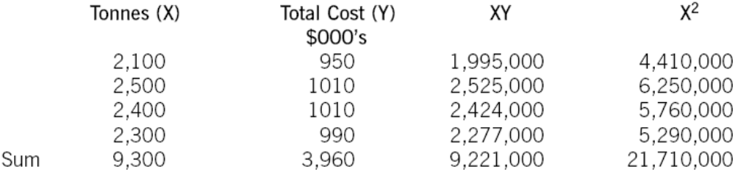
Y = a +bX
Where ‘a’ is fixed operating cost and ‘b’ is variable operating cost in this context.
Using the formula given:
b = (4 x 9,221,000 – 9,300 x 3,960)/(4 x 21,710,000 – (9,300)²)
b = 0·16 or $160 per tonne as the original data is in $000’s. This was the variable operating cost per tonne for 2009.

a = (3,960/4) – (0.16 x 9,300/4)
a = 618 or $618,000 as the original data is in $000’s. This was the fixed operating cost in 2009.

Allowing for inflation:
The variable operating cost in 2010 will be $160 x 1·05 = $168 per tonne
The fixed operating cost in 2010 will be $618,000 x 1·05 = $648,900

(c)
Advantages of an incremental budgeting approach:
- Local government organisations are often complex and incremental budgeting will be seen as a simple approach to a budget that will take little effort.
- Budget processes can be long ones, however incremental approaches do tend to be quicker than most. Complex local government organisations can suffer from very long budget processes and incremental budgeting can alleviate this a little.

Disadvantages of incremental budgeting:
- Public bodies, such as local governments, will be encouraged to use up all of this year’s budget in order to ensure that next year’s budget will be as high as possible to give themselves the flexibility they need to do whatever is needed. The public services required can be unpredictable and so local government organisations prefer to be able to be flexible.
- Overspends made in this year will be budgeted for again next year, this is hardly giving taxpayers value for money.

ACCA Marking Scheme
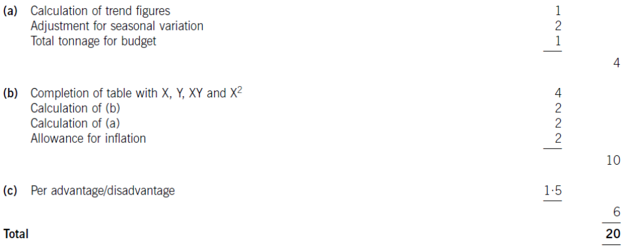

Answer – Exercise 2
(a)
Y = 150 + 10X
The 150 represents the trend when X = 0, i.e. the final quarter of 2011.
The 10 represents the increase in trend each quarter, that is we expect the trend to rise by 10 each quarter.
The seasonal indices can be interpreted as follows:
Quarter 1 = 80 – Means that we expect sales to be 80% of the trend value, i.e. 20% below the trend in quarter 1.
Quarter 2 = 110 – Means that we expect sales to be 10% above the trend in quarter 2.
Quarter 3 = 140 – Means that we expect sales to be 40% above the trend in quarter 3.
Quarter 4 = 70 – Means that we expect sales to be 30% below the trend in quarter 4.

(b)
In 2017, the 4 ‘X’ values and hence the trend will be:
Quarter | X | Trend
1 | 21 | 150 + 10 × 21 = 360
2 | 22 | 150 + 10 × 22 = 370
3 | 23 | 150 + 10 × 23 = 380
4 | 24 | 150 + 10 × 24 = 390

(c)
Quarter | Trend | Seasonal | Sales forecast
1 | 360 | 80 | 360 × 0.8 = 288
2 | 370 | 110 | 370 × 1.1 = 407
3 | 380 | 140 | 380 × 1.4 = 532
4 | 390 | 70 | 390 × 0.7 = 273

(d)
The two main factors that may cause errors are:
- Extrapolation error – we may be forecasting too far beyond the original regression.
- We are ignoring any residual variation, that is: T × S × R, ignoring R may cause our forecast to be wrong.

Examination Style Questions

Answer 1
(a)
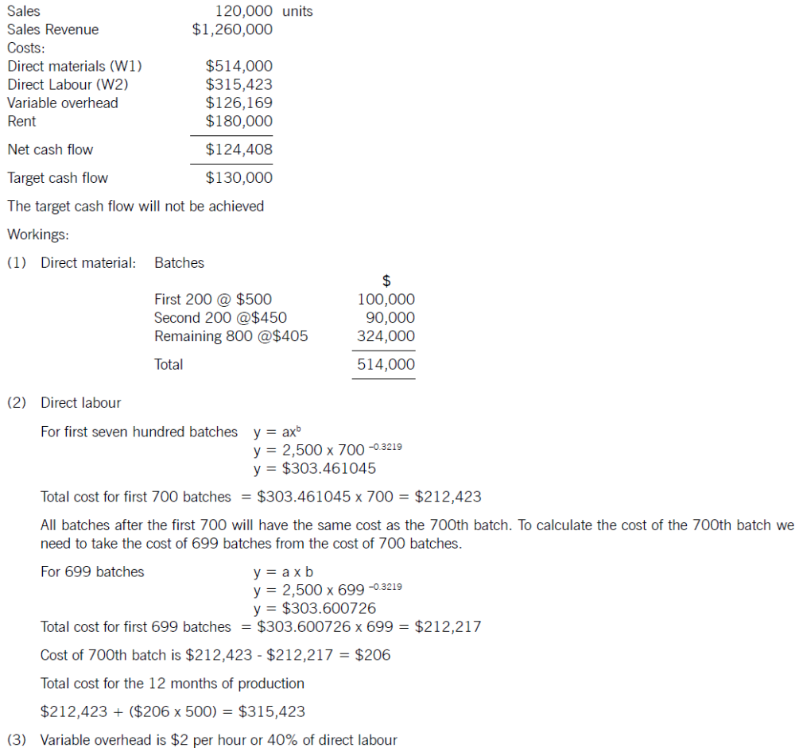

(b)
To calculate the learning factor BFG will have had to measure the time taken to make the first batch (500 hours) and then the time taken to make the second batch. The learning rate measures the relationship between the average time taken between two points as production doubles. The easiest way to measure the learning rate is when the production doubles between the first and second batches.

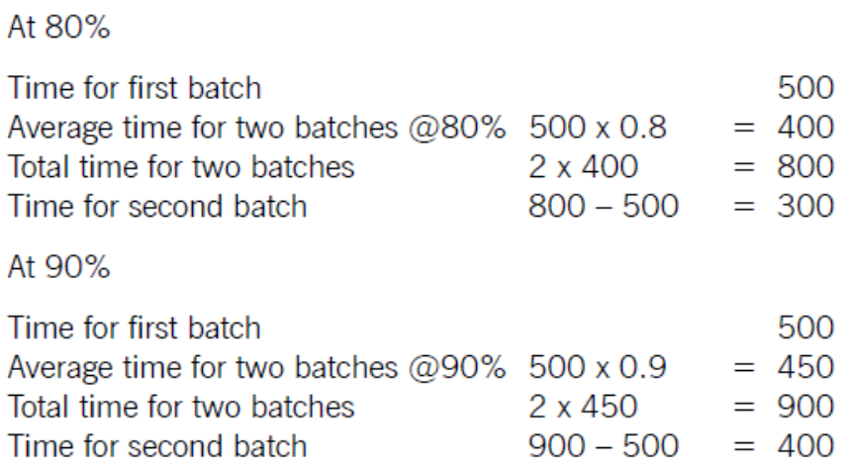

The 80% learning rate reduces the time taken for the two successive batches above by a greater amount (or faster). Hence the 80% learning rate is the faster learning.

(c)
Possible actions to improve the net cash flows are:
- Increase the price charged. The question states that an agreed specification has been reached, however further research may reveal that a higher price could be tolerated by the market. Equally a form of price skimming may be possible to improve short term net cash flow.
- Reduce the labour cost per batch by removing unnecessary operations or processes. It may be possible to simplify the design without damaging the ability to achieve the price stated.
- Improve the learning rate. This may involve improving the training or the quality of people involved in the production process. This does takes time and costs money in the short run.
- Consider substitute materials (without damaging the product specification). Also look for new suppliers to reduce the input cost.
- Consider ways to reduce the level of variable overhead incurred by the product.
- Investigate whether the production of product X could take place in existing space and hence avoid the extra rent charge. Re-negotiate the rent charge with the landlord.

ACCA Marking Scheme:
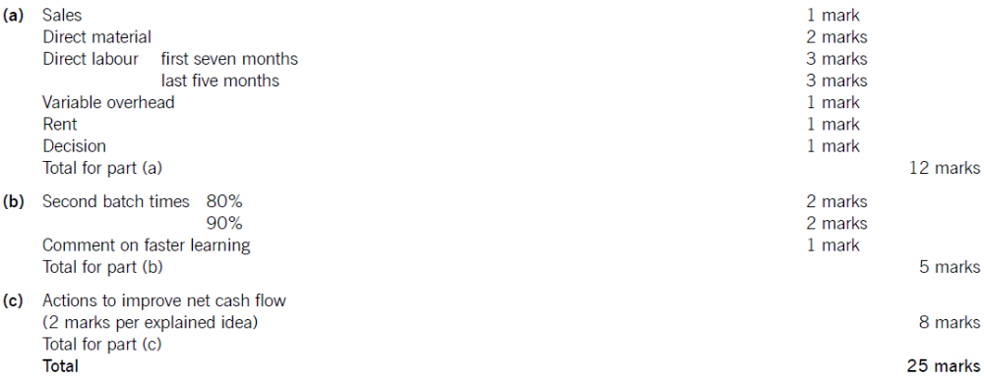

Answer 2
(a)
There are various issues that HC should consider in making the bid. (Only five are required for two marks each.)
Contingency allowance. HC should consider the extent to which its estimates are accurate and hence the degree of uncertainty it is subjected to. It may be sensible to allow for these uncertainties by adding a contingency to the bid.

Competition. HC must consider which other businesses are likely to bid and recognise that the builder may be able to choose between suppliers. Moreover, HC has not worked for this builder before, and so they will probably find the competition stiff and the lack of reputation a problem.

Inclusion of fixed overhead. In the long run fixed overhead must be covered by sales revenue in order to make a profit. In the short run it is often correctly argued that the level of fixed cost in a business may not be affected by a new contract and therefore could be ignored in bid calculation. HC needs to consider to what extent the fixed costs of its business will change if it wins this new contract. It is these incremental fixed costs that are relevant to a bid calculation.

Materials and loose tools. No allowance has been made for the use of tools and the various fixings (screws etc) that will be needed to assemble and fit the kitchens. It is possible that most fixings would be provided with the kitchen units, but HC should at least consider this.

Supervision of labour. The time given in the question is 24 hours to ‘fit’ the first kitchen. There seems no allowance for supervision of the labour force. It could, of course, be included within the overhead figures but no detail is shown.

Idle time. It is common for building works to be delayed by lack of materials for example. The labour time figure needs to reflect this.

Likelihood of repeat business. Some businesses consider it worthwhile to accept a low price for a new contract if it establishes a reputation with a new buyer. HC could offer to do this work cheaper in the hope of more profitable work later on.

The risk of non-payment. HC may decide not to bid at all if it feels that the builder may struggle to pay.

Opportunity costs of alternate work.

Possibility of working in overtime.

(b)
Bid calculations for HC to use as a basis for the apartment contract.
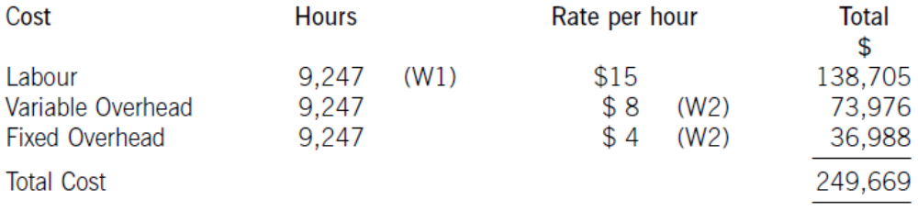

(W1)
Need to calculate the time for the 200th kitchen by taking the total time for the 199 kitchens from the total time for 200 kitchens.

For the 199 Kitchens
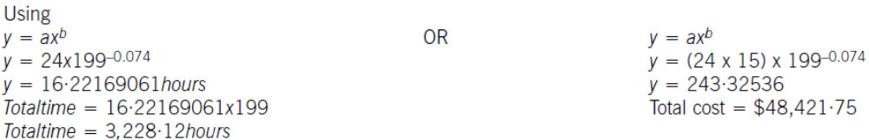

For the 200 Kitchens
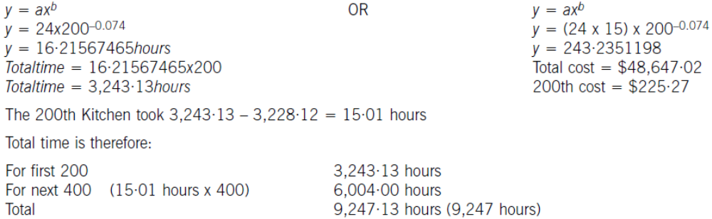

(W2)
The overheads need to be analysed between variable and fixed cost elements.
Taking the highest and lowest figures from the information given:
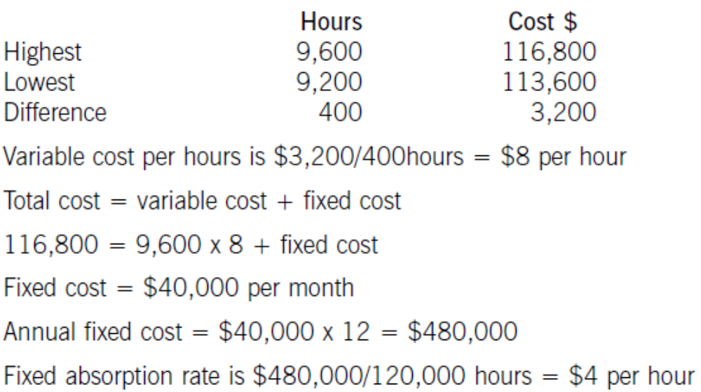

(c)
A table is useful to show how the learning rate has been calculated.
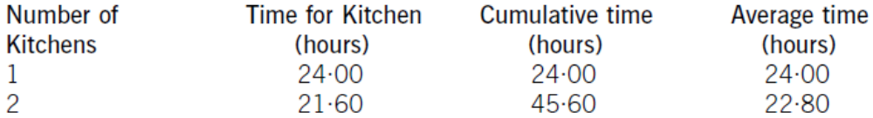

The learning rate is calculated by measuring the reduction in the average time per kitchen as cumulative production doubles (in this case from 1 to 2).
The learning rate is therefore 22·80/24·00 or 95%

ACCA Marking Scheme
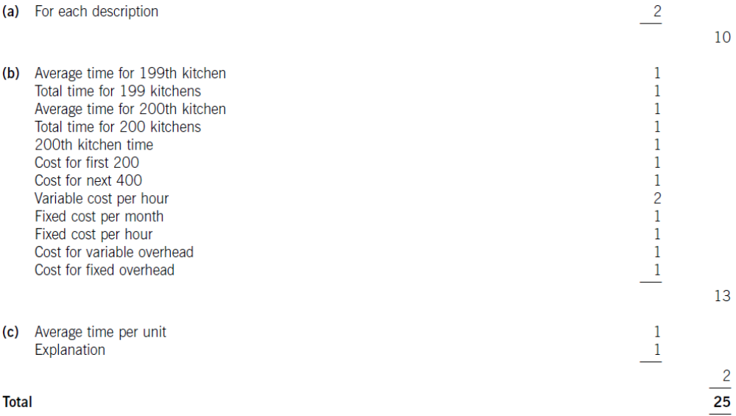

Answer 3
(a)
The average cost of the first 128 chairs is as follows:
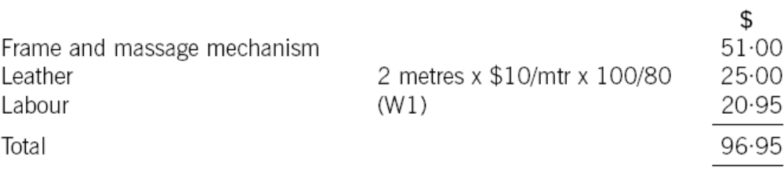
Target selling price is $120.
Target cost of the chair is therefore $120 x 80% = $96
The cost gap is $96.95 – $96.00 = $0.95 per chair

(W1)
The cost of the labour can be calculated using learning curve principles. The formula can be used or a tabular approach would also give the average cost of 128 chairs. Both methods are acceptable and shown here.

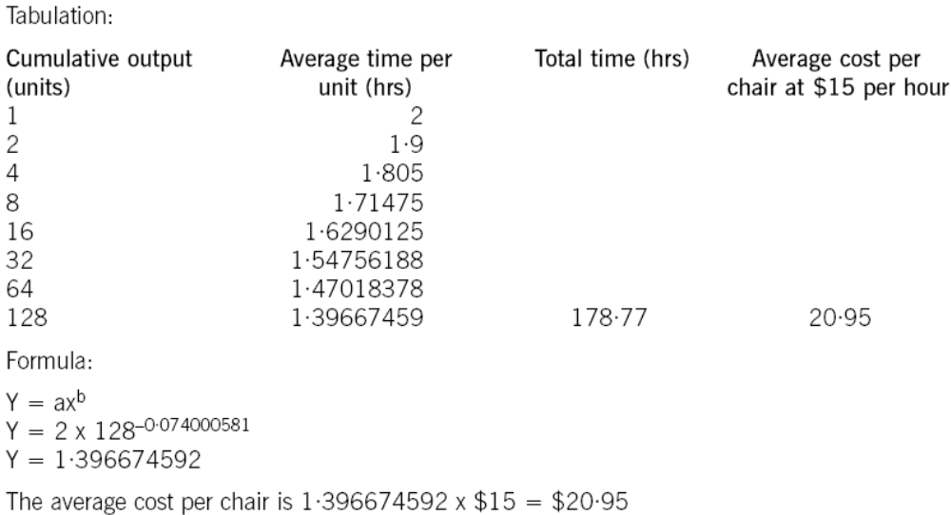

(b)
To reduce the cost gap various methods are possible (only four are needed for full marks)
- Re-design the chair to remove unnecessary features and hence cost
- Negotiate with the frame supplier for a better cost. This may be easier as the volume of sales improve as suppliers often are willing to give discounts for bulk buying. Alternatively a different frame supplier could be found that offers a better price. Care would be needed here to maintain the required quality
- Leather can be bought from different suppliers or at a better price also. Reducing the level of waste would save on cost. Even a small reduction in waste rates would remove much of the cost gap that exists
- Improve the rate of learning by better training and supervision
- Employ cheaper labour by reducing the skill level expected. Care would also be needed here not to sacrifice quality or push up waste rates.

(c)
The cost of the 128th chair will be:
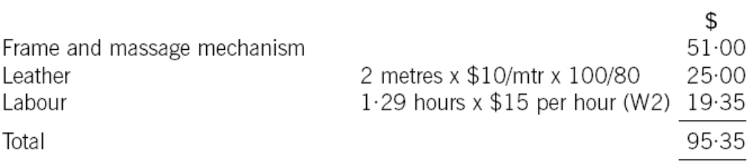

Against a target cost of $96 the production manager is correct in his assertion that the required return is now being achieved.

(W2)
Using the formula, we need to calculate the cost of the first 127 chairs and deduct that cost from the cost of the first 128 chairs.
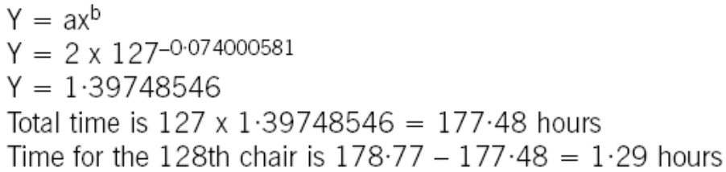

ACCA Marking Scheme
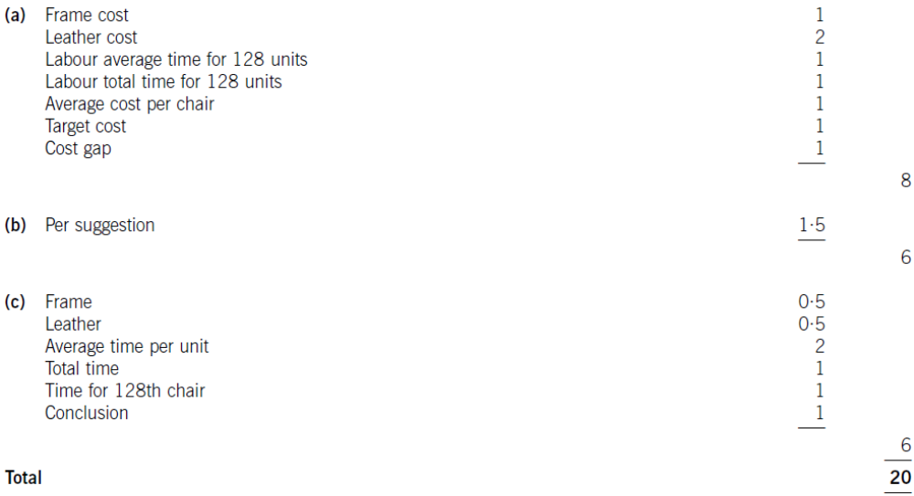

Answer 4
(a)
Profit
In order to ascertain the optimum price, you must use the formula P = a – bQ

Where P = price; Q = quantity; a = intersection (price at which quantity demanded will be nil); b = gradient of the demand curve.

The approach is as follows:
(i)
Establish the demand function
b = change in price/change in quantity = $15/1,000 = 0·015.
We know that if price = $735, quantity = 1,000 units.
Establish ‘a’ by substituting these values for P, Q and b into our demand function:
735 = a – 0·015Q
15 + 735 = a
Therefore a = 750.
Demand function is therefore P = 750 – 0·015Q

(ii)
Establish marginal cost
The labour cost of the 100th unit needs to be calculated as follows:
Formula = y = ax^{b}.
a = 1.5

Therefore, if x = 100 and b= –·0740005, then y = 1·5 x 100^{–0·0740005} = 1·0668178
Therefore cost per unit = 1·0668178 x $8 = $8·5345
Total cost for 100 units = $853·45.

If x = 99, y = 1·5 x 99^{–0·0740005} = 1·0676115
Therefore cost per unit = $8·5408
Total cost for 99 = $845·55
Therefore cost of 100th unit = $853·45 – $845·55 = $7·90.

Therefore total marginal cost = $42 + $7·90 = $49·90.
Fixed overheads have been ignored as they are not part of the marginal cost.

(iii)
Find profit
(1) Establish the marginal revenue function
MR = a – 2bQ
MR = 750 – 0·03Q
(2) Equate MC and MR
49·90 = 750 – 0·03Q
0·03Q = 700·1
Q = 23,337
(3) Find optimum price
P = 750 – (0·015 x 23,337)
= $399·95

(b)(i)
Penetration pricing
With penetration pricing, a low price would initially be charged for the Energy Buster. The idea behind this is that the price will make the product accessible to a larger number of buyers and therefore the high sales volumes will compensate for the lower prices being charged. A large market share would be gained and possibly, the Energy Buster might become accepted as the only industrial air conditioning unit worth buying.

The circumstances that would favour a penetration pricing policy are:
- highly elastic demand for the Energy Buster i.e. the lower the price, the higher the demand. The preliminary research does suggest that demand is elastic.
- if significant economies of scale could be achieved by Heat Co, then higher sales volumes would result in sizeable reductions in costs. This is not the case here, since learning ceases at 100 units.
- if Heat Co was actively trying to discourage new entrants into the market. In this case, new entrants cannot enter the market anyway, because of the patent.
- if Heat Co wished to shorten the initial period of the Energy Buster’s life cycle so as to enter the growth and maturity stages quickly. We have no evidence that this is the case for Heat Co, although it could be.

From the above, it can be seen that this could be a suitable strategy in some respects but it is not necessarily the best one.

(b)(ii)
Market skimming
With market skimming, high prices would initially be charged for the Energy Buster rather than low prices. This would enable Heat Co to take advantage of the unique nature of the product, thus maximising sales from those customers who like to have the latest technology as early as possible. The most suitable conditions for this strategy are:
- the product is new and different. This is indeed the case with the Energy Buster.
- the product has a short life cycle and high development costs that need to be recovered quickly. The life cycle is fairly short and high development costs have been incurred.
- since high prices attract competitors, there needs to be barriers to entry in order to deter competitors. In Heat Co’s case, there is a barrier, since it has obtained a patent for the Energy Buster.
- the strength and sensitivity of demand are unknown. Again, this is not the case here.

Once again, the Energy Buster meets only some of the conditions which would suggest that although this strategy may be suitable the answer is not clear cut. The fact that high development costs have been incurred and the life cycle is fairly short are fairly good reasons to adopt this strategy. Whilst we have demand curve data, we do not really know just how reliable this data really is, in which case a skimming strategy may be a safer option.

ACCA Marking Scheme
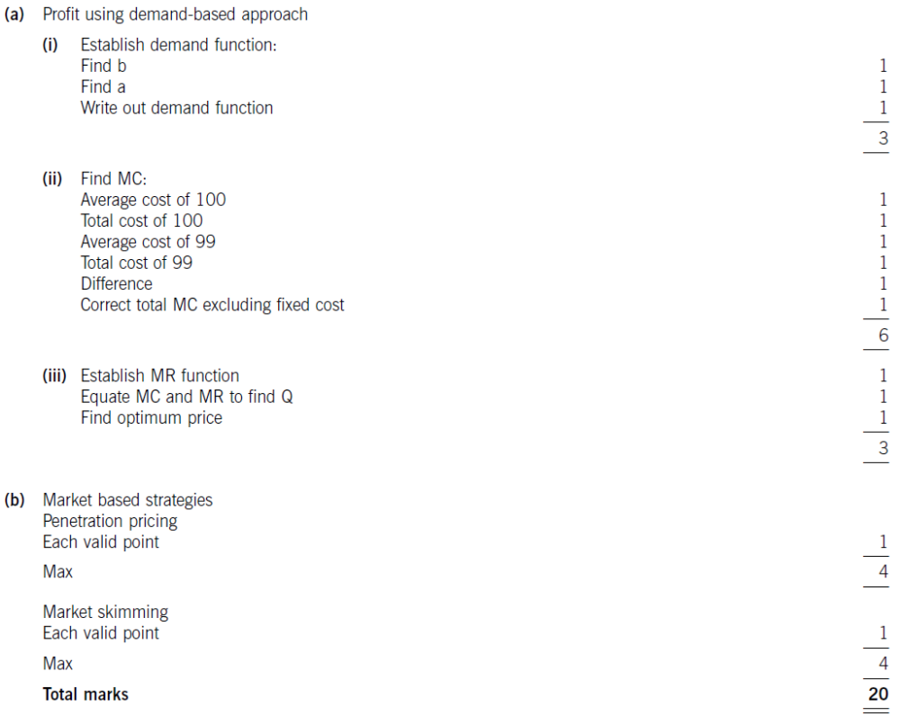

Answer 5
(a)
Life cycle cost per unit
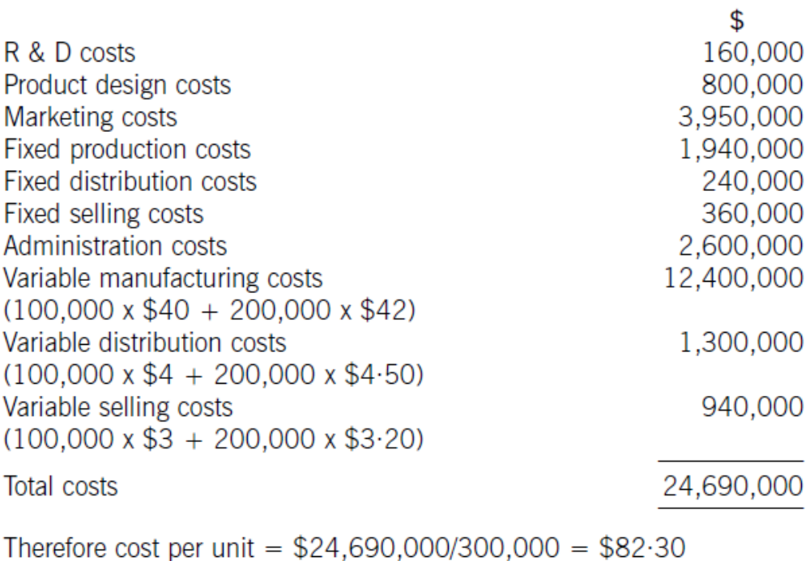

(b)
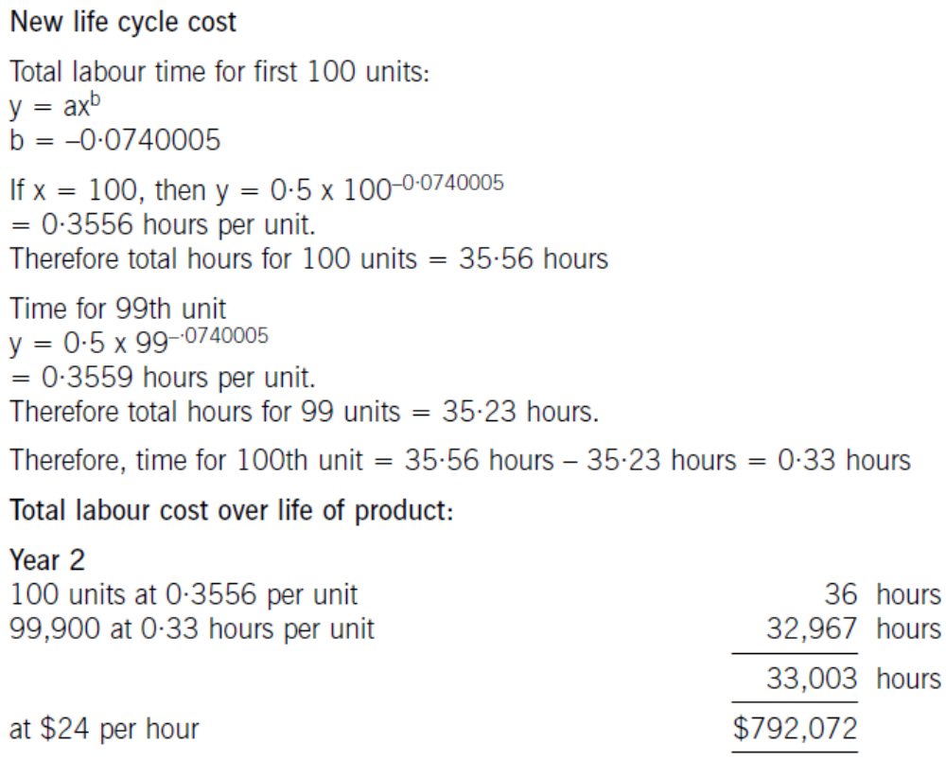

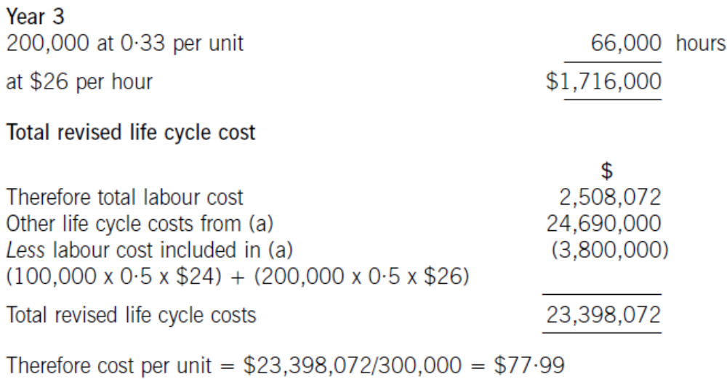

(c)
Benefits of life cycle costing
- The visibility of ALL costs is increased, rather than just costs relating to one period. This facilitates better decision-making.
- Individual profitability for products is more accurate because of this. This facilitates performance appraisal and decision-making, and means that prices can be determined with better knowledge of the true costs.
- More accurate feedback can take place when assessing whether new products are a success or a failure, since the costs of researching, developing and designing those products are also taken into account.

Note: Other valid benefits would also be awarded marks.

ACCA Marking Scheme


