Chapter 9 Divisional Performance Measures

Answer 1
(a)
A cost centre is a responsibility centre in a company where the managers are accountable for costs only.

A profit centre is a responsibility centre where the managers are accountable for revenue and cost (hence profit) only.

An investment centre is a responsibility centre where the managers are accountable for its investment return.

(b)
ROI = HK$1,000,000 / HK$5,000,000 = 20%

(c)
ROI = HK$260,000 / HK$2,000,000 = 13%
ROI = HK$1,260,000 / HK$7,000,000 = 18%

(d)
Both the ROI of the product and of the company decrease and so it is better not to invest in the new product.

(e)(i)
RI = HK$1,000,000 – 10% × HK$5,000,000 = HK$500,000

(e)(ii)
RI = HK$260,000 – 10% × HK$2,000,000 = HK$60,000

(e)(iii)
RI = HK$1,260,000 – 10% × HK$7,000,000 = HK$560,000

Answer 2
(a)
ROI is defined as profit after tax / total assets less total liabilities. In this case, the ROI is HK$130 million / HK$1,000 million = 13%.

(b)
Based on the definition, the three ways to increase ROI include increase in sales revenue (hence profit), reduce expense (hence increase profit) and to reduce assets and liabilities.

(c)
Evaluation just based on ROI may focus on revenue increase and cost decrease, this may not be in line with the company’s strategy.

(d)
EVA is RI which measures net operating profit earned less the minimum required return on average operating assets. EVA may fail to measure long term benefit such as movie production.

In addition, EVA does not consider the time value of money and could easily be distorted by accounting treatment as it starts with profit after tax.

(e)
EVA = profit after tax – cost of capital × equity used = HK$130 million – (10% × HK$1,000 million) = HK$30 million

(f)
Decentralised corporate structure enables management to make prompt decisions which are more responsive to the market. Management may also gain experience in the decision making process.

Answer 3
(a)

(b)

(b)(i)

(b)(ii)

(b)(iii)
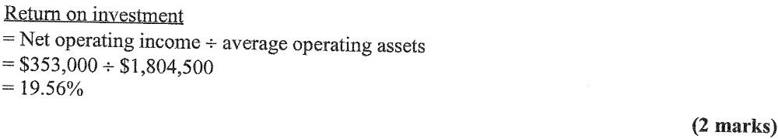

(b)(iv)
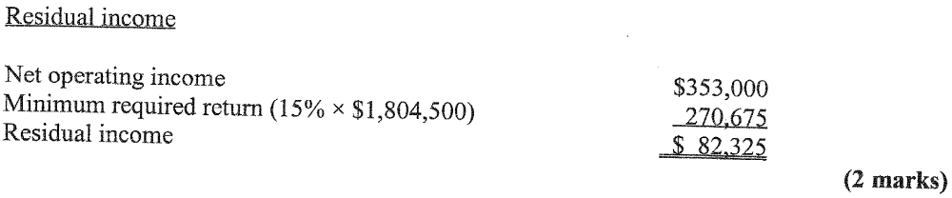

(c)
Divisional managers may reject otherwise profitable investment opportunities because they would reduce the division’s overall ROI figure. This can happen any time a division’s ROI exceeds the minimum required rate of return for the company. The RI approach overcomes this problem since any project whose rate of return exceeds the company’s minimum required rate of return will generate an increase in RI for the division. (4 marks)

Answer 4
(a)
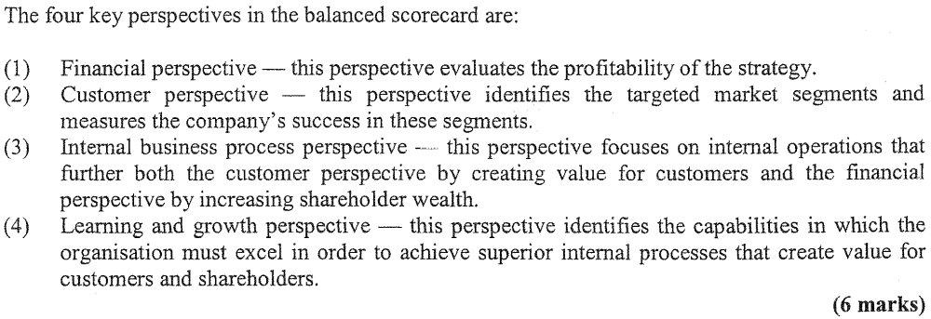

(b)

(c)

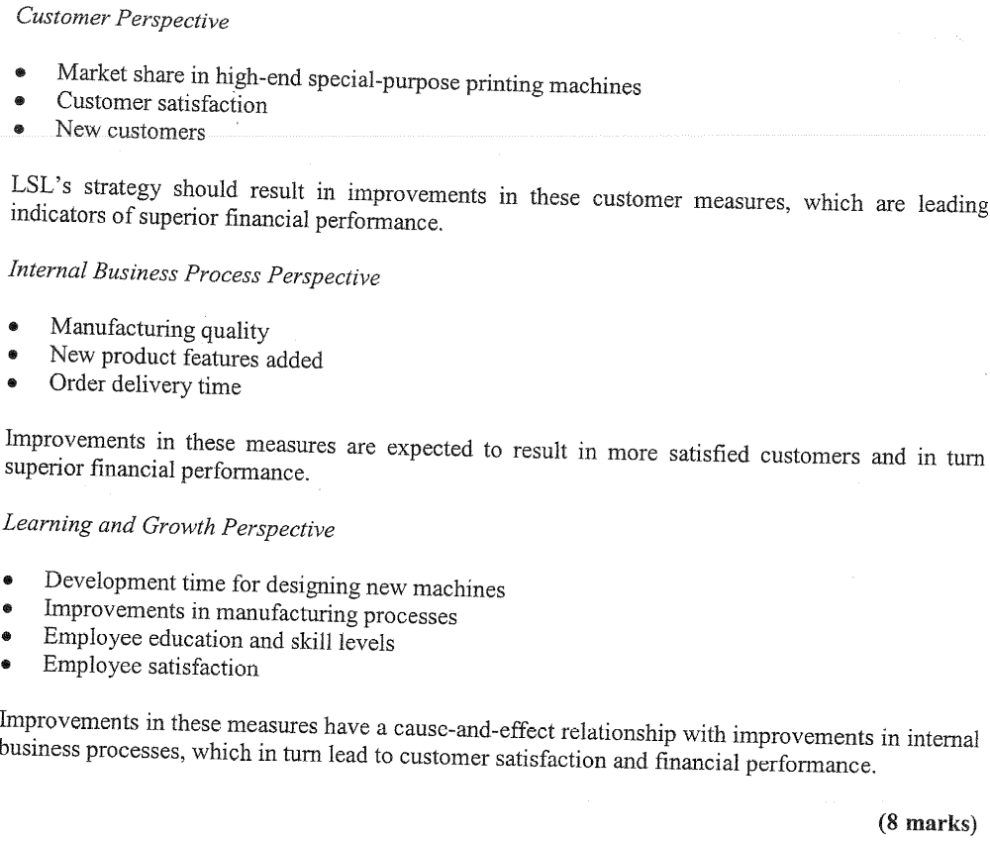

Answer 5
(a)
Project EVA = %$1,750,000 – ($12,5000,000 x 0.12) = $250,000 (2 marks)

(b)
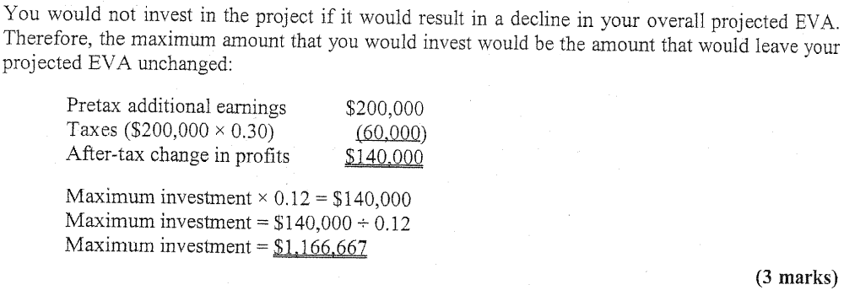

(c)
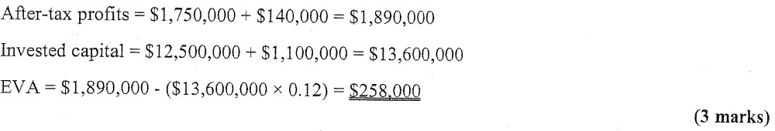

(d)
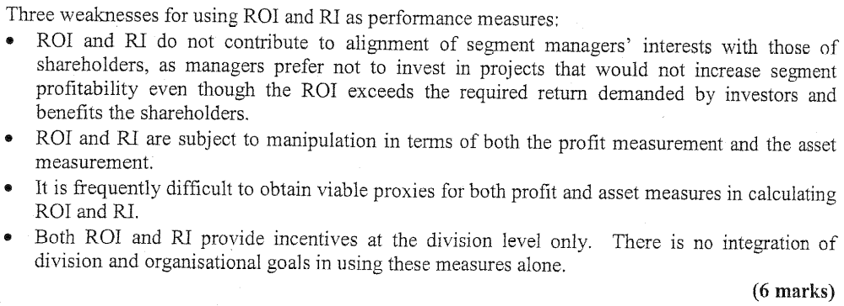

(e)
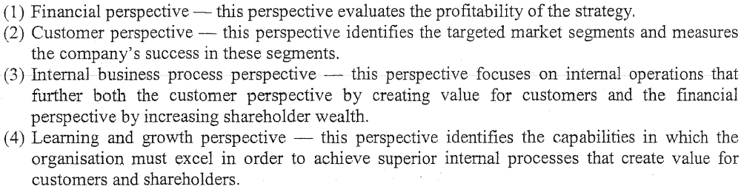

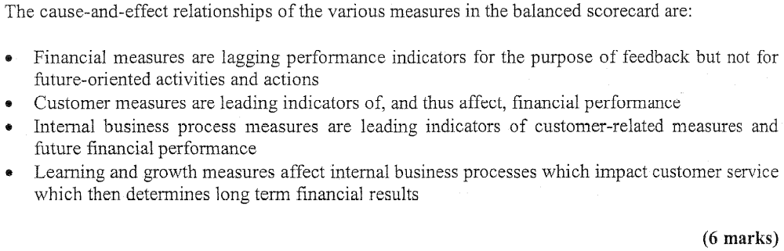

Answer 6
(a)
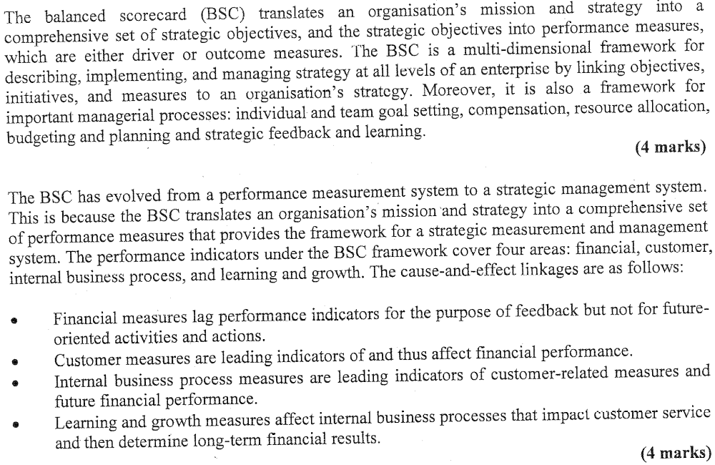

(b)
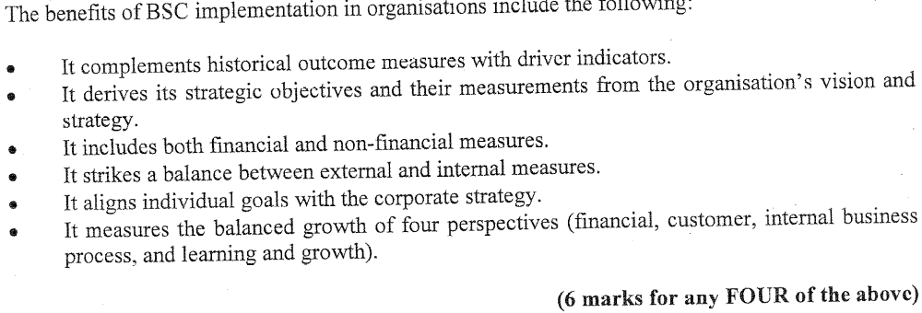

(c)
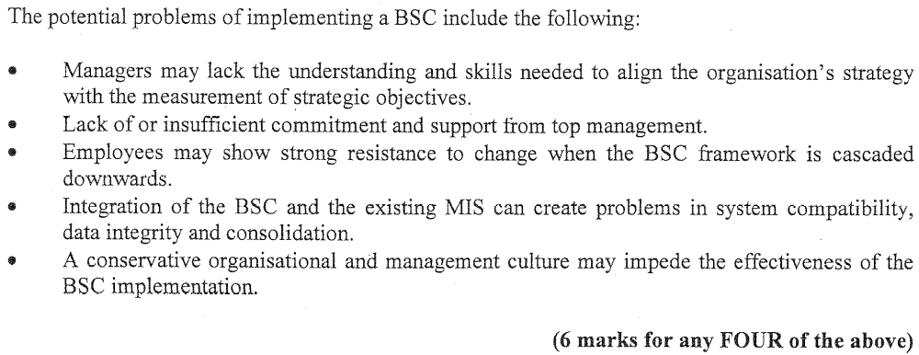
Answer 7
(a)
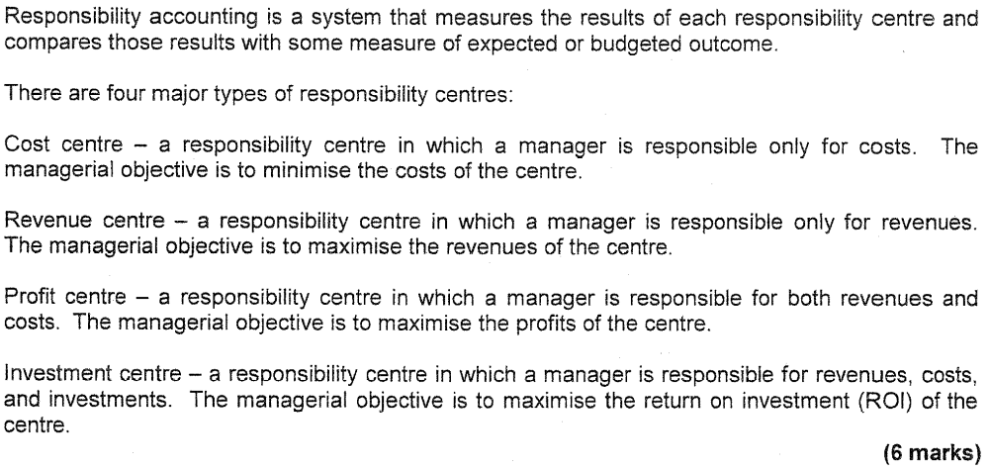

(b)
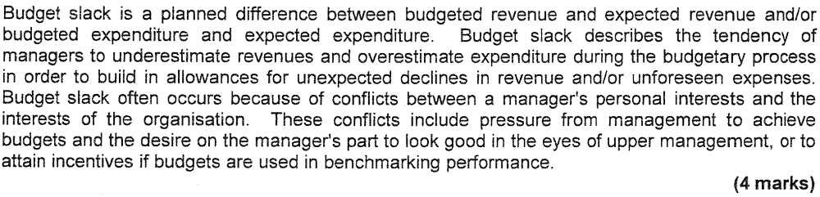

(c)

Answer 8
(a)
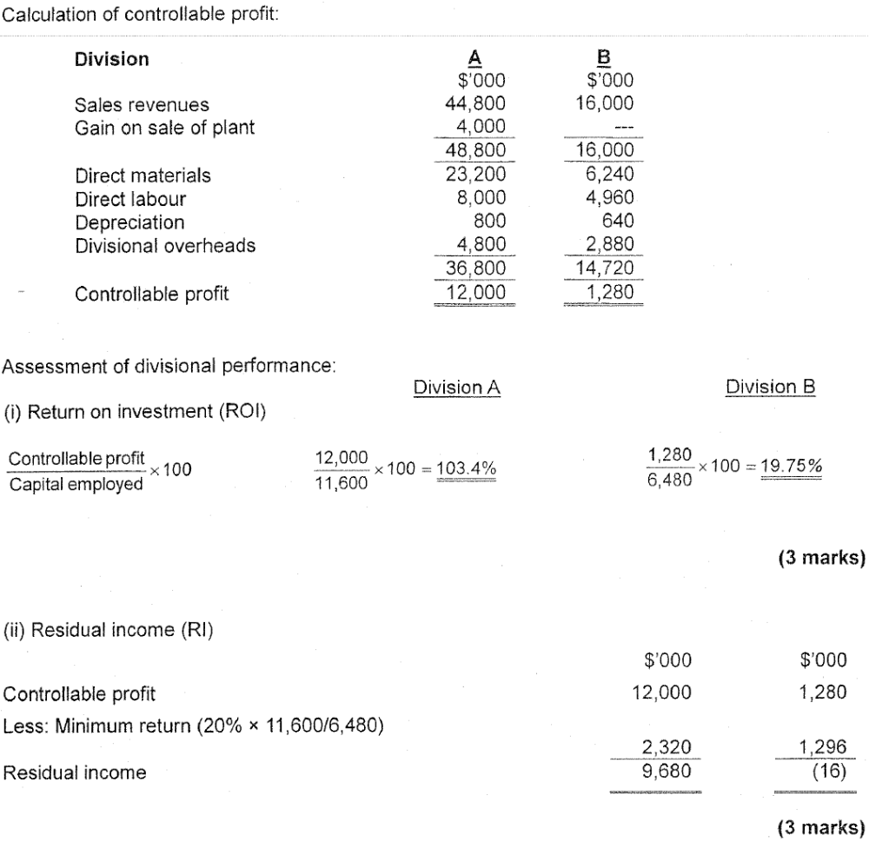

(b)

(c)

Answer 9
(a)

(b)

(c)
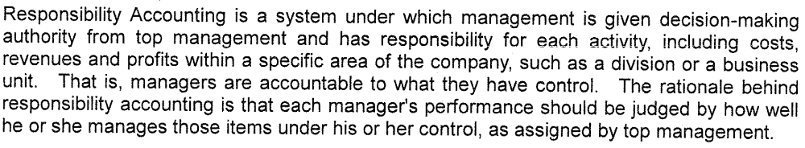

Answer 10
(a)

(b)

(c)

(d)

Answer 11
(a)

(b)

(c)

(d)
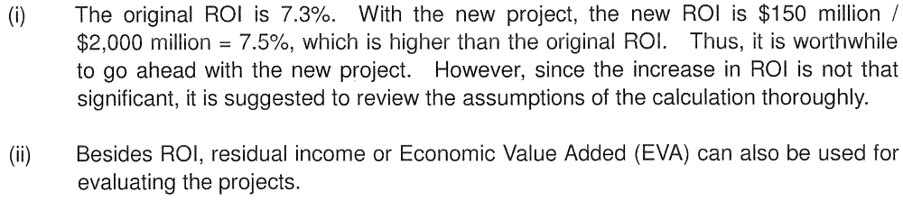

(e)


