Chapter 27 Market Efficiency

Answer – Test your understanding 1
(1) It is at most semi-strong.
(2) It is not efficient at all.
(3) It is strong form.
(4) It is at most weak form.

Examination Style Question

Answer 1
(a)
This observation does not indicate any violations of the efficient market hypothesis (EMH), which never states that returns ought to be the same across stocks.
[2.5 marks]
(b)
This represents a violation of the strong-form EMH, under which not even corporate insiders can earn superior returns on their purchases based on inside information.
[2.5 marks]
(c)
This violates the weak form of the EMH, and hence the semi-strong forma and strong form as well. When the market is weak-form efficient, stock returns are not serially correlated. That is, stock prices would follow a “random walk” – there would be a pattern in the stock prices that would allow investors to accurately forecast prices in the future. [2.5 marks]

(d)
This violates the weak-form, and hence the semi-strong and strong form of EMH as well. Again, the market should accurately reflect the information in a timely manner if it is efficient. From the description, it takes the market a long time to absorb the bad news into the stock price, an example of under-reaction. [2.5 marks]

Answer 2
(a)
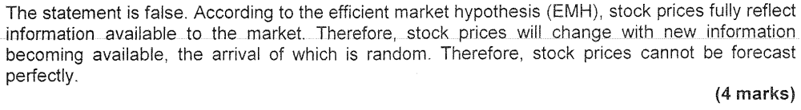

(b)
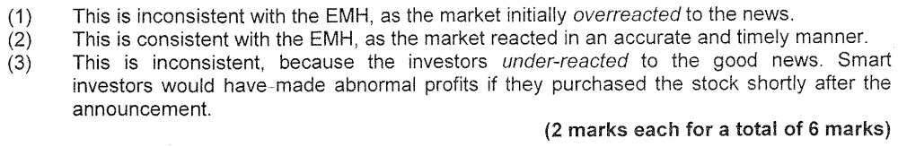

Answer 3
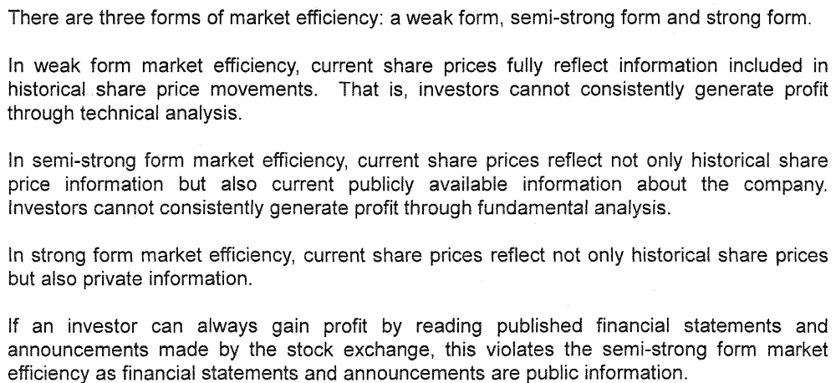

Answer 4
(a)
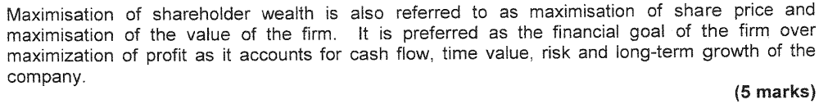

(b)
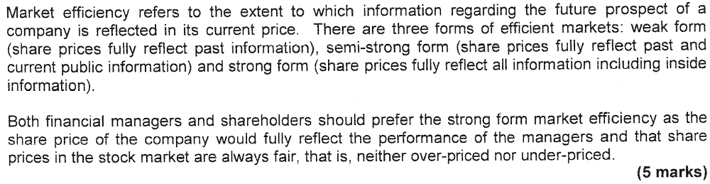

(c)
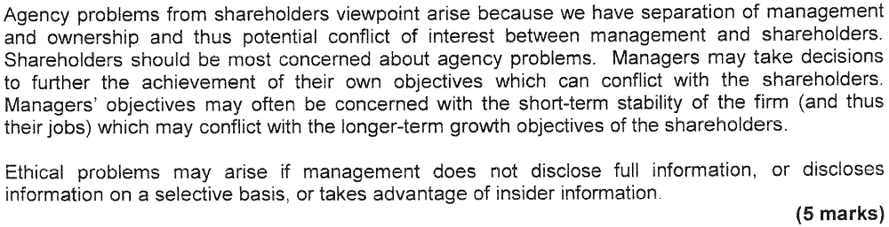

(d)
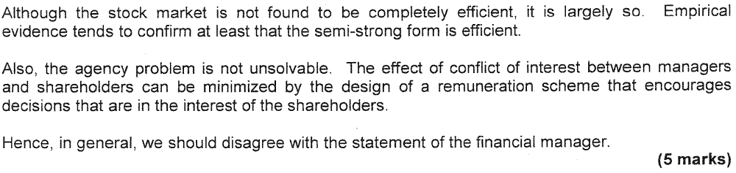

Answer 5
(a)
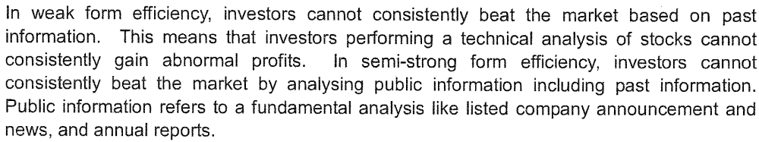

(b)
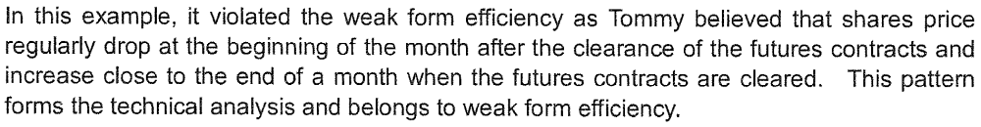

(c)

(d)(i)
Total cost = $100 + $100 + $30 + $35 = $265

(d)(ii)
If the cost = $265 and 20% profit on the sale price is required.
Sale price per person = $265 / 80% = $331.3

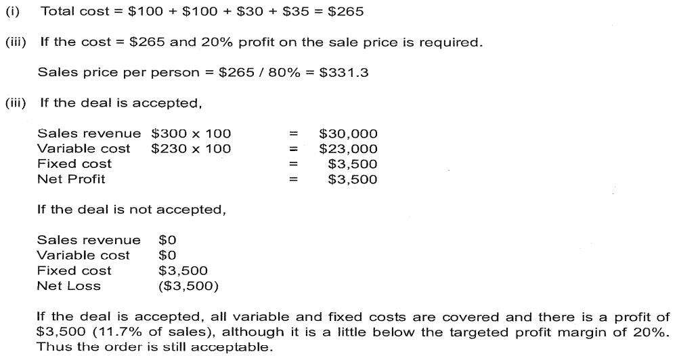

Answer 6
(a)
The three forms of market efficiency include weak form, semi-strong form and strong form efficiency.

(b)
This is weak form efficiency. People are conducting technical analysis and they have no consistent advantages.

(c)
This is semi-strong form efficiency. People are performing fundamental analyses of companies and they do not have consistent advantages in gaining a profit.

(d)
This is strong form efficiency and it is related to private information. The security guard believed that with the private information he could beat the market and earn more profits.

(e)
The statement is wrong. Market efficiency does not mean no profit can be generated. It means an investor cannot consistently generate profit through some trading rules and practices; otherwise, the market would violate certain forms of market efficiency.

Answer 7
(a)
It is related to weak form market efficiency as it is based on past prices. The analysis is called technical analysis.

(b)
It is related to semi-strong form market efficiency as it is based on public information such as accounting information. The analysis is called fundamental analysis.

(c)
The remaining one is strong form efficiency. When no one can make consistent profit from the stock market based on all the information including public and private information, then the market is strong form efficient.

(d)
EPS = HK$5,500,000,000 / 3,928,616,825 = HK$1.40

(e)
P/E ratio = HK$14 / 1.4 = 10. It takes 10 years of current earnings to pay back the original investment.

(f)
People criticize P/E as it based on historical profit and such accounting profit is subject to manipulation.

Answer 8
Weak form efficiency:
1. Stock market efficiency usually refers to the way in which the prices of traded financial securities reflect relevant information. When research indicates that share prices fully and fairly reflect past information, a stock market is described as weak-form efficient.
2. Investors cannot generate abnormal returns by analysing past information, such as share price movements in previous time periods, in such a market, since research shows that there is no correlation between share price movements in successive periods of time. Share prices appear to follow a ‘random walk’ by responding to new information as it becomes available.
[1 – 2 marks]

Semi-strong from:
1. When research indicates that share prices fully and fairly reflect public information as well as past information, a stock market is described as semi-strong form efficient.
2. Investors cannot generate abnormal returns by analysing either public information, such as published company reports, or past information, since research shows that share prices respond quickly and accurately to new information as it becomes publicly available.
[1 – 2 marks]
Strong from:
1. If research indicates that share prices fully and fairly reflect not only public information and past information, but private information as well, a stock market is described as strong form efficient.
2. Even investors with access to insider information cannot generate abnormal returns in such a market. Testing for strong form efficiency is indirect in nature, examining for example the performance of expert analysts such as fund managers. Stock markets are not held to be strong form efficient.
[1 – 2 marks]
Significance of semi-strong form efficiency:
1. The significance to a listed company of its shares being traded on a stock market which is found to be semi-strong form efficient is that any information relating to the company is quickly and accurately reflected in its share price.
2. Managers will not be able to deceive the market by the timing or presentation of new information, such as annual reports or analysts’ briefings, since the market processes the information quickly and accurately to produce fair prices.
3. Managers should therefore simply concentrate on making financial decisions which increase the wealth of shareholders.
[2 – 3 marks]

