ACCA

P2 (HKG)
June 2013
Mock 2 – Answers

Answer 1
(a)
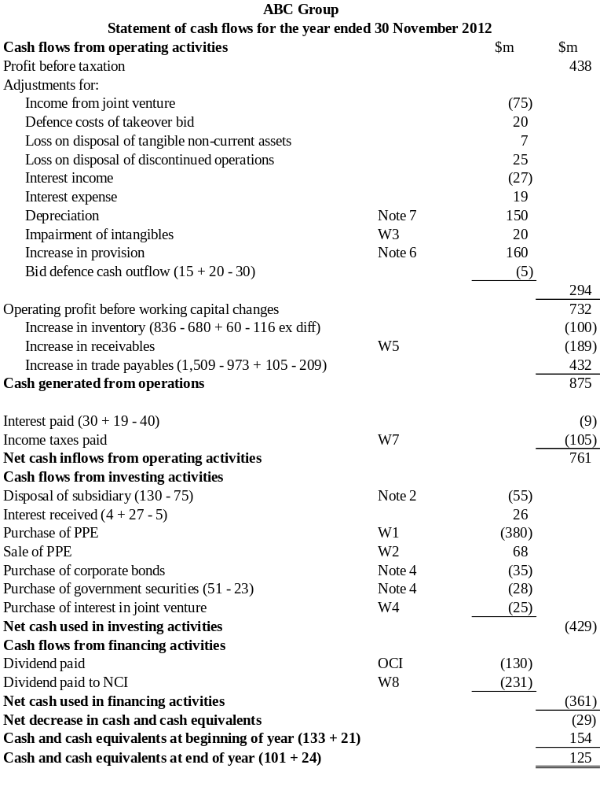

Workings:
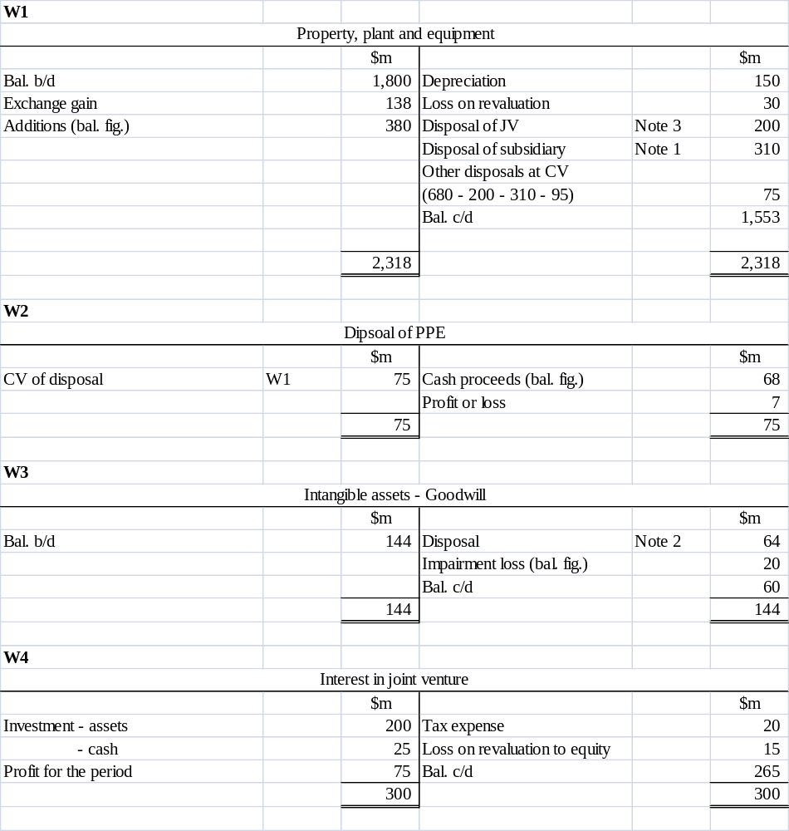

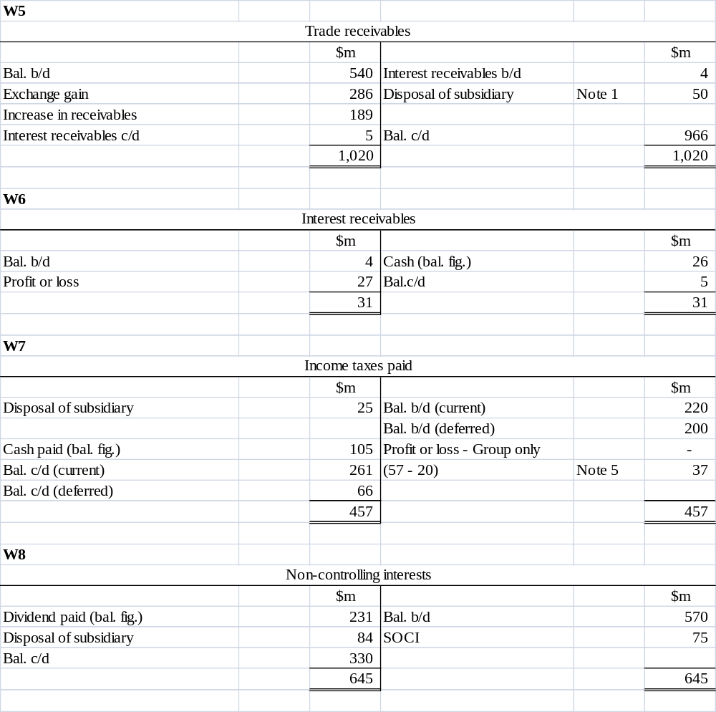

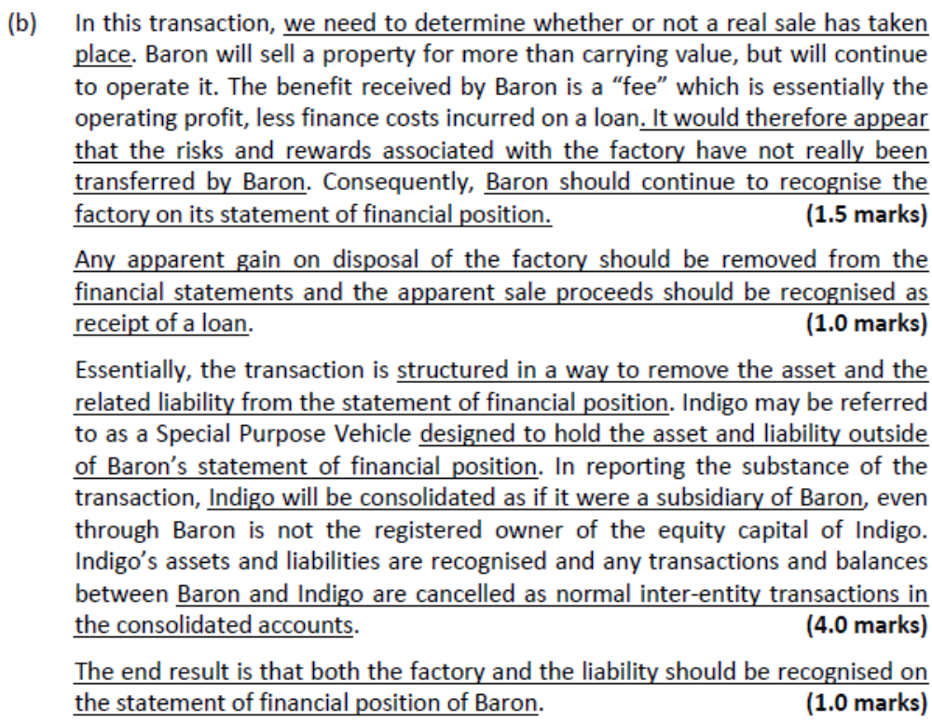

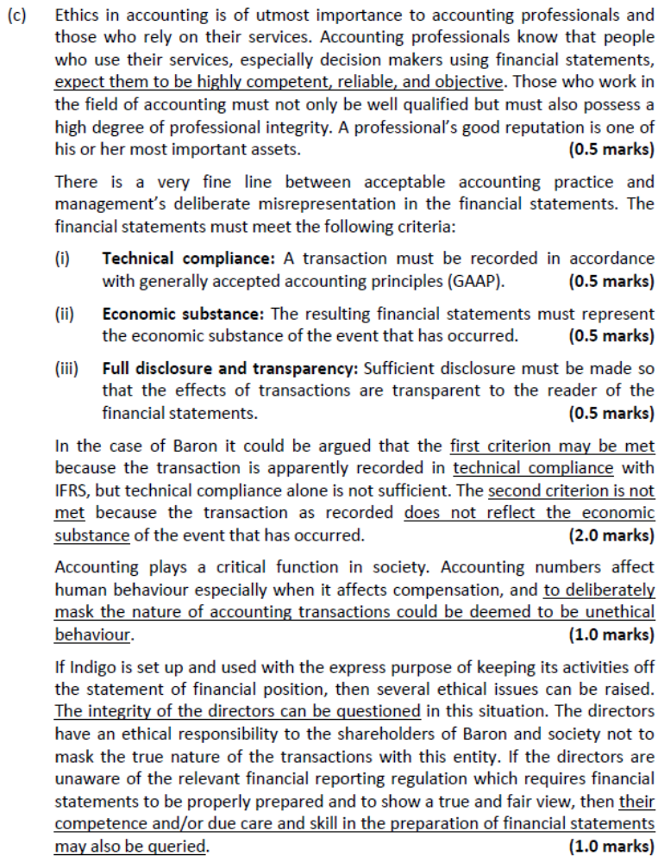

Answer 2
(a)
IFRS 11 Joint Arrangements defines a joint arrangement as an arrangement of which two or more parties have joint control. Joint control is the contractually agreed sharing of control of arrangement, which exists only when decisions about the relevant activities require the unanimous consent of the parties sharing control.

On the face of it, it would appear that York is a joint arrangement jointly controlled by Gow and Glass. Both venturers appear to have joint control and have contributed assets and other resources to the joint venture. The only issue however is that there is no written contract and the definition of a joint venture is that it is a contractual arrangement. However, the substance of the arrangement should be considered and with the minutes of the discussions about the setting up of the venture being formally approved by both companies this would certainly imply a contractual arrangement.

In terms of the accounting for such a joint arrangement, this depends on whether it is classified under IFRS 11 as a joint operation or a joint venture. A joint operation is a joint arrangement whereby the parties that have joint control of the arrangement have rights to the assets and obligations for the liabilities relating to the arrangement. A joint venture is a joint arrangement whereby the parties that have joint control of the arrangement have rights to the net assets of the arrangement.

The arrangement is structured through a separate entity – as such it could be either. However, there are no facts to suggest that Gow and Glass have rights to substantially all the benefits of the asset of York, nor an obligation for its liabilities. It appears rather that each company has an interest in the net assets of York and should account for it as a joint venture using the equity method in the group accounts of both Gow and Glass.

(b)
The loss of the only customer of the power statement (a cash generating unit) would be an indicator of a possible impairment of that cash generating unit. Therefore, according to IAS 36 Impairment of Assets, an impairment test must be carried out on the power station. The power station has a current carrying value of $20 million. This must be compared to the recoverable amount of the power station which is the higher of the power station’s fair value less costs to sell and its value in use.

The fair value less costs of disposal is the potential sale proceeds (offer of $16m) less the disposal costs ($1m). The value in use is the discounted value of the expected future cash flows from the power station. The future dismantling costs of $5 million must also be included in this calculation as it has been agreed with the government that this will take place therefore it is a liability.

Carrying value = $20 million
Fair value less costs to sell = $(16 – 1) million = $15 million
Value in use (W1) = $21 million

Therefore the recoverable amount is the higher of $21 million and $15 million. As this recoverable amount of $21 million is actually higher than the carrying value of the power station ($20 million) then there is no impairment. The discounted present value must be shown as a long term provision and as part of the cost of land and buildings.

There is however a further issue with Gow’s assets and that is the debt from Race. IFRS 9 financial assets must be assessed at each reporting date for impairment. It is highly likely that the debt from Race is impaired as Race has gone into receivership. The value of the amount to be received is the anticipated cash from the final settlement. As the cash is not likely to be received for a year then it should be discounted.

Value of receivable (W2) = $3.8 million

A further factor here is that the value of the contract with Race shown as an intangible asset will now be zero.

Glass’s net assets
The building remains an asset of the joint venture and there is no reason to alter its carrying value. However, its remaining useful life will change and the future depreciation charges will be $2 million each year for the next two years. As this is a change in estimate it is accounted for prospectively not retrospectively. Therefore this does not affect the current statement of financial position.

The lease liability must be assessed under IFRS 9 to determine whether it is to be derecognized. In this case there is a change to the lease term but it will not be derecognized. The lease liability, however, will change and will be measured at the present value of the future cash payments.

Value of lease liability (W3) = $1.1 million

The lease receivable is also extinguished as this is the payment of $1 million on 31 October 2012.

IAS 38 states that if intangible non-current assets are to be recognized in the statement of financial position, they must give a right to future economic benefits, be capable of being disposed of separately from the business and have a readily ascertainable market value. The payment to the agency of $0.5 million does not meet any of these criteria and cannot be recognized as an intangible asset and must be removed from the statement of financial position.

The terms of the contract with overseas retailer can in fact be split into two separate contracts in accordance with IAS 18 Revenue. There is one contract to provide gas to the overseas retailer and the income from this will be accounted fro in the normal way when gas is supplied. The other element of the contract is not to supply gas to any other company in that country over the four year period. Therefore the $1.5 million deposit received should not be taken to profit or loss immediately but spread over the four year period. The deposit should not have been deducted from intangible assets but instead should be shown as deferred income.

Intangible assets (W4) = $3m
Deferred income (W5) = $1.5m

Statement of financial position of York as at 31 October 2012

 | $m | $m
Land and building (9 + 4 + 4 (W1)) |  | 17.0
Intangible assets (W4) |  | 3.0
 |  | 20.0
Current assets
Inventory | 6.0
Receivables (W2) | 3.8
Cash (1 + 10) | 11.0
 |  | 20.8
Total assets |  | 40.8
Share capital |  | 30.0
Reserves (bal. fig.) |  | 4.2
 |  | 34.2
Lease liability (W3) |  | 1.1
Long-term provision (W1) |  | 4.0
Deferred income (W5) |  | 1.5
 |  | 40.8

W1
Value in use – power station
Cash flows | $m
31 Oct 2013 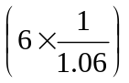 | 5.7
31 Oct 2014 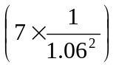 | 6.2
31 Oct 2015 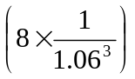 | 6.7
31 Oct 2016 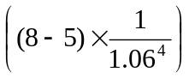 | 2.4
 | 21.0

The dismantling costs must be also be discounted and added into the value of property, plant and equipment: $5 million × 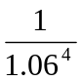 = $4 million.

W2
Value of receivable – Race
= $5 million × 80% ×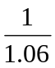 = $3.8 million

W3
Value of lease payable
 | $m
$0.6 million ×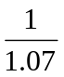 | 0.56
$0.6 million ×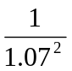 | 0.52
 | 1.08
Round to $1.1 million

W4
Intangible asset in Glass
 | $m
Per statement of financial position | 2.0
Less: agency fee | (0.5)
Add: value of overseas deposit | 1.5
 | 3.0

W5
Deferred income
Deposit from overseas retailer = $1.5 million

Answer 3
(a)
Units X and Y are to be disposed of in a single transaction and are therefore classified as a ‘disposal group’ under IFRS 5. The measurement basis to apply to the non-current assets should be applied to the whole of the disposal group, and a test for impairment should apply to the whole disposal group rather than each cash generating unit separately.

On classification as held for sale, disposal groups should be measured at the lower of carrying value and fair value less costs to sell. Any impairment loss should be recognized in profit or loss (except to the extent that the impairment loss reverses a previous revaluation of the assets).

At 30 November 2012, when the disposal group is classified as held for sale, it should be valued at $66 million, which is the lower of carrying value and fair value less costs to sell.

At 31 December 2012, a subsequent reporting date, the disposal group should be valued at fair value less costs to sell. Any increase in fair value minus costs to sell should be recognized, but not in excess of the cumulative impairment loss that has previously been recognized in accordance with either IFRS 5 or IAS 36.

In this situation, there has been an increase in fair value less costs to sell of the disposal group, amounting to $13 million (= 30m + 65m – 82m). The impairment loss previously recognized in Unit X is $12 million (= 36m – 24m).

Therefore a 31 December 2012 the fair value less costs to sell of the disposal group can be increased by $12 million to $94 million (= 82m + 12m). The gain on the revaluation will be recognized in profit or loss. The effect of the adjustment is therefore to increase profit before interest and tax by $12 million and increase capital employed by $12 million. This will have effect of increasing the reported ROCE.

(b)
IAS 12 states that as a general rule deferred tax liabilities should be recongised for all taxable temporary differences. A deferred tax assets should be recognized but only to the extent that there will be taxable profits against which the deductible taxable temporary differences can be used.

At the end of each reporting period, any deferred tax asset should be reviewed and reduced to the extent that it is no longer probable that there will be taxable profits against which the deductible taxable temporary differences can be used.

The situation after adjusting the tax base is as follows:

 | Carrying amount | Tax base | Temporary difference
 | $m | $m | $m
Equipment | 28 | 34 | 6
Plant | 39 | 44 | 5
Other taxable temporary difference |  |  | (3)
 |  |  | 8

The tax base is higher than the carrying amount of the non-current assets. This means that there is a deferred tax asset of $8 million × 25%, on the assumption that there will be taxable profits against which the deductible taxable temporary differences can be used.

The situation in the draft accounts of Batter, before revaluation of the tax base, is as follows:
 | Carrying amount | Tax base | Temporary difference
 | $m | $m | $m
Equipment | 28 | 25 | 3
Plant | 39 | 36 | 3
Other taxable temporary difference |  |  | 3
 |  |  | 9

The tax base is lower than the carrying amount of the non-current assets. This means that there is a deferred tax liability. This is $9 million × 25% = $2.25 million. On revaluation of the tax base, the deferred tax liability is removed and a current tax asset of $2 million is created.

Since this affects the tax charge, it does not affect profit before interest and tax. However, total capital employed will increased by $4.25 million (= $2m liability removed + $2.25m asset created). The effect of this adjustment is therefore to reduce ROCE.

(c)
Under the principles of IFRS 2 Share Based Payment, this arrangement will be regarded as an equity share based payment.

The fair value of the equity settled share based payment will be credited to equity debited to expenses (or occasionally included in the carrying amount of another asset) over the vesting period.

Where the transaction is with employees, fair value is measured as the market value of the equity instrument at the grant date.

The vesting condition relating to the number of executives who remain with Batter is a non-market condition so it is taken into account when estimating the number of options that will vest.

The vesting condition relating to the share price is a market condition so it is taken into account when measuring the fair value of an option at grant date.

Therefore, the total estimated fair value of the share based payment is $1,545,600 (92 × 20,000 × $0.84). 1/3 of this amount ($515,200) is recognized in the year ended 31 December 2012. $515,200 is credited to equity and debited to expenses.

The effect of the transaction is therefore decrease profit before interest and tax by $515,200 and decrease capital employed by the same amount. This will have the effect of decreasing the reported ROCE.

The overall effect of the adjustments on ROCE is as follows.
 | $m
PBIT in draft accounts | 36.00
Increase in profit: revaluation of disposal group | 12.00
Less: Employee benefits | (0.52)
Adjusted PBIT | 47.48
Capital employed in draft accounts | 250.0
Revaluation of disposal group | 12.00
Change in deferred tax | 4.25
Less: Employee benefits | (0.52)
Adjusted capital employed | 265.73

The new ROCE is 17.9% (= 47.48/265.73), which is higher than the ROCE that would have been reported without the adjustments.

(d)
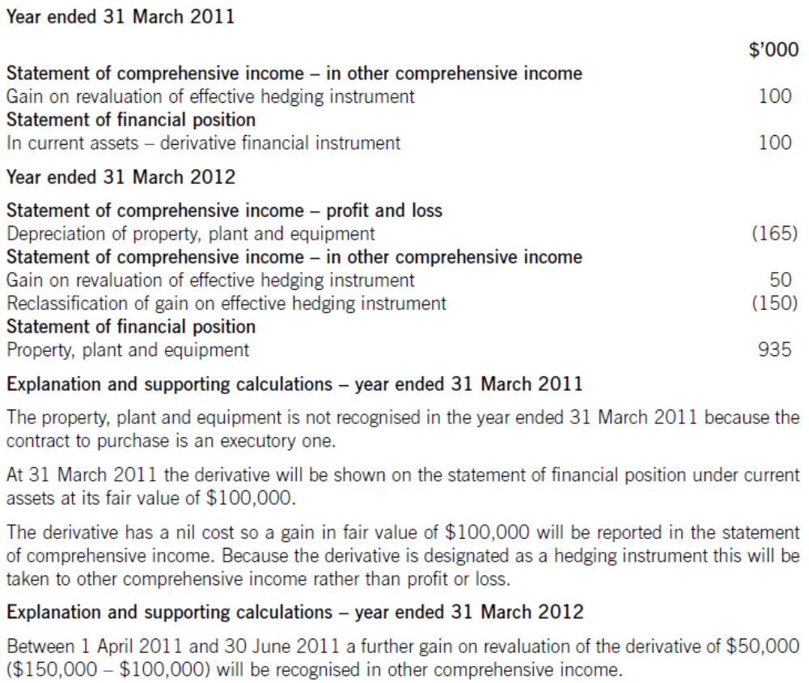

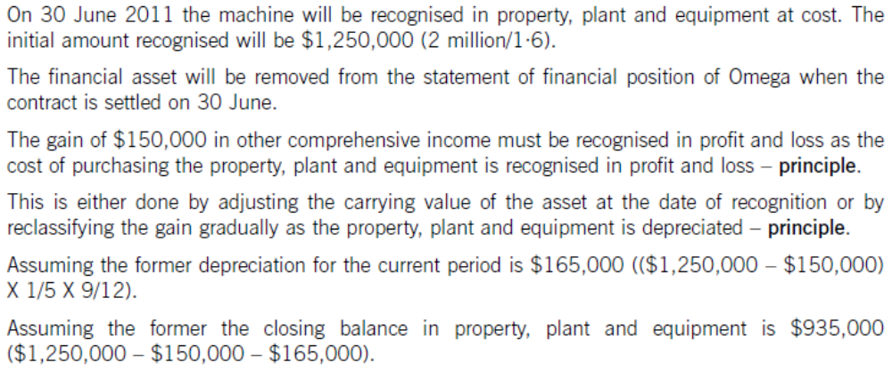

Answer 4
(a)

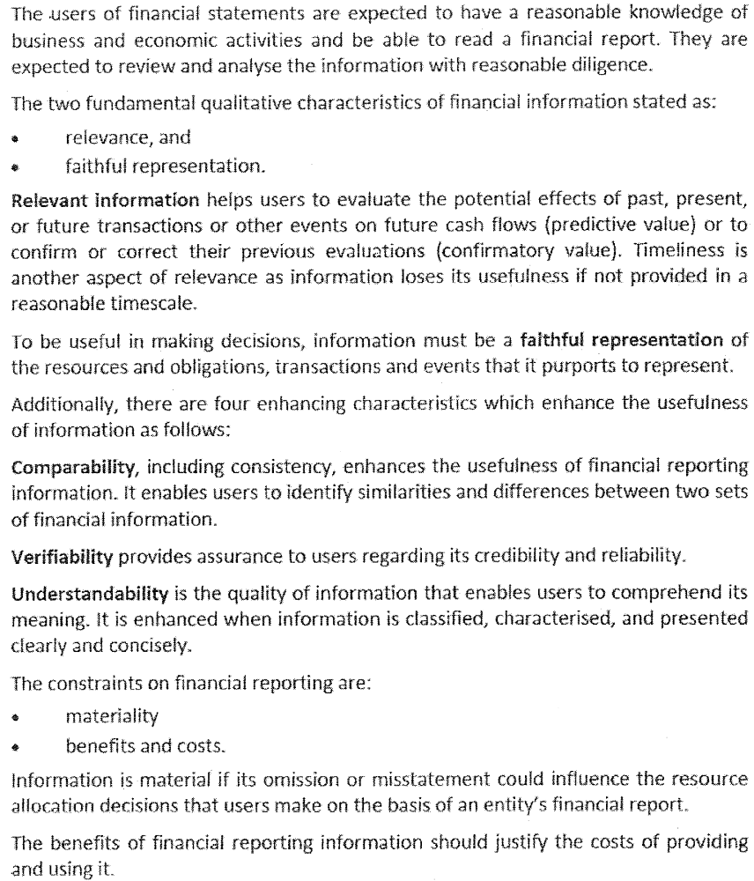

(b)(i)

(b)(ii)
Provisions
- The IASB’s ‘Framework’ would require recognition of the full discounted liability for the decommissioning.
- The problem is that this can only be achieved by creating an asset on the other side of the statement of financial position. This asset struggles to meet the Framework’s definition of an asset and is somewhat dubious by nature.
- An asset is a resource controlled by the company as a result of past events and from which future economic benefits are expected to flow. It is difficult to see how a future cost can meet this definition.
- The other strange aspect to the treatment of this item is that depreciation (and hence part of the provision) will be treated as an operating cost and the unwinding of the discount could be treated as a finance cost. This latter treatment could fail any qualitative test in terms of the relevance and reliability of the information.

- A liability is defined in the Framework as a present obligation arising from past events, the settlement of which is expected to result in an outflow of economic benefits. The idea of a ‘constructive obligation’ utilised in IAS 37 is also included as a requirement in the Framework. Assets and liabilities are essentially a collection of rights and obligations.

(b)(iii)
Deferred tax
- The provision for deferred taxation does not meet the criteria for a liability (or an asset) as set out in the Framework. The only tax liability (present obligation as a result of past events) is in fact the ‘current tax’ due to the tax authorities. A deferred tax liability can be avoided, for example, if a company makes future losses, and with suitable tax planning strategies it may never result in taxable amounts.

- A deferred tax asset is dependent upon the certainty of future profits or tax planning opportunities. It can be argued that a deferred tax asset does not confer any ‘right’ to future economic benefits as future profits are never certain.

(c)
Purpose of the Management Commentary (MC)
- The IFRS Practice Statement (PS) Management Commentary was published in December 2010 and provides a broad, non-binding framework for the presentation of management commentary that relates to financial statements that have been prepared in accordance with International Financial Reporting Standards.

- It is a narrative report that provides a context within which to interpret the financial position, financial performance and cash flows of an entity.
- Management is able to explain its objectives and its strategies for achieving those objectives.
- Users routinely use this type information provided in MC to help them evaluate an entity’s prospects and its general risks, as well as the success of management’s strategies for achieving its stated objectives.
- For many entities, management commentary is already an important element of their communication with the capital markets, supplementing as well as complementing the financial statements.
- This PS helps management to provide useful commentary to financial statements prepared in accordance with IFRS information.

Framework for presentation of MC
- The following principles should be applied when a MC is prepared:
  - to provide management’s view of the entity’s performance, position and progress; and
  - to supplement and complement information presented in the financial statements.

- Consequently, the MC should include information which is both forward-looking and adheres to the qualitative characteristics of information as described in the Conceptual Framework for Financial Reporting 2010.

- The management commentary should provide information to help users of the financial reports to assess the performance of the entity and the actions of its management relative to stated strategies and plans for progress.
- That type of commentary will help users of the financial reports to understand risk exposures and strategies of the entity, relevant non-financial factors and other issues not otherwise included within the financial statements.

Elements of MC
- MC should include information that is essential to an understanding of:
  - the nature of business;
  - management’s objectives and its strategies for meeting those objectives;
  - the entity’s most significant resources, risks and relationships;
  - the results of operations and prospects; and
  - the critical performance measures and indicators that management uses to evaluate the entity’s performance against stated objectives.

