Revision 3 – Working Capital Management

Answer 1
(a)
Objectives of working capital management:
1. The objectives of working capital management are profitability and liquidity.
2. The objective of profitability supports the primary financial management objective, which is shareholder wealth maximisation.
3. The objective of liquidity ensures that companies are able to meet their liabilities as they fall due, and thus remain in business.
[1 mark]
Discussion of conflict between objectives:
4. However, funds held in the form of cash do not earn a return, while near-liquid assets such as short-term investments earn only a small return.
5. Meeting the objective of liquidity will therefore conflict with the objective of profitability, which is met by investing over the longer term in order to achieve higher returns.
[2 marks]
Good working capital management therefore needs to achieve a balance between the objectives of profitability and liquidity if shareholder wealth is to be maximised.

ACCA Marking Scheme

(b)
Objectives of working capital management:
1. Profitability and liquidity are usually cited as the twin objectives of working capital management.
2. The profitability objective reflects the primary financial management objective of maximising shareholder wealth, while liquidity is needed in order to ensure that financial claims on an organisation can be settled as they become liable for payment.
[1 – 2 marks]
Conflict between two objectives:
3. The two objectives are in conflict because liquid assets such as bank accounts earn very little return or no return, so liquid assets decrease profitability. Liquid assets in fact incur an opportunity cost equivalent either to the cost of short-term finance or to the profit lost by not investing in profitable projects.
[1 – 2 marks]
Trade-off between two objectives:
4. Whether profitability is a more important objective than liquidity depends in part on the particular circumstances of an organisation. Liquidity may be the more important objective when short-term finance is hard to find, while profitability may become a more important objective when cash management has become too conservative. In short, both objectives are important and neither can be neglected.
[1 mark]
ACCA Marking Scheme

(c)
Objectives and advantages of working capital management:
1. The objectives of working capital management are often stated to be profitability and liquidity. These objectives are often in conflict, since liquid assets earn the lowest return and so liquidity is achieved at the expense of profitability. However, liquidity is needed in the sense that a company must meet its liabilities as they fall due if it is to remain in business. For this reason cash is often called the lifeblood of the company, since without cash a company would quickly fail. Good working capital management is therefore necessary if the company is to survive and remain profitable.
[2 marks]
Credit management effect:
2. The fundamental objective of the company is to maximise the wealth of its shareholders and good working capital management helps to achieve this by minimising the cost of investing in current assets. Good credit management, for example, aims to minimise the risk of bad debts and expedite the prompt payment of money due from debtors in accordance with agreed terms of trade. Taking steps to optimise the level and age of debtors will minimise the cost of financing them, leading to an increase in the returns available to shareholders.
[2 marks]
Stock management effect:
3. A similar case can be made for the management of stock. It is likely that Velm plc will need to have a good range of stationery and office supplies on its premises if customers’ needs are to be quickly met and their custom retained. Good stock management, for example using techniques such as the economic order quantity model, ABC analysis, stock rotation and buffer stock management can minimise the costs of holding and ordering stock. The application of just-in-time methods of stock procurement and manufacture can reduce the cost of investing in stock. Taking steps to improve stock management can therefore reduce costs and increase shareholder wealth.
[2 marks]
Other example:
4. Cash budgets can help to determine the transactions need for cash in each budget control period, although the optimum cash position will also depend on the precautionary and speculative need for cash. Cash management models such as the Baumol model and the Miller-Orr model can help to maintain cash balances close to optimum levels. [1 mark]

The different elements of good working capital management therefore combine to help the company to achieve its primary financial objective.

ACCA Marking Scheme
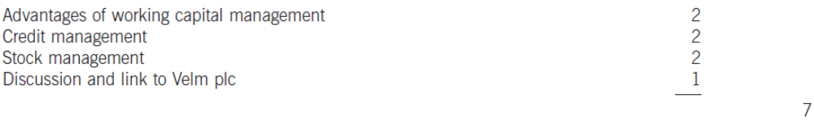

Answer 2
(a)
Calculation of ratios:
Stock days | 2006: (3,000/9,300) × 365 = 118 days
 | 2005: (1,300/6,600) × 365 = 72 days
 | Sector average: 90 days
Debtor days | 2006: (3,800/15,600) × 365 = 89 days
 | 2005: (1,850/11,100) × 365 days = 61 days
 | Sector average: 60 days
Creditor days | 2006: [2,870/(9,300 × 95%)] × 365 = 119 days
 | 2005: [1,600/(6,600 × 95%)] x 365 = 93 days
 | Sector average: 80 days
[3 marks]

Comment:
In each case, the ratio in 2006 is higher than the ratio in 2005, indicating that deterioration has occurred in the management of stock, debtors and creditors in 2006.

Stock days have increased by 46 days or 64%, moving from below the sector average to 28 days – one month – more than it. Given the rapid increase in turnover (40%) in 2006, Anjo plc may be expecting a continuing increase in the future and may have built up stocks in preparation for this, i.e. stock levels reflect future sales rather than past sales. Accounting statements from several previous years and sales forecasts for the next period would help to clarify this point.

Debtor days have increased by 28 days or 46% in 2006 and are now 29 days above the sector average. It is possible that more generous credit terms have been offered in order to stimulate sales. The increased turnover does not appear to be due to offering lower prices, since both gross profit margin (40%) and net profit margin (34%) are unchanged.

In 2005, only management of creditors was a cause for concern, with Anjo plc taking 13 more days on average to settle liabilities with trade creditors than the sector. This has increased to 39 days more than the sector in 2006. This could lead to difficulties between the company and its suppliers if it is exceeding the credit periods they have specified. Anjo plc has no long-term debt and the statement of financial position indicates an increased reliance on short-term finance, since cash has reduced by $780,000 or 87% and the overdraft has increased by $850,000 to $1 million.

Perhaps the company should investigate whether it is undercapitalised (overtrading). It is unusual for a company of this size to have no long-term debt.
[3 marks]
(b)
Cash operating cycle (2005) = 72 + 61 – 93 = 40 days [1 mark]
Cash operating cycle (2006) = 118 + 89 – 119 = 88 days [1 mark]

The cash operating cycle or working capital cycle gives the average time it takes for the company to receive payment from debtors after it has paid its trade creditors. This represents the period of time for which debtors require financing. The cash operating cycle of Anjo plc has lengthened by 48 days in 2006 compared with 2005. This represents an increase in working capital requirement of approximately $15,600,000 x 48/365 = $2.05 million.
[2 mark]
(c)
Working capital and business solvency:
1. The objectives of working capital management are liquidity and profitability, but there is a tension between these two objectives. Liquid funds, for example cash, earn no return and so will not increase profitability. Near-liquid funds, with short investment periods, earn a lower return than funds invested for a long period. Profitability is therefore decreased to the extent that liquid funds are needed.

2. The main reason that companies fail, though, is because they run out of cash and so good cash management is an essential part of good working capital management. Business solvency cannot be maintained if working capital management in the form of cash management is of a poor standard.
[3 – 4 marks]
Factors influencing optimum cash level:
In order to balance the twin objectives of liquidity and profitability in terms of cash management, a company needs to decide on the optimum amount of cash to hold at any given time. There are several factors that can aid in determining the optimum cash balance.

1. First, it is important to note that cash management is a forward-looking activity, in that the optimum cash balance must reflect the expected need for cash in the next budget period, for example in the next month. The cash budget will indicate expected cash receipts over the next period, expected payments that need to be made, and any shortfall that is expected to arise due to the difference between receipts and payments. This is the transactions need for cash, since it is based on the amount of cash needed to meet future business transactions.

2. However, there may be a degree of uncertainty as to the timing of expected receipts. Debtors, for example, may not all pay on time and some may take extended credit, whether authorised or not. In order to guard against a possible shortfall of cash to meet future transactions, companies may keep a ‘buffer stock’ of cash by holding a cash reserve greater than called for by the transactions demand. This is the precautionary demand for cash and the optimum cash balance will reflect management’s assessment of this demand.

3. Beyond this, a company may decide to hold additional cash in order to take advantage of any business opportunities that may arise, for example the possibility of taking over a rival company that has fallen on hard times. This is the speculative demand for cash and it may contribute to the optimum cash level for a given company, depending on that company’s strategic plan.
[4 – 5 marks]

(d)
 | $000 | Marks
Current debtors = | 3,800
Debtors under factor = 3,800 x 0.7 = | 2,660
Reduction in debtors = | 1,140 | [1]
Finance cost saving = 1,140 x 0.08 = | 91.2 | [1]
Administration cost saving = 1,000 x 0.02 = | 20.0 | [1]
Interest on advance = 2,660 x 0.8 x 0.01 | (21.3) | [2]
Factor’s annual fee = 15,600 x 0.005 = | (78.0) | [1]
Net benefit of accepting factor’s offer | 11.9 | [1]

Conclusion and discussion:
Although the terms of the factor’s offer are financially acceptable, suggesting a net financial benefit of $11,900, this benefit is small compared with annual turnover of $15.6 million. Other benefits, such as the application of the factor’s expertise to the debtor management of Anjo plc, might also be influential in the decision on whether to accept the offer. [1 mark]

ACCA Marking Scheme
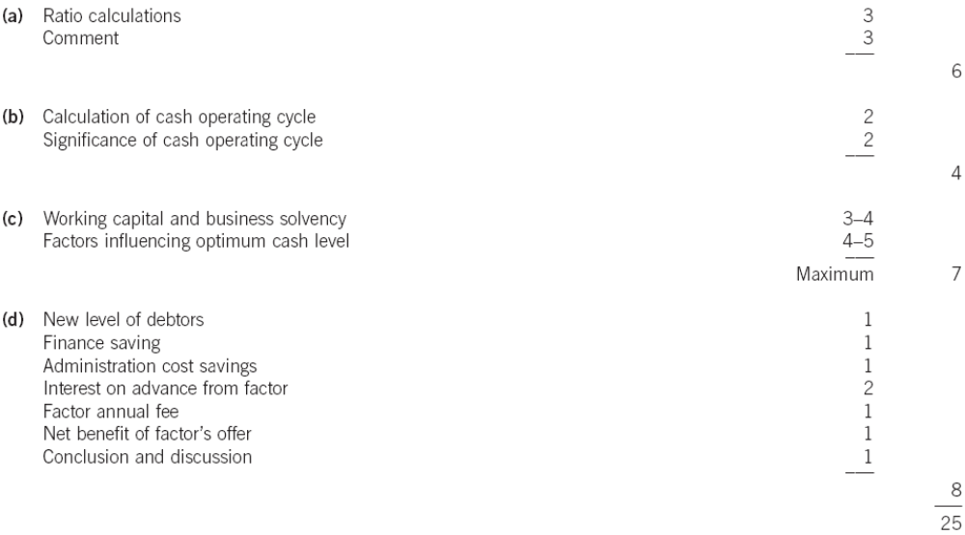

Answer 3
(a)
Financial analysis
Fixed interest debt proportion (2006) = 100 x 2,425/ 2,425 + 1,600) = 60%
Fixed interest debt proportion (2007) = 100 x 2,425/(2,425 + 3,225) = 43%
Fixed interest payments = 2,425 x 0·08 = $194,000
Variable interest payments (2006) = 274 – 194 = $80,000 or 29%
Variable interest payments (2007) = 355 – 194 = $161,000 or 45%
(Alternatively, considering the overdraft amounts and the average variable overdraft interest rate of 5% per year:
Variable interest payments (2006) = 1·6m x 0·05 = $80,000 or 29%
Variable interest payments (2007) = 3·225m x 0·05 = $161,250 or 45%)
Interest coverage ratio (2006) = 2,939/ 274 = 10·7 times
Interest coverage ratio (2007) = 2,992/ 355 = 8·4 times
Debt/equity ratio (2006) = 100 x 2,425/ 11,325 = 21%
Debt/equity ratio (2007) = 100 x 2,425/ 12,432 = 20%
Total debt/equity ratio (2006) = 100 x (2,425 +1,600)/ 11,325 = 35%
Total debt/equity ratio (2007) = 100 x (2,425 +3,225)/ 12,432 = 45%
[1 – 2 marks]
Discussion of effects of interest rate increase:
1. Gorwa Co has both fixed interest debt and variable interest rate debt amongst its sources of finance. The fixed interest bonds have ten years to go before they need to be redeemed and they therefore offer Gorwa Co long term protection against an increase in interest rates.

2. In 2006, 60% of the company’s debt was fixed interest in nature, but in 2007 this had fallen to 43%.
3. The floating-rate proportion of the company’s debt therefore increased from 40% in 2006 to 57% in 2007.
4. The interest coverage ratio fell from 10·7 times in 2006 to 8·4 times in 2007, a decrease which will be a cause for concern to the company if it were to continue.
5. The debt/equity ratio (including the overdraft due to its size) increased over the same period from 35% to 45% (if the overdraft is excluded, the debt/equity ratio declines slightly from 21% to 20%).

6. From the perspective of an increase in interest rates, the financial risk of Gorwa Co has increased and may continue to increase if the company does not take action to halt the growth of its variable interest rate overdraft. The proportion of interest payments linked to floating rate debt has increased from 29% in 2006 to 45% in 2007. An increase in interest rates will further reduce profit before taxation, which is lower in 2007 than in 2006, despite a 40% increase in turnover.
[3 – 4 marks]
Interest rate hedging:
1. One way to hedge against an increase in interest rates is to exchange some or all of the variable-rate overdraft into long-term fixed-rate debt. There is likely to be an increase in interest payments because long-term debt is usually more expensive than short-term debt. Gorwa would also be unable to benefit from falling interest rates if most of its debt paid fixed rather than floating rate interest.
2. Interest rate options and interest rate futures may be of use in the short term, depending on the company’s plans to deal with its increasing overdraft.
3. For the longer term, Gorwa Co could consider raising a variable-rate bank loan, linked to a variable rate-fixed interest rate swap.
[2 – 3 marks]
(b)
Financial analysis
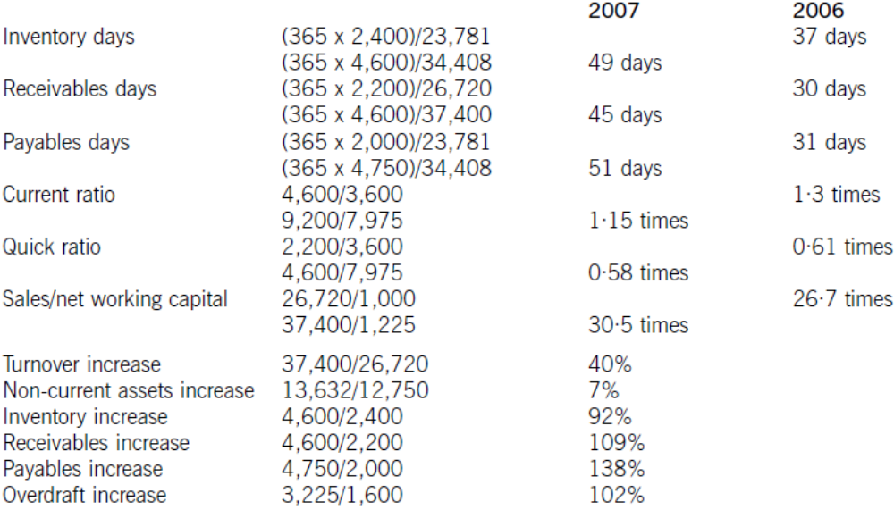
[5 – 6 marks]
Discussion
1. Overtrading or undercapitalisation arises when a company has too small a capital base to support its level of business activity. Difficulties with liquidity may arise as an overtrading company may have insufficient capital to meet its liabilities as they fall due.
2. Overtrading is often associated with a rapid increase in turnover and Gorwa Co has experienced a 40% increase in turnover over the last year. Investment in working capital has not matched the increase in sales, however, since the sales/net working capital ratio has increased from 26·7 times to 30·5 times.

3. Overtrading could be indicated by a deterioration in inventory days. Here, inventory days have increased from 37 days to 49 days, while inventory has increased by 92% compared to the 40% increase in turnover. It is possible that inventory has been stockpiled in anticipation of a further increase in turnover, leading to an increase in operating costs.

4. Overtrading could also be indicated by deterioration in receivables days. In this case, receivables have increased by 109% compared to the 40% increase in turnover. The increase in turnover may have been fuelled in part by a relaxation of credit terms.

5. As the liquidity problem associated with overtrading deepens, the overtrading company increases its reliance on short-term sources of finance, including overdraft, trade payables and leasing. The overdraft of Gorwa Co has more than doubled in size to $3.225 million, while trade payables have increased by $2·74 million or 137%. Both increases are much greater than the 40% increase in turnover. There is evidence here of an increased reliance on short-term finance sources.

6. Overtrading can also be indicated by decreases in the current ratio and the quick ratio. The current ratio of Gorwa Co has fallen from 1·3 times to 1·15 times, while its quick ratio has fallen from 0·61 times to 0·58 times.
[4 – 5 marks]
Conclusion:
There are clear indications that Gorwa Co is experiencing the kinds of symptoms usually associated with overtrading. A more complete and meaningful analysis could be undertaken if appropriate benchmarks were available, such as key ratios from comparable companies in the same industry sector, or additional financial information from prior years so as to establish trends in key ratios. [1 mark]

(c)
Current receivables = $4,600,000
Receivables under factor = 37,400,000 x 30/365 = $3,074,000
Reduction in receivables = 4,600 – 3,074 = $1,526,000
Reduction in finance cost = 1,526,000 x 0·05 = $76,300 per year [2 marks]
Administration cost savings = $100,000 per year [0.5 mark]
Bad debt savings = $350,000 per year [0.5 mark]
Factor’s annual fee = 37,400,000 x 0·03 = $1,122,000 per year [1 mark]
Extra interest cost on advance = 3,074,000 x 80% x (7% – 5%) = $49,184 per year
[2 marks]
Net cost of factoring = 76,300 + 100,000 + 350,000 – 1,122,000 – 49,184 = $644,884
[1 mark]
The factor’s offer cannot be recommended, since the evaluation shows no financial benefit arising. [1 mark]

ACCA Marking Scheme
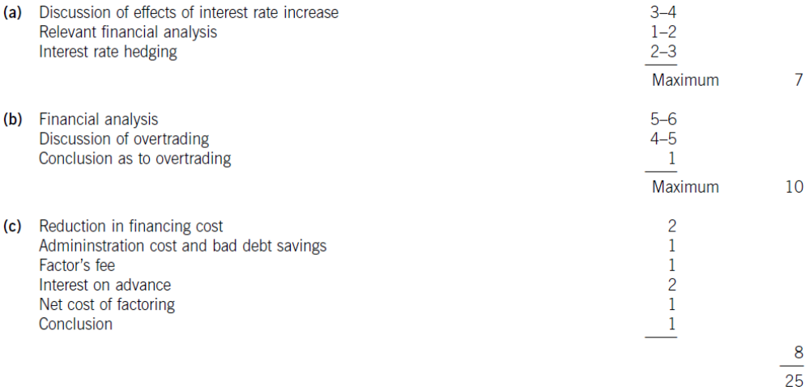
Answer 4
(a)
Cost of the current ordering policy
Order size = 10% of 160,000 = 16,000 units per order
Number of orders per year = 160,000/16,000 = 10 orders per year
Annual ordering cost = 10 x 400 = $4,000 per year [1 mark]
Holding cost ignoring buffer inventory = 5·12 x (16,000/2) = $40,960 per year
Holding cost of buffer inventory = 5·12 x 5,000 = $25,600 per year [1 mark]
Total cost of current policy = 4,000 + 40,960 + 25,600 = $70,560 per year [1 mark]

Cost of the ordering policy using the EOQ model
Order size = (2 x 400 x 160,000/5·12)^{0·5} = 5,000 units per order
Number of orders per year = 160,000/5,000 = 32 orders per year [1 mark]
Annual ordering cost = 32 x 400 = $12,800 per year
Holding cost ignoring buffer inventory = 5·12 x (5,000/2) = $12,800 per year
Holding cost of buffer inventory = 5·12 x 5,000 = $25,600 per year
Total cost of EOQ policy = 12,800 + 12,800 + 25,600 = $51,200 per year [1 mark]

Change in costs of inventory management by using EOQ model
Decrease in costs = 70,560 – 51,200 = $19,360 [1 mark]

Examiner’s Note
Since the buffer inventory is the same in both scenarios, its holding costs do not need to be included in calculating the change in inventory management costs.

(b)
Concept of JIT
1. Holding costs can be reduced by reducing the level of inventory held by a company. Holding costs can be reduced to a minimum if a company orders supplies only when it needs them, avoiding the need to have any inventory at all of inputs to the production process. This approach to inventory management is called just-in-time (JIT) procurement.

Benefits of JIT
2. The benefits of a JIT procurement policy include a lower level of investment in working capital, since inventory levels have been minimized,
3. a reduction in inventory holding costs; a reduction in materials handling costs, due to improved materials flow through the production process;
4. an improved relationship with suppliers, since supplier and customer need to work closely together in order to make JIT procurement a success;
5. improved operating efficiency, due to the need to streamline production methods in order to eliminate inventory between different stages of the production process; and
6. lower reworking costs due to the increased emphasis on the quality of supplies, since hold-ups in production must be avoided when inventory between production stages has been eliminated.
[5 marks]
(c)
Evaluation of changes in receivables management
The current level of receivables days = (18/87·6) x 365 = 75 days
Since 25% of credit customers will take the discount, 75% will not be doing so.
The revised level of receivables days = (0·25 x 30) + (0·75 x 60) = 52·5 days

Current level of trade receivables = $18m
Revised level of trade receivables = 87·6 x (52·5/365) = $12·6m
Reduction level of trade receivables = 18 – 12·6 = $5·4m [2 marks]

Cost of short-term finance = 5·5%
Reduction in financing cost = 5·4m x 0·055 = $297,000 [1 mark]
Administration and operating cost savings = $753,000
Total benefits = 297,000 + 753,000 = $1,050,000

Cost of early settlement discount = 87·6m x 0·25 x 0·01 = $219,000 [1 mark]
Net benefit of early settlement discount = 1,050,000 – 219,000 = $831,000

The proposed changes in receivables management are therefore financially acceptable, although they depend heavily on the forecast savings in administration and operating costs.
[1 mark]
Maximum early settlement discount
Comparing the total benefits of $1,050,000 with 25% of annual credit sales of $87,600,000, which is $21,900,000, the maximum early settlement discount that could be offered is 4·8% (100 x (1·050/21·9)). [1 mark]

(d)
Factors that should be considered when formulating working capital policy on the management of trade receivables include the following:

The level of investment in trade receivables
If the amount of finance tied up in trade receivables is substantial, receivables management policy may be formulated with the intention of reducing the level of investment by tighter control over the way in which credit is granted and improved methods of assessing client creditworthiness.

The cost of financing trade credit
If the cost of financing trade credit is high, there will be pressure to reduce the amount of credit offered and to reduce the period for which credit is offered.

The terms of trade offered by competitors
In order to compete effectively, a company will need to match the terms offered by its competitors, otherwise customers will migrate to competitors, unless there are other factors that will encourage them to be loyal, such as better quality products or a more valuable after-sales service.

The level of risk acceptable to the company
Some companies may feel that more relaxed trade credit terms will increase the volume of business to an extent that compensates for a higher risk of bad debts. The level of risk of bad debts that is acceptable will vary from company to company. Some companies may seek to reduce this risk through a policy of insuring against non-payment by clients.

The need for liquidity
Where the need for liquidity is relatively high, a company may choose to accelerate cash inflow from credit customers by using invoice discounting or by factoring.

The expertise available within the company
Where expertise in the assessment of creditworthiness and the monitoring of customer accounts is not to a sufficiently high standard, a company may choose to outsource its receivables management to a third party, i.e. a factor.

ACCA Marking Scheme
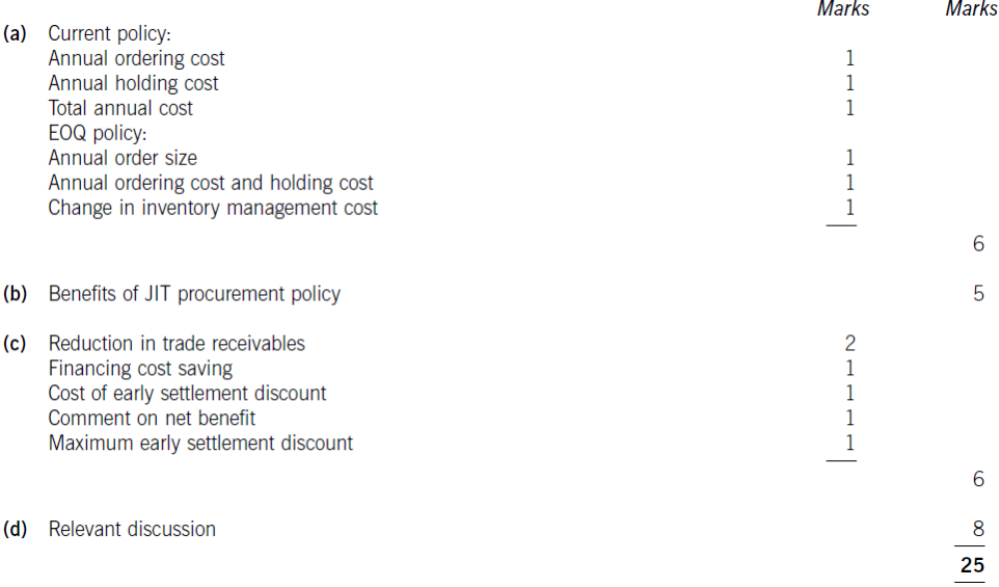

Answer 5
(a)
Working capital policies can cover the level of investment in current assets, the way in which current assets are financed, and the procedures to follow in managing elements of working capital such as inventory, trade receivables, cash and trade payables. The twin objectives of working capital management are liquidity and profitability, and working capital policies support the achievement of these objectives. There are several factors that influence the formulation of working capital policies, as follows.

Nature of the business
The nature of the business influences the formulation of working capital policy because it influences the size of the elements of working capital. A manufacturing company, for example, may have high levels of inventory and trade receivables, a service company may have low levels of inventory and high levels of trade receivables, and a supermarket chain may have high levels of inventory and low levels of trade receivables.
[1 – 2 marks]
The operating cycle
The length of the operating cycle, together with the desired level of investment in current assets, will determine the amount of working capital finance needed. Working capital policies will therefore be formulated so as to optimise as much as possible the length of the operating cycle and its components, which are the inventory conversion period, the receivables conversion period and payables deferral period. [1 – 2 marks]
Terms of trade
Since a company must compete with other companies to be successful, a key factor in the formulation of working capital policy will be the terms of trade offered by competitors. The terms of trade must be comparable with those of competitors and the level of receivables will be determined by the credit period offered and the average credit period taken by customers.
[1 – 2 marks]
Risk appetite of company
A risk-averse company will tend to operate with higher levels of inventory and receivables than a company which is more risk-seeking.

Similarly, a risk-averse company will seek to use long-term finance for permanent current assets and some of its fluctuating current assets (conservative policy), while a more risk-seeking company will seek to use short-term finance for fluctuating current assets as well as for a portion of the permanent current assets of the company (an aggressive policy).
[1 – 2 marks]
(b)(i)
Early settlement discount
Annual cost of components = 120,000 x 7·50 = $900,000 per year
Value of discount offered = 900,000 x 0·005 = $4,500 [1 mark]
Current level of payables = 900,000 x 90/365 = $221,918
Revised level of payables = 900,000 x 30/365 = $73,973
(Alternatively, 221,918 x 1/3 = $73,973)
Reduction in payables = 221,918 – 73,973 = $147,945
(Alternatively, 221,918 x 2/3 = $147,945, or 900,000 x 60/365 = $147,945)
Annual cost of borrowing = 4·5% per year
Increase in financing cost by taking discount = 147,945 x 0·045 = $6,657 [1 mark]
Since the increase in financing cost is $2,157 greater than the discount offered, ZPS Co will not benefit financially by taking the early settlement discount. [1 mark]

(b)(ii)
Bulk purchase discount
Current number of orders = 120,000/10,000 = 12 orders
Current ordering cost = 12 x 200 = $2,400 per year
Current holding cost = (10,000/2) x 1 = $5,000 per year
Annual cost of components = $900,000 per year
Inventory cost under current policy = 900,000 + 2,400 + 5,000 = $907,400 per year [1 mark]
To gain the bulk purchase discount, the order size must increase to 30,000 components
The number of orders will decrease to 120,000/30,000 = 4 orders per year
The revised ordering cost will be 4 x 200 = $800 per year [0.5 mark]
The revised holding cost will be (30,000/2) x 2·2 = $33,000 per year [0.5 mark]
The annual cost of components will be 120,000 x 7·50 x 0·964 = $867,600 per year
Inventory cost using discount = 867,600 + 800 + 33,000 = $901,400 per year [1 mark]
ZPS Co will benefit financially if it takes the bulk discount offered by the supplier, as it saves $6,000 per year in inventory costs or 0·66% of current inventory costs. [1 mark]

ACCA Marking Scheme
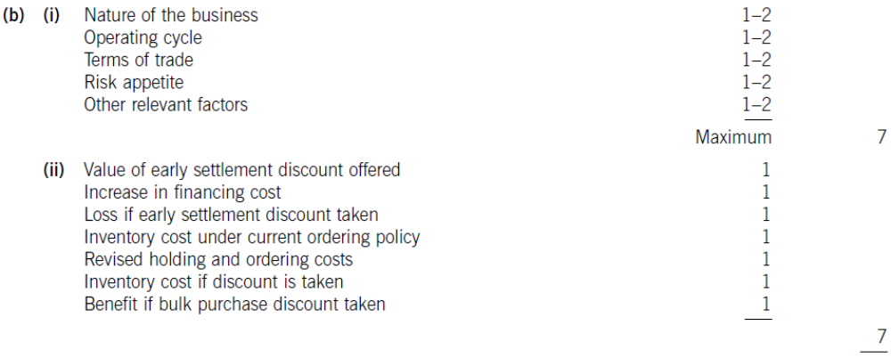

Answer 6
Problems of credit granted to foreign customers:
When credit is granted to foreign customers, two problems may become especially significant.
1. First, the longer distances over which trade takes place and the more complex nature of trade transactions and their elements means foreign accounts receivable need more investment than their domestic counterparts. Longer transaction times increase accounts receivable balances and hence the level of financing and financing costs.
2. Second, the risk of bad debts is higher with foreign accounts receivable than with their domestic counterparts. In order to manage and reduce credit risks, therefore, exporters seek to reduce the risk of bad debt and to reduce the level of investment in foreign accounts receivable.
[1 – 2 marks]
Many foreign transactions are on ‘open account’, which is an agreement to settle the amount outstanding on a predetermined date. Open account reflects a good business relationship between importer and exporter. It also carries the highest risk of non-payment.

How to manage and reduce?
1. One way to reduce investment in foreign accounts receivable is to agree early payment with an importer, for example by payment in advance, payment on shipment, or cash on delivery. These terms of trade are unlikely to be competitive, however, and it is more likely that an exporter will seek to receive cash in advance of payment being made by the customer.

2. One way to accelerate cash receipts is to use bill finance. Bills of exchange with a signed agreement to pay the exporter on an agreed future date, supported by a documentary letter of credit, can be discounted by a bank to give immediate funds. This discounting is without recourse if bills of exchange have been countersigned by the importer’s bank.

Documentary letters of credit are a payment guarantee backed by one or more banks. They carry almost no risk, provided the exporter complies with the terms and conditions contained in the letter of credit. The exporter must present the documents stated in the letter, such as bills of lading, shipping documents, bills of exchange, and so on, when seeking payment. As each supporting document relates to a key aspect of the overall transaction, letters of credit give security to the importer as well as the exporter.

3. Companies can also manage and reduce risk by gathering appropriate information with which to assess the creditworthiness of new customers, such as bank references and credit reports.

4. Insurance can also be used to cover some of the risks associated with giving credit to foreign customers. This would avoid the cost of seeking to recover cash due from foreign accounts receivable through a foreign legal system, where the exporter could be at a disadvantage due to a lack of local or specialist knowledge.

5. Export factoring can also be considered, where the exporter pays for the specialist expertise of the factor as a way of reducing investment in foreign accounts receivable and reducing the incidence of bad debts.
[6 – 7 marks]

Answer 7
(a)
Analysis of current assets:
1. When considering the financing of working capital, it is useful to divide current assets into fluctuating current assets and permanent current assets.
2. Fluctuating current assets represent changes in the level of current assets due to the unpredictability of business activity.
3. Permanent current assets represent the core level of investment in current assets needed to support a given level of turnover or business activity.
4. As turnover or level of business activity increases, the level of permanent current assets will also increase. This relationship can be measured by the ratio of turnover to net current assets.
[1 – 2 marks]
Short-term and long-term finance:
The financing choice as far as working capital is concerned is between short-term and long-term finance.
1. Short-term finance is more flexible than long-term finance: an overdraft, for example, is used by a business organisation as the need arises and variable interest is charged on the outstanding balance.
2. Short-term finance is also more risky than long-term finance: an overdraft facility may be withdrawn, or a short-term loan may be renewed on less favourable terms. In terms of cost, the term structure of interest rates suggests that short-term debt finance has a lower cost than long-term debt finance.
[2 – 3 marks]
Matching principle:
1. The matching principle suggests that long-term finance should be used for long-term investment. Applying this principle to working capital financing, long-term finance should be matched with permanent current assets and non-current assets.
2. A financing policy with this objective is called a ‘matching policy’. HGR Co is not using this financing policy, since of the $16,935,000 of current assets, $14,000,000 or 83% is financed from short-term sources (overdraft and trade payables) and only $2,935,000 or 17% is financed from a long-term source, in this case equity finance (shareholders’ funds) or traded bonds.
[1 – 2 marks]
Financing approach used by company:
1. The financing policy or approach taken by HGR Co towards the financing of working capital, where short-term finance is preferred, is called an aggressive policy.
2. Reliance on short-term finance makes this riskier than a matching approach, but also more profitable due to the lower cost of short-term finance. Following an aggressive approach to financing can lead to overtrading (undercapitalisation) and the possibility of liquidity problems.
[1 – 2 marks]
(b)
Bank balance in three months’ time if no action is taken:
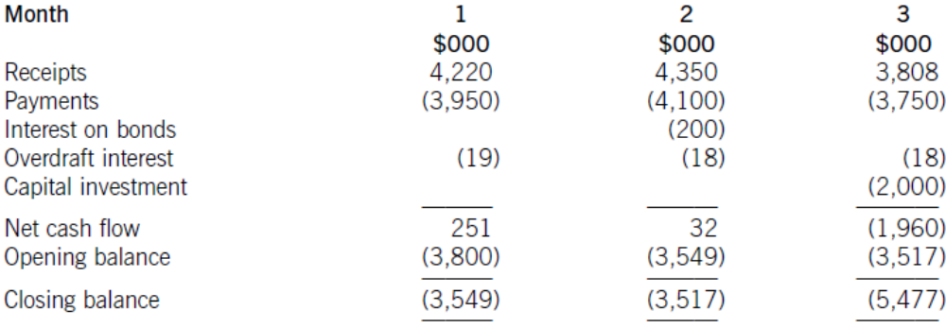
[2 marks]
Bank balance in three months’ time if the finance director’s proposals are implemented:
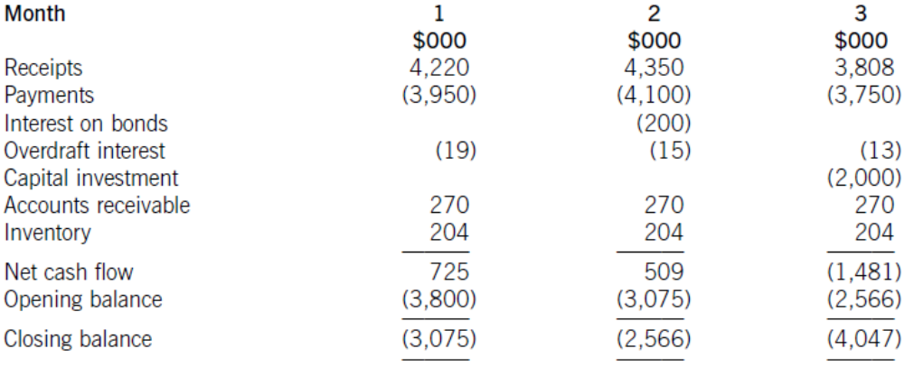
[5 marks]
Workings:
Reduction in accounts receivable days
Current accounts receivable days = (8,775/49,275) x 365 = 65 days
Reduction in days over six months = 65 – 53 = 12 days
Monthly reduction = 12/6 = 2 days
Each receivables day is equivalent to 8,775,000/65 =$135,000
(Alternatively, each receivables day is equivalent to 49,275,000/365 =$135,000)
Monthly reduction in accounts receivable = 2 x 135,000 = $270,000

Reduction in inventory days
Current inventory days = (8,160/37,230) x 365 = 80 days
Each inventory day is equivalent to 8,160,000/80 = $102,000
(Alternatively, each inventory day = 37,230,000/365 = $102,000)
Monthly reduction in inventory = 102,000 x 2 = $204,000

Overdraft interest calculations
Monthly overdraft interest rate = 1·0617^{1/12} = 1·005 or 0·5%

If no action is taken:
Period 1 interest = 3,800,000 x 0·005 = $19,000
Period 2 interest = 3,549,000 x 0·005 = $17,745 or $18,000
Period 3 interest = 3,517,000 x 0·005 = $17,585 or $18,000

If action is taken:
Period 1 interest = 3,800,000 x 0.005 = $19,000
Period 2 interest = 3,075,000 x 0.005 = $15,375 or $15,000
Period 3 interest = 2,566,000 x 0.005 = $12,830 or $13,000

Discussion
Working capital management implication:
1. If no action is taken, the cash flow forecast shows that HGR Co will exceed its overdraft limit of $4 million by $1·48 million in three months’ time.
2. If the finance director’s proposals are implemented, there is a positive effect on the bank balance, but the overdraft limit is still exceeded in three months’ time, although only by $47,000 rather than by $1·47 million.

3. In each of the three months following that, the continuing reduction in accounts receivable days will improve the bank balance by $270,000 per month. Without further information on operating receipts and payments, it cannot be forecast whether the bank balance will return to less than the limit, or even continue to improve.

4. The main reason for the problem with the bank balance is the $2 million capital expenditure. Purchase of non-current assets should not be financed by an overdraft, but a long-term source of finance such as equity or bonds. If the capital expenditure were removed from the area of working capital management, the overdraft balance at the end of three months would be $3·48 million if no action were taken and $2·05 million if the finance director’s proposals were implemented. Given that HGR Co has almost $50 million of non-current assets that could possibly be used as security, raising long-term debt through either a bank loan or a bond issue appears to be sensible. Assuming a bond interest rate of 10% per year, current long-term debt in the form of traded bonds is approximately ($200m x 2)/0·1 = $4m, which is much less than the amount of noncurrent assets.
[1 – 2 marks]
Advice on course of action
A suitable course of action for HGR Co to follow would therefore be:
1. Firstly, to implement the finance director’s proposals and
2. Secondly, to finance the capital expenditure from a long-term source. Consideration could also be given to using some long-term debt finance to reduce the overdraft and to reduce the level of accounts payable, currently standing at 100 days.
[1 – 2 marks]
(c)
Problems of credit granted to foreign customers:
When credit is granted to foreign customers, two problems may become especially significant.
1. First, the longer distances over which trade takes place and the more complex nature of trade transactions and their elements means foreign accounts receivable need more investment than their domestic counterparts. Longer transaction times increase accounts receivable balances and hence the level of financing and financing costs.
2. Second, the risk of bad debts is higher with foreign accounts receivable than with their domestic counterparts. In order to manage and reduce credit risks, therefore, exporters seek to reduce the risk of bad debt and to reduce the level of investment in foreign accounts receivable.
[1 – 2 marks]
Many foreign transactions are on ‘open account’, which is an agreement to settle the amount outstanding on a predetermined date. Open account reflects a good business relationship between importer and exporter. It also carries the highest risk of non-payment.

How to manage and reduce?
1. One way to reduce investment in foreign accounts receivable is to agree early payment with an importer, for example by payment in advance, payment on shipment, or cash on delivery. These terms of trade are unlikely to be competitive, however, and it is more likely that an exporter will seek to receive cash in advance of payment being made by the customer.

2. One way to accelerate cash receipts is to use bill finance. Bills of exchange with a signed agreement to pay the exporter on an agreed future date, supported by a documentary letter of credit, can be discounted by a bank to give immediate funds. This discounting is without recourse if bills of exchange have been countersigned by the importer’s bank.

Documentary letters of credit are a payment guarantee backed by one or more banks. They carry almost no risk, provided the exporter complies with the terms and conditions contained in the letter of credit. The exporter must present the documents stated in the letter, such as bills of lading, shipping documents, bills of exchange, and so on, when seeking payment. As each supporting document relates to a key aspect of the overall transaction, letters of credit give security to the importer as well as the exporter.

3. Companies can also manage and reduce risk by gathering appropriate information with which to assess the creditworthiness of new customers, such as bank references and credit reports.

4. Insurance can also be used to cover some of the risks associated with giving credit to foreign customers. This would avoid the cost of seeking to recover cash due from foreign accounts receivable through a foreign legal system, where the exporter could be at a disadvantage due to a lack of local or specialist knowledge.

5. Export factoring can also be considered, where the exporter pays for the specialist expertise of the factor as a way of reducing investment in foreign accounts receivable and reducing the incidence of bad debts.
[6 – 7 marks]
ACCA Marking Scheme:
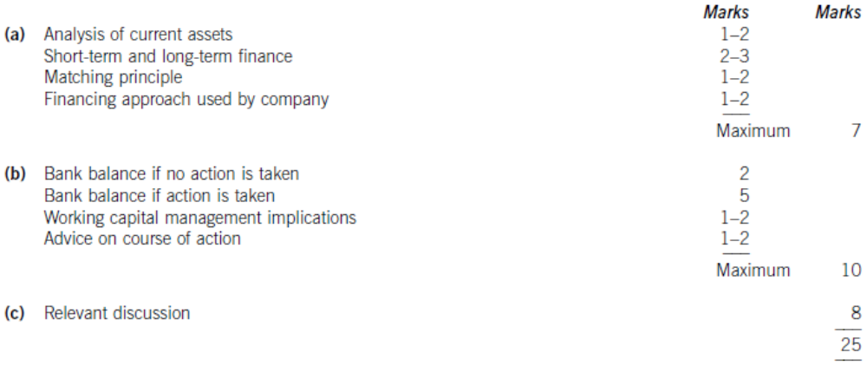
Answer 8
(a)
1. The role of financial intermediaries in providing short-term finance for use by business organisations is to provide a link between investors who have surplus cash and borrowers who have financing needs.
2. The amounts of cash provided by individual investors may be small, whereas borrowers need large amounts of cash: one of the functions of financial intermediaries is therefore to aggregate invested funds in order to meet the needs of borrowers. In so doing, they provide a convenient and readily accessible route for business organisations to obtain necessary funds.
3. Small investors are likely to be averse to losing any capital value, so financial intermediaries will assume the risk of loss on short-term funds borrowed by business organisations, either individually or by pooling risks between financial intermediaries. This aspect of the role of financial intermediaries is referred to as risk transformation.
4. Financial intermediaries also offer maturity transformation, in that investors can deposit funds for a long period of time while borrowers may require funds on a short-term basis only, and vice versa. In this way the needs of both borrowers and lenders can be satisfied.
[4 marks]
(b)
Forecast income statement:
 | $m | Marks
Turnover = 16.00m x 1.084 | 17.344
Cost of sales = 17.344m – 5.203m | 12.141
Gross profit = 17.344m x 30% | 5.203 | [1]
Other expenses = 5.203m – 3.469m | 1.734
Net profit = 17.344m x 20% | 3.469 | [1]
Interest = (10m x 0.08) + 0.14m | 0.940
Profit before tax | 2.529 | [1]
Tax = 2.529m x 0.3 | 0.759
Profit after tax | 1.770
Dividends = 1.770m x 50% | 0.885
Retained profit | 0.885 | [1]

Forecast statement of financial position:
 | $m | $m | Marks
Non-current assets |  | 22.00
Current assets
Inventory | 3.66 |  | [1]
Trade receivables | 3.09 |  | [1]
 |  | 6.75
Total assets |  | 28.75
Equity and liabilities:
Equity
Ordinary shares | 5.00
Reserves | 8.39 |  | [1]
 |  | 13.39
Non-current liabilities
Bank loan |  | 10.00
Current liabilities
Trade payables | 2.49 |  | [1]
Overdraft | 2.87 |  | [1]
 |  | 5.36
Total equity and liabilities |  | 28.75
(Layout and format – [1 mark])

Workings
Inventory = 12·141m x (110/365) = $3·66m
Trade receivables = 17·344m x (65/365) = $3·09m
Trade payables = 12·141m x (75/365) = $2·49m
Reserves = 7·5m + 0·885m = $8·39m
Overdraft = 28·75m – 23·39m – 2·49 = $2·87m (balancing figure)

(c)
Working capital financing policies:
1. Working capital financing policies can be classified into conservative, moderate (or matching) and aggressive, depending on the extent to which fluctuating current assets and permanent current assets are financed by short-term sources of finance. Permanent current assets are the core level of investment in current assets needed to support a given level of business activity or turnover, while fluctuating current assets are the changes in the levels of current assets arising from the unpredictable nature of some aspects of business activity.

2. A conservative working capital financing policy uses long-term funds to finance non-current assets and permanent current assets, as well as a proportion of fluctuating current assets. This policy is less risky and less profitable.
3. An aggressive working capital financing policy uses short-term funds to finance fluctuating current assets and a proportion of permanent current assets as well.
4. Between these two extremes lies the moderate (or matching) policy, which uses long-term funds to finance long-term assets (non-current assets and permanent current assets) and short-term funds to finance short-term assets (fluctuating current assets)
[2 – 3 marks]
Financial analysis:
1. The current statement of financial position shows that APX Co uses trade payables and an overdraft as sources of short-term finance. In terms of the balance between short- and long-term finance, 89% of current assets (100 x 4·1/4·6) are financed from short-term sources and only 11% are financed from long-term sources. Since a high proportion of current assets are permanent in nature, this appears to be a very aggressive working capital financing policy which carries significant risk. If the overdraft were called in, for example, APX Co might have to turn to more expensive short-term financing.
[1 – 2 marks]

2. The forecast statement of financial position shows a lower reliance on short-term finance, since 79% of current assets (100 x 5·36/6·75) are financed from short-term sources and 21% are financed from long-term sources. This decreased reliance on an aggressive financing policy is sensible, although with a forecast interest coverage ratio of only 3·7 times (3·469/0·94), APX Co has little scope for taking on more long-term debt. An increase in equity funding to decrease reliance on short-term finance could be considered.
[2 – 3 marks]
(d)
Working capital management
1. Financial analysis shows deterioration in key working capital ratios.
a. The inventory turnover period is expected to increase from 81 days to 110 days,
b. the trade receivables period is expected to increase from 50 days to 65 days
c. and the trade payables period is expected to increase from 64 days to 75 days.
d. It is also a cause for concern here that the values of these working capital ratios for the next year are forecast, i.e. APX Co appears to be anticipating a worsening in its working capital position. The current and forecast values could be compared to average or sector values in order to confirm whether this is in fact the case.
2. Because current assets are expected to increase by more than current liabilities,
a. the current ratio and the quick ratio are both expected to increase in the next year, the current ratio from 1·12 times to 1·26 times and the quick ratio from 0·54 times to 0·58 times.
b. Again, comparison with sector average values for these ratios would be useful in making an assessment of the working capital management of APX Co.
c. The balance between trade payables and overdraft finance is approximately the same in both years (trade payables are 46% of current liabilities in the current statement of financial position and 47% of current liabilities in the forecast statement of financial position), although reliance on short-term finance is expected to fall slightly in the next year.
3. The deteriorating working capital position may be linked to an expected deterioration in the overall financial performance of APX Co. For example, the forecast gross profit margin (30%) and net profit margin (20%) are both less than the current values of these ratios (32% and 23% respectively), and despite the increase in turnover, return on capital employed (ROCE) is expected to fall from 16·35% to 14·83%.
[3 – 4 marks]
Analysis
Extracts from current income statement:
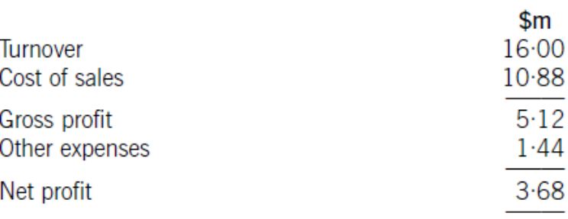
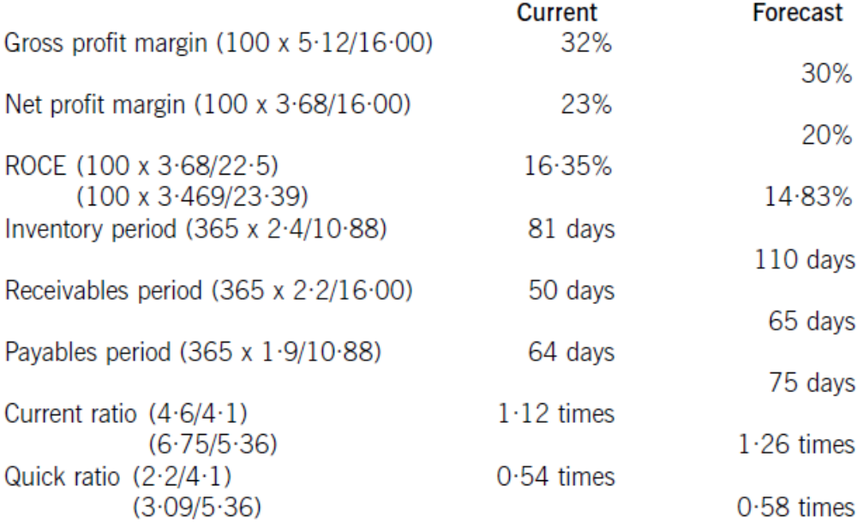
[2 – 4 marks]

ACCA Marking Scheme:
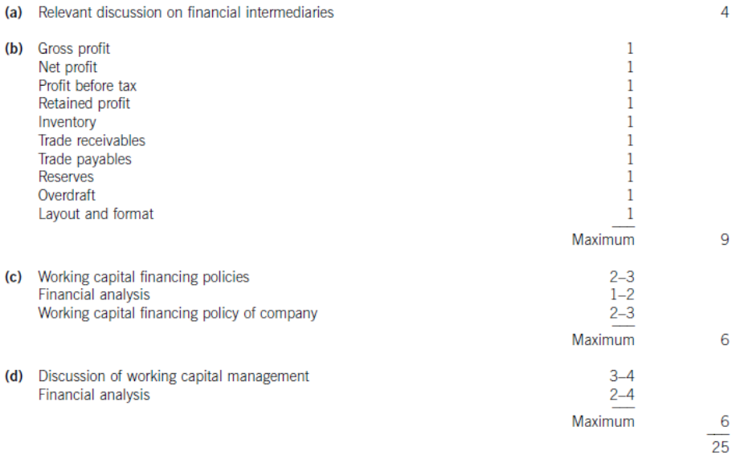

Answer 9
(a)
Evaluation of change in credit policy
Current average collection period = 30 + 10 = 40 days
Current accounts receivable = 6m x 40/ 365 = $657,534
Average collection period under new policy = (0.3 x 15) + (0.7 x 60) = 46.5 days
New level of credit sales = $6.3 million
Accounts receivable after policy change = 6.3 x 46.5/ 365 = $802,603
Increase in financing cost = (802,603 – 657,534) x 0.07 = $10,155

 | $ | Marks
Increase in financing cost | 10,155 | [2]
Incremental costs = 6.3m x 0.005 = | 31,500 | [1]
Cost of discount = 6.3m x 0.015 x 0.3 | 28,350 | [1]
Increase in costs | 70,005
Contribution from increased sales = 6m x 0.05 x 0.6 | 180,000 | [1]
Net benefit of policy change | 109,995

The proposed policy change will increase the profitability of Ulnad Co. [1 mark]

(b)
Determination of spread:
Daily interest rate = 5.11/ 365 = 0.014% per day
Variance of cash flows = 1,000 x 1,000 = $1,000,000 per day
Transaction cost = $18 per transaction
Spread = 3 x ((0.75 x transaction cost x variance)/interest rate)1/3
= 3 x ((0.75 x 18 x 1,000,000)/ 0.00014)1/3 = 3 x 4,585.7 = $13,757
[2 marks]
Lower limit (set by Renpec Co) = $7,500
Upper limit = 7,500 + 13,757 =$21,257 [1 mark]
Return point = 7,500 + (13,757/ 3) = $12,086 [1 mark]

Explanation of findings:
1. The Miller-Orr model takes account of uncertainty in relation to receipts and payment. The cash balance of Renpec Co is allowed to vary between the lower and upper limits calculated by the model.
2. If the lower limit is reached, an amount of cash equal to the difference between the return point and the lower limit is raised by selling short-term investments.
3. If the upper limit is reached an amount of cash equal to the difference between the upper limit and the return point is used to buy short-term investments.
4. The model therefore helps Renpec Co to decrease the risk of running out of cash, while avoiding the loss of profit caused by having unnecessarily high cash balances.
[2 marks]
(c)
There are four key areas of accounts receivable management: policy formulation, credit analysis, credit control and collection of amounts due.

Policy formulation
This is concerned with establishing the framework within which management of accounts receivable in an individual company takes place. The elements to be considered include establishing terms of trade, such as period of credit offered and early settlement discounts; deciding whether to charge interest on overdue accounts; determining procedures to be followed when granting credit to new customers; establishing procedures to be followed when accounts become overdue, and so on.
[1 – 2 marks]
Credit analysis
Assessment of creditworthiness depends on the analysis of information relating to the new customer. This information is often generated by a third party and includes bank references, trade references and credit reference agency reports. The depth of credit analysis depends on the amount of credit being granted, as well as the possibility of repeat business.
[1 – 2marks]
Credit control
Once credit has been granted, it is important to review outstanding accounts on a regular basis so overdue accounts can be identified. This can be done, for example, by an aged receivables analysis. It is also important to ensure that administrative procedures are timely and robust, for example sending out invoices and statements of account, communicating with customers by telephone or e-mail, and maintaining account records.
[1 – 2 marks]
Collection of amounts due
Ideally, all customers will settle within the agreed terms of trade. If this does not happen, a company needs to have in place agreed procedures for dealing with overdue accounts. These could cover logged telephone calls, personal visits, charging interest on outstanding amounts, refusing to grant further credit and, as a last resort, legal action. With any action, potential benefit should always exceed expected cost.
[1 – 2 marks]
(d)
Analysis of assets:
1. When considering how working capital is financed, it is useful to divide assets into non-current assets, permanent current assets and fluctuating current assets.
2. Permanent current assets represent the core level of working capital investment needed to support a given level of sales. As sales increase, this core level of working capital also increases.
3. Fluctuating current assets represent the changes in working capital that arise in the normal course of business operations, for example when some accounts receivable are settled later than expected, or when inventory moves more slowly than planned.
[1 – 2 marks]

Short-term and long-term debt
1. The matching principle suggests that long-term finance should be used for long-term assets. Under a matching working capital funding policy, therefore, long-term finance is used for both permanent current assets and non-current assets. Short-term finance is used to cover the short-term changes in current assets represented by fluctuating current assets.

2. Long-term debt has a higher cost than short-term debt in normal circumstances, for example because lenders require higher compensation for lending for longer periods, or because the risk of default increases with longer lending periods.
3. However, long-term debt is more secure from a company point of view than short-term debt since, provided interest payments are made when due and the requirements of restrictive covenants are met, terms are fixed to maturity. Short-term debt is riskier than long term debt because, for example, an overdraft is repayable on demand and short-term debt may be renewed on less favourable terms.
[2 – 3 marks]
Discussion of policies:
1. A conservative working capital funding policy will use a higher proportion of long-term finance than a matching policy, thereby financing some of the fluctuating current assets from a long-term source. This will be less risky and less profitable than a matching policy, and will give rise to occasional short-term cash surpluses.

2. An aggressive working capital funding policy will use a lower proportion of long-term finance than a matching policy, financing some of the permanent current assets from a short-term source such as an overdraft. This will be more risky and more profitable than a matching policy.
[2 – 3 marks]
Other factors
Other factors that influence a working capital funding policy include:
1. Management attitudes to risk – it will determine whether there is a preference for a conservative, an aggressive or a matching approach.
2. Previous funding decisions – it will determine the current position being considered in policy formulation.
3. Organisation size – it will influence its ability to access different sources of finance. A small company, for example, may be forced to adopt an aggressive working capital funding policy because it is unable to raise additional long-term finance, whether equity of debt.
[1 – 2 marks]

ACCA Marking Scheme
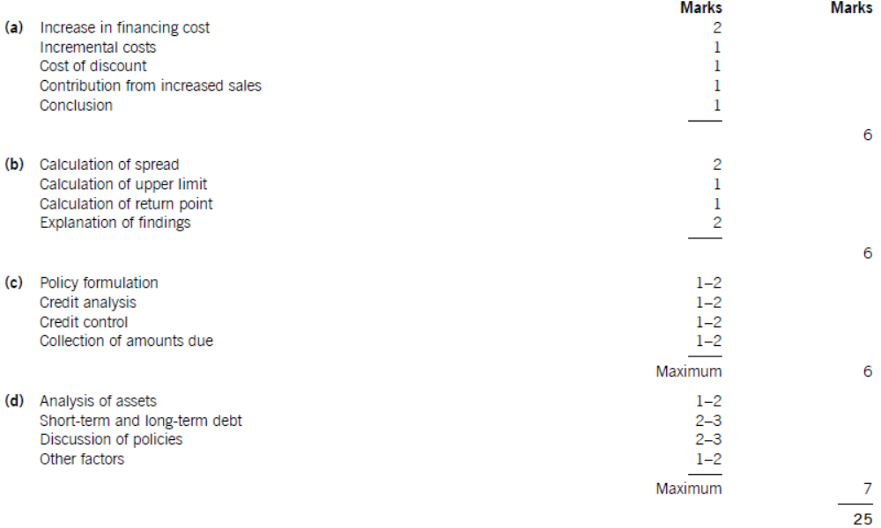

Answer 10
Advantages of overdraft:
1. An advantage of an overdraft is that it is a flexible source of finance, since it can be used as and when required, provided that the overdraft limit is not exceeded.
2. In addition, it will only have to pay interest on the amount of the overdraft facility used, with the interest being charged at a variable rate linked to bank base rate. In contrast, interest is paid on the full for the company’s bank loan (assume fixed interest rate) whether the money is used or not. The interest rate on the overdraft is likely to be lower than that on long-term debt.

Disadvantages of overdraft:
3. A disadvantage of an overdraft is that it is repayable on demand, although in practice notice is given of the intention to withdraw the facility.
4. The interest payment may also increase, since the company is exposed to the risk of an interest rates increase.
5. Banks usually ask for some form of security, such as a floating charge on the company’s assets or a personal guarantee from a company’s owners, in order to reduce the risk associated with their lending.
[5 marks]

Answer 11
(a)
The following factors will influence the rate of interest charged on the new bank loan.
Risk of default
The bank providing the loan to Blin will make an assessment of the risk that the company might default on its loan commitments and charge an interest rate that reflects this risk. Since Blin is listed on a stock exchange it will be seen as less risky than an unlisted company and will pay a lower interest rate as a result. The period of time that the company has been listed may also be an influential factor.

Since Blin has expanded sales significantly and relies heavily on overdraft finance, it may be in an overtrading situation. This could increase the risk of default and so increase the rate of interest charged on the loan. The bank would need to be convinced through financial information supporting the loan application, such as cash flow forecasts, that Blin would be able to meet future interest payments and repayments of principal.
[2 marks]
Security offered
The rate of interest charged on the loan will be lower if the debt is secured against an asset or assets of the company. It is likely in Blin’s case that the loan will carry a fixed charge on particular assets, such as land or buildings. In the event of default by the company, the bank can recover its loan by selling the secured assets.
[2 marks]
Duration of loan
The longer the period of the loan taken out by Blin, the higher the interest rate that will be charged. This reflects the shape of the normal yield curve.
[1 mark]
Yield curve
The normal yield curve shows that the yield required on debt increases in line with the term to maturity. One reason for this is that loan providers require compensation for deferring their use of the cash they have lent, and the longer the period for which they are deprived of their cash, the more compensation they require. This is described as the liquidity preference explanation for the shape of the normal yield curve.

Other explanations for the shape of the normal yield curve are expectations theory and market segmentation theory. Expectations theory suggests that interest rates rise with maturity because rates of interest are expected to rise in the future, for example due to an expected increase in inflation. Market segmentation theory suggests that the market for long-term debt differs from the market for short-term debt.
[3 marks]
Amount borrowed
The rate of interest charged on the new loan could be lower if the amount borrowed is not a small sum. It is more convenient from an administrative point of view for a bank to lend a large sum rather than several small amounts.
[1 mark]
(b)
The approaches that Blin could adopt regarding the relative proportions of long- and short-term finance to meet its working capital needs have been described as conservative, moderate and aggressive.

Classification of current assets
The assets of a business can be divided into current assets and fixed assets, where current assets are used up on a regular basis within a single accounting period and fixed assets benefit a business for several accounting periods.
1. Current assets can be further divided into permanent current assets and fluctuating current assets. Permanent current assets represent the core level of investment in current assets needed for a given level of business activity, and arise from the need for businesses to carry stock and to extend credit. Fluctuating current assets represent a variable need for investment in current assets, arising from either seasonal or unpredictable variations in business activity.

Discussion of conservative approach
2 .A conservative approach to the financing mix would emphasize long-term finance as the main source of working capital funds. This approach would use long-term finance for fixed assets, permanent current assets and some fluctuating current assets. [2 marks]

Relative risk of long- and short-term finance
3. Long-term debt finance is less risky to a company than short-term debt finance, since once in place it is not subjected to the dangers of renewal or immediate repayment, but is more expensive in that the rate of interest charged normally increases with maturity.
4. A conservative approach would therefore increase the amount of lower-risk long-term debt finance used by the company, but would also incur higher total interest payments than an approach emphasizing the use of short-term debt, and so would lead to relatively lower profitability. A similar argument can be made with reference to equity finance, which requires a higher return than long-term debt finance.
[1 mark]
Discussion of aggressive approach
5. An aggressive approach to the financing mix would emphasize short-term finance as the main source of working capital funds. This approach, which is currently being used by Blin, uses short-term finance for fluctuating current assets and some permanent current assets, with long-term finance being used for the balance of permanent current assets and fixed assets.
6. This increases the relative amount of higher-risk short-term finance used by the company, but will also incur lower total interest payments than the conservative approach discussed above, leading to relatively higher profitability.
[2 marks]
Discussion of moderate/matching approach
7. Between these two approaches lies a moderate or matching approach. This approach applies the matching principle, whereby the maturity of the funding is matched with life of the assets financed. Here, long-term finance is used for permanent current assets and fixed assets, while short-term finance is used for fluctuating current assets. [2 marks]

Comment on repayment of overdraft
8. The repayment of the overdraft will result in Blin adopting a conservative approach to the mix of long- and short-term finance. This will resolve an overtrading situation, if it exists, but may reduce profitability more than necessary. If Blin continues to expand sales, or reintroduces overdraft finance, the conservative position will only be temporary and a moderate position may arise in the future.
9. The speed with which this happens will depend on the size of the loan taken out, and whether a moderate position is desirable will depend on the company’s attitude to risk and return. It may be preferable to reduce the overdraft to a lower level rather than repaying it completely. A clearer picture would emerge if we knew the intended use for, and the amount of, the balance of the loan not being used to repay the overdraft.
[2 marks]
(c)
Meaning of cash operating cycle:
The cash operating cycle is the length of time between paying trade creditors and receiving cash from debtors. It can be calculated by adding together the average stock holding period and the average debtors’ deferral period, and then subtracting the average creditors’ deferral period. The stock holding period may be subdivided into the holding periods for raw materials, work-in-progress and finished goods. In terms of accounting ratios, the cash operating cycle can be approximated by adding together stock days and debtor days (debtors’ ratio) and subtracting creditor days (creditors’ ratio). If creditors are paid before cash is received from debtors, the cash operating cycle is positive; if debtors pay before trade creditors are paid, the cycle is negative.
[2 marks]
Significant level of working capital management:
1. The significance of the cash operating cycle in determining the level of investment in working capital is that the longer the cash operating cycle, the higher the investment in working capital.
2. The length of the cash operating cycle varies between industries: for example, a service organization may have no stock holding period, a retail organization will have a stock holding period based almost entirely on finished goods and a very low level of debtors, and a manufacturing organization will have a stock holding period based on raw materials, work-in-progress and finished goods. The level of investment in working capital will therefore depend on the nature of business operations.

3. The cash operating cycle and the resulting level of investment in working capital does not depend only on the nature of the business, however. Companies within the same business sector may have different levels of investment in working capital, measured for example by the accounting ratio of sales/net working capital, as a result of adopting different working capital policies. A relatively aggressive policy on the level of investment in working capital is characterized by lower levels of stock and debtors: this lower level of investment increases profitability but also increases the risk of running out of stock, or of losing potential customers due to better credit terms being offered by competitors. A relatively conservative policy on the level of investment in working capital has higher levels of investment in stock and debtors: profitability is therefore reduced, but the risk of stock-outs is lower and new credit customers may be attracted by more generous terms.

4. It is also possible to reduce the level of investment in working capital by reducing the length of the cash operating cycle. This is achieved by reducing the stock holding period (for example by using JIT methods), by reducing the debtor deferral period (for example by improving debtor management), or by increasing the creditor deferral period (for example by settling invoices as late as possible). In this way an understanding of the cash operating cycle can assist in taking steps to improve working capital management and profitability.
[5 marks]

ACCA Marking Scheme
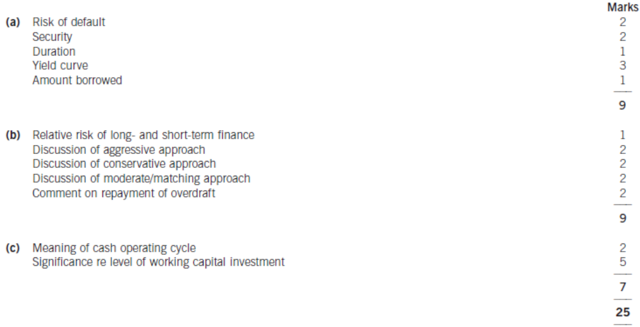

Answer 12
(a)
 | High demand | Medium demand | Low demand | Expected demand
 | £ | £ | £ | £
February | 22,000 × 0.05 | 20,000 × 0.85 | 19,000 × 0.1 | 20,000
March | 26,000 × 0.05 | 24,000 × 0.85 | 23,000 × 0.1 | 24,000
April | 30,000 × 0.05 | 28,000 × 0.85 | 27,000 × 0.1 | 28,000
May | 29,000 × 0.05 | 27,000 × 0.85 | 26,000 × 0.1 | 27,000
June | 35,000 × 0.05 | 33,000 × 0.85 | 32,000 × 0.1 | 33,000
[2 marks]

 | Jan | Feb | Mar | Apr | May | June | Marks
Receipts: | £ | £ | £ | £ | £ | £ | £
Capital | 150,000 |  |  |  |  |  | [1]
Cash sales (W1) |  | 2,000 | 2,400 | 2,800 | 2,700 | 3,300 | [4]
Credit sales (W1) |  |  | 8,775 | 10,530 | 12,285 | 11,846 | [4]
 |  |  |  | 9,000 | 10,800 | 12,600 | [4]
Payments:
Fixed assets |  | (200,000) |  | (50,000) |  |  | [1]
Labour (W2) | (6,300) | (7,560) | (8,820) | (8,505) | (10,395) | (10,395) | [5]
Materials (W2) |  | (4,200) | (5,040) | (5,880) | (5,670) | (6,930) | [5]
Overheads (W2) |  |  | (2,100) | (2,520) | (2,940) | (2,835) | [5]
Fixed costs | (7,000) | (7,000) | (7,000) | (7,000) | (7,000) | (7,000) | [1]
Consultant |  | (12,000) |  |  |  |  | [1]
Net cash flow | 136,700 | (228,760) | (11,785) | (51,575) | (220) | 586
Bal. b/d | 0 | 136,700 | (92,060) | (103,845) | (155,420) | (155,640) | [1]
Bal. c/d | 136,700 | (92,060) | (103,845) | (155,420) | (155,640) | (155,054) | [1]

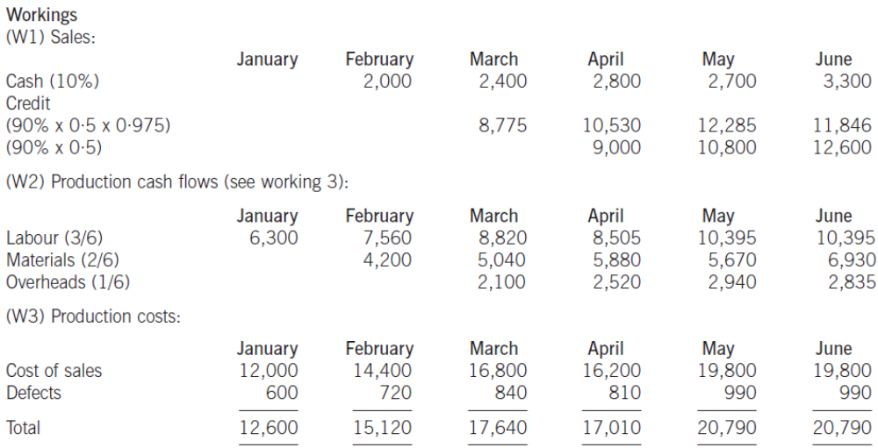

(b)
Note
Only the cash flows for sales and labour are required. The remainder of the cash budget is provided to prove the figures supplied in the question.

The basic point is that high demand cannot be satisfied with a just-in-time stock management system.
 | Medium demand | Low demand | Expected demand
 | £ | £ | £
February | 20,000 × 0.9 | 19,000 × 0.1 | 19,900
March | 24,000 × 0.9 | 23,000 × 0.1 | 23,900
April | 28,000 × 0.9 | 27,000 × 0.1 | 27,900
May | 27,000 × 0.9 | 26,000 × 0.1 | 26,900
June | 33,000 × 0.9 | 32,000 × 0.1 | 32,900

 | Jan | Feb | Mar | Apr | May | June | Marks
Receipts: | £ | £ | £ | £ | £ | £
Capital | 150,000
Cash sales (W4) |  | 1,990 | 2,390 | 2,790 | 2,690 | 3,290 | [4]
Credit sales (W4) |  |  | 8,731 | 10,486 | 12,241 | 11,802 | [4]
 |  |  |  | 8,955 | 10,755 | 12,555 | [4]
Payments:
Fixed assets |  | (200,000) |  | (50,000)
Labour (W2) |  | (6,269) | (7,529) | (8,789) | (8,474) | (10,364) | [2]
Materials (W2) |  |  | (4,179) | (5,019) | (5,859) | (5,649) | [2]
Overheads (W2) |  |  |  | (2,090) | (2,510) | (2,930) | [2]
Fixed costs | (7,000) | (7,000) | (7,000) | (7,000) | (7,000) | (7,000)
Consultant |  | (12,000)
Net cash flow | 143,000 | (223,279) | (7,587) | (50,667) | 1,843 | 1,704
Bal. b/d | 0 | 143,000 | (80,279) | (87,866) | (138,533) | (136,690)
Bal. c/d | 143,000 | (80,279) | (87,866) | (138,533) | (136,690) | (134,986)

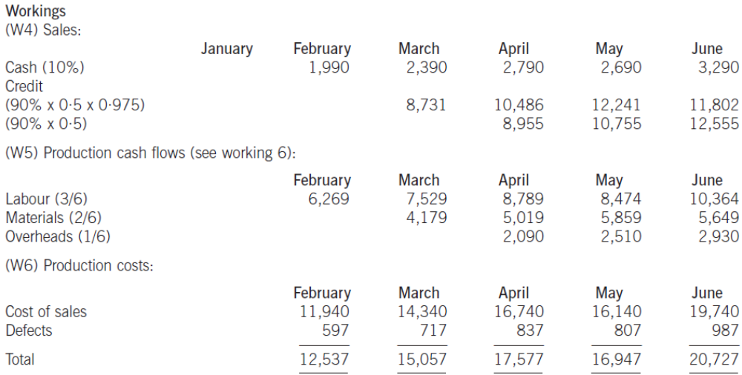

NB a quicker method is merely to deduct 63 from each of the totals in requirement (a) as the loss of sales is constant.

(c)
The introduction of just-in-time stock management for finished goods has a number of benefits:
(1) It significantly improves the short-term liquidity of the business with a maximum financing requirement of £138,533 rather than £155,640. There is also a more rapidly improving deficit thereafter, with the balance falling to £134,986 by the end of June. In the longer term, however, there is continued loss of profitability due to lost sales when demand is high.

The primary reason for this is the reduced investment in stock that is tying up cash. Under the original proposal there is surplus stock amounting to the next month’s sales which means production is necessary at an earlier stage thereby using up cash resources.
(2) Interest costs and stock holding costs are saved by reduced stock levels, thereby adding to profit.
(3) There already appears to be a just-in-time stock management policy with respect to raw materials and work in progress and such a policy for finished goods would be consistent with this.

There are, however, a number of problems with just-in-time stock management in these circumstances:

(1) When demand is higher than expected the additional sales are lost as there is insufficient production to accommodate demand above the mean expected level as no stock is carried. This, however, amounts to only £100 per month of sales on average, which may be a price worth paying in return for improved liquidity in terms of a reduced cash deficit.
(2) In addition to losing contribution there may be a loss of goodwill and reputation if customers cannot be supplied. They may go elsewhere not just for the current sale but also for future sales if Mr Geep is seen as an unreliable supplier. This results from the fact that customers demand immediate delivery of orders.
(3) Just-in-time management of stock relies upon not just reliable timing and quantities but also reliable quality. The number of defects can be planned if it is constant but if they occur irregularly this presents an additional problem.
(4) If production in each month is to supply demand each month this relies on the fact that demand parallels production within the month. If the majority of demand is at the beginning of each month this would cause problems without a level of safety stock given that prompt delivery is expected by customers.

A number of compromises between the two positions would be possible:

(1) Stock could be held sufficient to accommodate demand when it was high. This amounts to only an extra £2,000 at selling values thus an extra £1,200 at variable cost. This is significantly lower than a whole month’s production but would accommodate peak demand.
(2) Liquidity is very important initially as the business attempts to become established. Minimal stocks could be held in the early months therefore, with perhaps slightly increased stocks once the business and its cash flows become established.
[2 marks for each explained point]
(d)
Report
To: Mr J Geep
From: An Accountant
Date: December 2002
Subject: Liquidity and financing

(i) The Extent of Financing Required
It is clear that sales are uncertain with high, low and medium estimates of demand. This of itself gives some uncertainty but the reliability and probability of these estimates will need to be established by appropriate market research. If sales are lower than expected then any bank finance will take longer to repay, thus increasing the amount of finance needed and the proportion of longer-term finance.

Assuming that just-in-time stock management is not implemented then the maximum finance requirement is £155,640.

After July 2003 the expected net cash inflow will be constant (ignoring any further purchases of fixed assets) as follows:
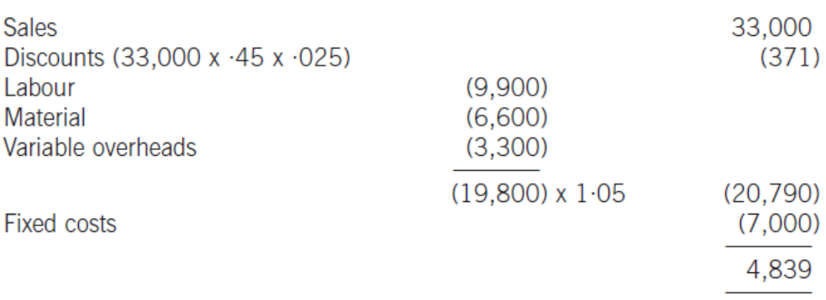

Thus, to pay off a loan of £155,054 it would mean payments over 32 months (155,054/4,839) would have to take place, excluding interest charges. Any variation in these estimates would, however, affect the amount of the financing needed.

In addition to uncertain trading results affecting the amount of future financing, there is an additional requirement to finance future capital investment as the business expands. This is likely to be a major financing need in the future depending on the rate of expansion.

The levels of the drawings, taxation and interest charges will also extend the amount of finance needed, as these items were not included in the cash budget presented.

(ii) Short- and long-term financing mix
In forming a new business there is no business history to present to the bank, thus there is additional uncertainty, which will need to be considered before any finance is likely to be forthcoming, either of a short-term or a long-term nature.

If, however, there is a good relationship with the bank an overdraft might be possible for the entire financing requirement, but this runs the risk of being payable immediately on demand and thus if planned cash flows did not turn out as expected then the bank may get nervous and possibly withdraw credit facilities.

A medium-term loan would also be possible to meet the entire financing requirement. This has the advantage of security in that it cannot be recalled unless there is a breach in the terms. Most likely it would come from a bank, the issue of debentures being entirely out of the question on the grounds of scale. Other considerations would be the term of the loan, security required, fixed or variable interest rates, other conditions (e.g. accounts, covenants, reviews).

Other forms of finance include leasing which can be regarded as a quasi loan if entering into a long-term contract, although other considerations may apply such as variability of rental terms, transfer of risk, residual value of asset, cancellation rights, amount of rentals, period of agreement.

A further option would be for Mr Geep to put in more ownership capital, perhaps secured on the equity in his house.

A mixture of these various forms of finance would be most likely.

The precise mix will depend upon a number of factors (although some of these may also influence the total amount of finance needed):

(1) The ability and willingness of Mr Geep to supply funds initially and additionally if plans do not turn out as expected.
(2) A loan would require some security. The company has few assets to use as security as there does not appear to be any property, the machinery has a low net realisable value and there is little stock, which is normally poor security anyway. An overdraft may also require security but may place increased emphasis on the cash generating potential of the business to make appropriate repayments. Ultimately, however, this is an unlimited business and Mr Geep’s personal assets, and particularly the equity in his house, will act as security.
(3) Other costs are necessary including: the drawings of the owner Mr Geep and interest charges. These will reduce the ability of the business to repay any loan and thus extend the period of repayments in excess of the above estimate of 35 months.
(4) There may be more restrictive covenants in a loan agreement than an overdraft as an overdraft is repayable on demand, and thus the bank needs less protection from other clauses in the contact. There are, however, likely to be restrictive covenants in overdraft agreements.
(5) Overdraft interest is only payable on the balance outstanding, thus if major inflows occur this will reduce interest costs.
(6) The difference between short- and long-term interest rates may influence the relative charges on an overdraft or a medium-term loan.
(7) The purpose of the finance is also likely to affect the form of finance. For example, if funds are required to finance fixed assets then it might be appropriate to use long-term finance to match the long-term usage of the asset.

(iii) Working Capital Management
It has already been seen (in requirement (b)) that a reduction in stock due to the introduction of just-in-time stock management can improve liquidity by improving cash flows and reducing any cash deficit. The same principle can be applied to other types of working capital.

Some of the same arguments also apply, however, in that while liquidity may be improved there could be offsetting disadvantages in terms of lost profitability or increased risk.

Debtors.
Giving two months’ credit makes a significant level of debtors that needs financing.

In steady state of sales of £33,000 per month then debtors will be:

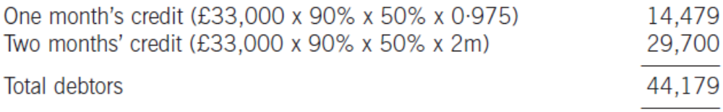

This is a significant proportion of the maximum financing requirement.

Whether the credit terms themselves can be changed may depend upon the credit terms of competitors when set alongside the other conditions of sale. If the business is out of line with competitors then lost sales may result and a balance between liquidity and profitability may need to be struck.

In terms of debt collection it would appear that all debtors are expected to pay on time so there is little that can be done in this area given the current credit terms.

Accelerated payment could be encouraged by a higher cash discount but this is expensive, particularly as customers who would pay within one month anyway would also receive a greater reduction in price without any benefit to the business.

Invoice discounting and debt factoring may be alternatives but these are expensive and in the particular circumstances of the business, where there are expected to be no late payers or bad debts, it might seem inappropriate to use outside assistance.

Creditors
It may be possible to delay payment to creditors in respect of materials and variable overheads. This may, however, damage relationships with suppliers and this might be significant for a new business.

ACCA Marking Scheme
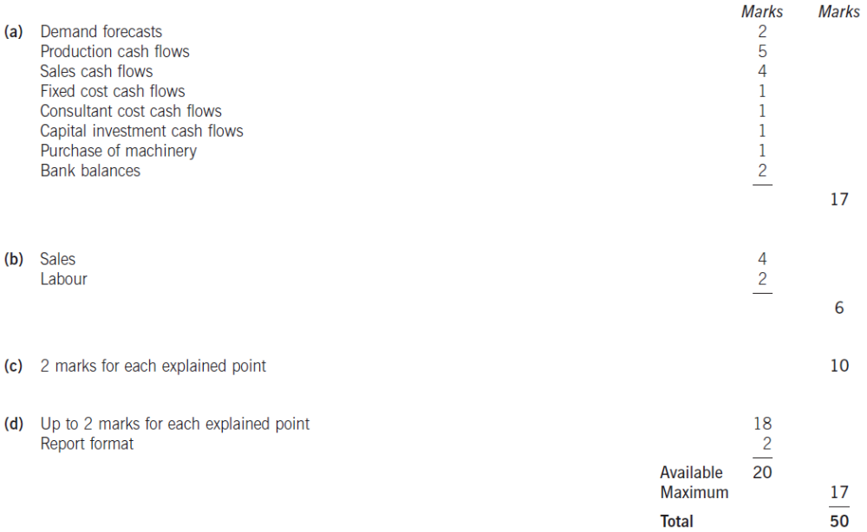

Answer 13
(a)
To: The Board of Doe Ltd
Subject: Overtrading Suggestion
Date: December 2003

1. Introduction
This report presents my findings regarding the suggestion made at the last board meeting that our company is overtrading. Overtrading is also known as undercapitalisation, and occurs when the volume of trade is not supported by an adequate supply of capital. Overtrading can lead to liquidity problems that can cause serious difficulties if they are not dealt with promptly.
[1 mark]
2. Signs of Overtrading
There are a number of generally recognised signs that a company may be overtrading. These are considered, together with relevant financial data from Appendix 1, in the following paragraphs.

- Rapid increase in turnover – The forecast financial statements for 2003 show that our turnover is expected to increase by 25% during the year.
- Rapid increase in current assets – Current assets are expected to rise by 27%, slightly more than the increase in turnover.
- Increase in stock days and debtor days – Debtor days are expected to increase from 110 to 121 days, with a 38% increase in total debtors, but stock days are not expected to increase, but to fall from 265 days to 238 days. Nevertheless, a 19% increase in stocks is anticipated.
- Increased reliance on short term finance – Reserves are expected to increase by £100,000 whereas total assets are expected to increase by £1,400,000. The expansion of our business activity is therefore based primarily on an expansion of short-term finance (trade creditors and overdraft). Creditor days will increase from 177 to 190 days, while in relative terms creditors will increase by 42% – more than the expected rise in turnover (25%) and in our overdraft (20%).
- Decrease in current ratio and quick ratio – The current ratio is expected to fall very slightly from 1·04 to 1·03, but the quick ratio is not expected to fall, but to increase from 0·44 to 0·47.
[2 marks]
However, any interpretation of these ratios should reflect the fact that different industries have different working capital needs. Sector average data can be useful here.

3. Comparison with sector averages
Any conclusion concerning the signs of overtrading needs to be put in the context of the normal values of accounting ratios indicated by the sector averages. However, it should be recognised that averages exist because no two companies are identical, even when in the same business sector, and the following discussion should be read with this in mind.

- The increasing trend of debtor days away from the sector average of 100 days is clearly a cause for concern. If our level of debtors was brought into line with the sector average our financing need would fall by £477,000 (£2·75m x 21/121), which is equivalent to 17% of our forecast overdraft.
- The decrease in stock days is encouraging, although forecast stock days remain 13% higher than the sector average, indicating the possibility of further improvement.

- There is clear evidence of an increased reliance on short-term finance. The trend of creditor days is increasing away from the sector average of 120 days and the forecast of 190 days is a very worrying 58% more than the average. This represents £940,000 (£2·55m x 70/190) more in trade finance that our company is carrying compared to a similar company in our business sector. On this evidence, it is likely that our suppliers will begin to press for earlier settlement in the near future and this will add to the pressure already being exerted by our bank.

- The quick ratio is expected to increase but will still be 15% below the sector average, while the current ratio is expected to be 25% lower than the average. The low current and quick ratios reflect the increased reliance of our company in comparative terms on short-term sources of finance.
[3 marks]
4. Conclusion on overtrading
- Most of the evidence suggests that our company is moving into an overtrading situation, although the evidence is not conclusive.
- Current pressure from our bank to reduce our overdraft serves to highlight the fact that our company needs to reduce its reliance on short-term finance, whether trade finance or overdraft finance.
- Improved working capital management could reduce the level of investment in debtors, and to a lesser extent perhaps in stocks, which would ease our financial difficulties. However, more drastic measures than this will be needed to deal with our reliance on short-term finance. Although the size of the reduction in the overdraft required by the bank is not known at present, simply reducing trade credit to an average level would need £1m of additional finance.
- Factoring of debtors has been suggested as a source of working capital finance and it is certainly true that this would produce an immediate injection of cash that could decrease our overdraft and lower our average trade credit period.
- A further consideration is that our company has no long-term debt and given our continuing growth, this source of finance also deserves serious consideration.
[1 mark]
Appendix 1: Financial Analysis
Growth in turnover = 100 x (8,300 – 6,638)/6,638 = 25%
Growth in current assets = 100 x (5,950 – 4,700)/4,700 = 27%
Increase in overdraft = 100 x (2,750 – 2,300)/2,300 = 20%
Increase in trade creditors = 100 x (2,550 – 1,800)/1,800 = 42%

 |  | 2003 |  | 2002
Stock days | 3,200/4,900 x 365 | 238 days | 2,700/3,720 x 365 | 265 days
Debtor days | 2,750/8,300 x 365 | 121 days | 2,000/6,638 x 365 | 110 days
Creditor days | 2,550/4,900 x 365 | 190 days | 1,800/3,720 x 365 | 177 days
Current ratio | 5,950/5,800 | 1.03 | 4,700/4,500 | 1.04
Quick ratio | 2,750/5,800 | 0.47 | 2,000/4,500 | 0.44
[4 marks]
(b)(i)
Evaluation of factor’s offer using overdraft interest rate of 6%
 | £ | Marks
Forecast level of debtors | 2,750,000
New level of debtors (8,300,000 × 90 ÷ 365) | 2,047,000
Reduction in level of debtors | 703,000 | [1]
Saving in financing cost (703,000 × 6%) | 42,180 | [1]
Saving in administration costs | 15,000 | [1]
 | 57,180
Increased in financing cost (2.047m × 80% × 2%) | (32,752) | [1]
Factor’s fee (8.3m × 1%) | (83,000) | [1]
Net cost of factoring | (58,572) | [1]

On this analysis, the factor’s offer is not financially acceptable. The offer was on a non-recourse basis, however, and the information given does not refer to any reduction of bad debts. If bad debts are currently more than 0·7% of turnover (58,572/8·3m), the factor’s offer might become financially attractive. [1 mark]

Evaluation of factor’s offer using medium-term bank loan rate of 10%
As the overdraft must be reduced anyway, the 10% interest cost of the medium-term bank loan could be seen as the opportunity cost of not accepting the factor’s offer. An alternative evaluation of the factor’s offer could be as follows:

 | £
Current financing cost (2.75m × 10%) | 275,000
Revised financing cost:
2.047m × 0.8 × 8% | 131,000
2.047m × 0.2 × 10% | 40,940
Saving in financing cost | 103,060
Saving in administration costs | 15,000
Factor’s fee (8.3m × 1%) | (83,000)
Net cost of factoring | 35,060

On this analysis, the factor’s offer is financially acceptable, even before considering any reduction in bad debts.

(b)(ii)
The following benefits of factoring are commonly identified.

Factor finance
The factoring company will advance up to 80% of the face value of invoices raised. This would allow Doe Ltd to pay its trade creditors promptly and perhaps take advantage of any early payment discounts available. It would also allow Doe Ltd to finance its growth from sales rather than by seeking external finance. [2 marks]

Reduces administration costs
The factor would take over the administration of Doe Ltd’s sales ledger, allowing a reduction in administration costs in the longer term. [2 marks]

Factor expertise
In the areas of credit analysis and debtor collection, the expertise of the factor is likely to be higher than Doe Ltd’s, leading to lower bad debts and more efficient collection of amounts owed by debtors. [2 marks]

Credit protection
If the factoring is without recourse, Doe Ltd will be effectively insured against the possibility of bad debts, although this will be included in the factor’s fee. [2 marks]

(c)
No information has been provided on the current methods used by Doe Ltd to manage its debtors and so this answer is in general terms. The question asked for three methods to be discussed.

Credit Analysis
Potential credit customers should be carefully screened using such methods as trade references, bank references, credit reports from credit reference agencies, and analysis of financial statements. The extent of the credit analysis should depend on the size of the initial order as well as the potential for repeat business. Credit analysis can improve debtor management by reducing the incidence of bad debts, slow payers and troublesome customers. [Up to 3 marks]

Terms of Trade
Doe Ltd should negotiate agreed terms of trade with its customers in order to encourage prompter payment. These terms of trade may offer discounts for early payment, which apart from cash flow benefits will reduce the likelihood of late payments and bad debts.
[Up to 3 marks]
Credit Control
Once credit has been extended it is important to ensure that customers abide by agreed terms of trade. Regular checks on customer accounts, for example using an aged debtor analysis, can direct attention to overdue accounts or those close to their credit limit. Statements of account should be mailed to debtors on a regular basis in order to remind them of their outstanding debts. Late payers should be contacted by telephone to enquire after the reason for the delay in settling their accounts. A policy of charging interest on overdue accounts might be considered in order to encourage prompt payment.
[Up to 3 marks]
Debtor Collection
The company should have an agreed policy or procedure for dealing with accounts in default. This policy should be included in the terms of trade so that customers are aware of the steps the company is likely to take if payment is not made on time. The company could decide, for example, to take legal action to recover debts more than one month old. However, the benefit of such action must always exceed the cost incurred.
[Up to 3 marks]

Factoring and Invoice Discounting
The cash flow and other benefits of factoring were discussed earlier. Invoice discounting also offers cash flow advantages. Here, selected invoices of good quality are sold in exchange for an advance of up to 80% of face value. The balance, less a fee charged by the invoice discounter, is received when the invoices are settled.

(d)
It is appropriate to use the after-tax cost of borrowing as the discount rate since Doe Ltd is clearly in a tax-paying situation and hence is in a position to claim the tax benefits of lease payments and capital allowances.

Care must be taken when determining the timing of cash flows, since financial evaluation models seek to represent the real world. As lease payments are made on the first day of Doe Ltd’s accounting period, it is appropriate to treat them for discounting purposes as though they occur at the end of the previous accounting period. However, the tax benefits of lease payments will occur in the accounting period following that in which payment is made. Similarly, it is appropriate to treat the purchase cost on 1 January of the first year of use as being made at year 0 for discounting purposes, even though the tax benefit from the first capital allowance will arise in year 2, i.e. in the accounting period following the one in which payment is made.

Capital allowances and associated tax benefits:
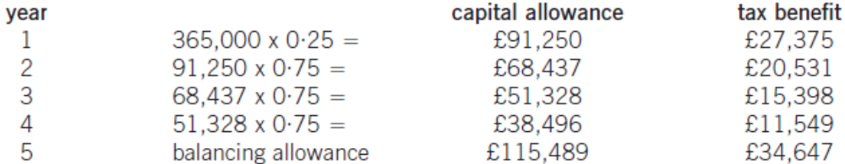
[3 marks]
Evaluation of borrowing to buy:
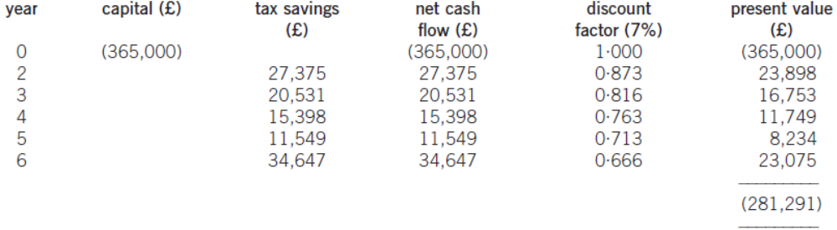
[2 marks]
The cost of borrowing to buy is £281,291.

Evaluation of leasing
Year | Cash flow | £ | DF @ 7% | PV (£) | Marks
0 – 4 | Lease rentals | (77,250) | 4.387 | (338,896) | [1]
2 – 6 | Tax benefits | 23,175 | 3.832 | 88,807 | [1]
 |  |  |  | (250,089)

The cost of leasing is £250,089 [1 mark]
Leasing has the lower cost by £31,202 and is therefore preferred to borrowing. [1 mark]

(e)
The optimum price will be the one that optimises total contribution over the five-year life of the new machine.

Sales price of £70 per unit
Contribution per unit = 70 – 42 = £28 per unit
Sales growth is 20% per annum

Year | 1 | 2 | 3 | 4 | 5 | Marks
Sales volume (units) | 10,000 | 12,000 | 14,400 | 17,280 | 20,000 | [1]
Contribution (£/unit) | 28 | 28 | 28 | 28 | 28
Total contribution (£) | 280,000 | 336,000 | 403,200 | 483,840 | 560,000 | [1]

Year 5 sales volume is limited to the maximum capacity of the new machine
Total contribution over the five years is £2,063,040 [0.5 mark]

Sales price of £67 per unit
Contribution per unit = 67 – 42 = £25 per unit
Sales growth is 23% per annum

Year | 1 | 2 | 3 | 4 | 5 | Marks
Sales volume (units) | 11,000 | 13,530 | 16,640 | 20,000 | 20,000 | [1]
Contribution (£/unit) | 25 | 25 | 25 | 25 | 25
Total contribution (£) | 275,000 | 338,250 | 416,050 | 500,000 | 500,000 | [1]

Sales volume is restricted in years 4 and 5
Total contribution over the five years is £2,029,300 [0.5 mark]

The sales price of £70 per unit appears to be marginally preferable on the basis of total contribution. The incremental fixed production overheads will be the same irrespective of which sales price is selected and so may be omitted from the analysis. [1 mark]

ACCA Marking Scheme
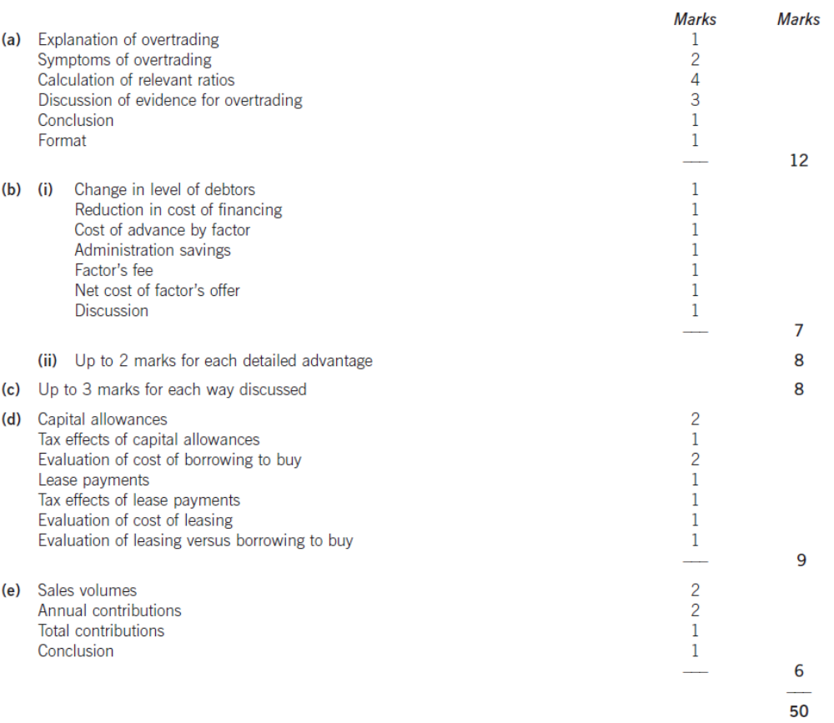

Answer 14
(a)
There are a number of factors that determine the level of investment in current assets and their relative importance varies from company to company.

Length of working capital cycle
1. The working capital cycle or operating cycle is the period of time between when a company settles its accounts payable and when it receives cash from its accounts receivable.
2. Operating activities during this period need to be financed and as the operating period lengthens, the amount of finance needed increases. Companies with comparatively longer operating cycles than others in the same industry sector, will therefore require comparatively higher levels of investment in current assets.
[1 – 2 marks]
Terms of trade
3. These determine the period of credit extended to customers, any discounts offered for early settlement or bulk purchases, and any penalties for late payment. A company whose terms of trade are more generous than another company in the same industry sector will therefore need a comparatively higher investment in current assets.
[1 mark]
Policy on level of investment in current assets
4. Even within the same industry sector, companies will have different policies regarding the level of investment in current assets, depending on their attitude to risk. A company with a comparatively conservative approach to the level of investment in current assets would maintain higher levels of inventory, offer more generous credit terms and have higher levels of cash in reserve than a company with a comparatively aggressive approach.
5. While the more aggressive approach would be more profitable because of the lower level of investment in current assets, it would also be more risky, for example in terms of running out of inventory in periods of fluctuating demand, of failing to have the particular goods required by a customer, of failing to retain customers who migrate to more generous credit terms elsewhere, and of being less able to meet unexpected demands for payment.
[2 marks]
Industry in which organisation operates
6. Another factor that influences the level of investment in current assets is the industry within which an organisation operates. Some industries, such as aircraft construction, will have long operating cycles due to the length of time needed to manufacture finished goods and so will have comparatively higher levels of investment in current assets than industries such as supermarket chains, where goods are bought in for resale with minimal additional processing and where many goods have short shelf-lives.
[1 – 2 marks]
(b)
Discussion of factoring:
1. Factoring involves a company turning over administration of its sales ledger to a factor, which is a financial institution with expertise in this area. The factor will assess the creditworthiness of new customers, record sales, send out statements and reminders, collect payment, identify late payers and chase them for settlement, and take appropriate legal action to recover debts where necessary.

2. The factor will also offer finance to a company based on invoices raised for goods sold or services provided. This is usually up to 80% of the face value of invoices raised. The finance is repaid from the settled invoices, with the balance being passed to the issuing company after deduction of a fee equivalent to an interest charge on cash advanced.

3. If factoring is without recourse, the factor rather than the company will carry the cost of any bad debts that arise on overdue accounts. Factoring without recourse therefore offers credit protection to the selling company, although the factor’s fee (a percentage of credit sales) will be comparatively higher than with non-recourse factoring to reflect the cost of the insurance offered.
[4 – 5 marks]
Discussion of invoice discounting:
4. Invoice discounting is a way of raising finance against the security of invoices raised, rather than employing the credit management and administration services of a factor. A number of good quality invoices may be discounted, rather than all invoices, and the service is usually only offered to companies meeting a minimum turnover criterion.
[1 – 2 marks]
(c)
Calculation of size of overdraft
Inventory period = operating cycle + payables period – receivables period = 3 + 1 – 2 = 2 months
Inventory = 1·89m x 2/12 = $315,000 [1 mark]
Accounts receivable = 4·2m x 2/12 = $700,000 [0.5 mark]
Current assets = 315,000 + 700,000 = $1,015,000
Current liabilities = current assets/current ratio = 1,015,000/1·4 = $725,000 [1 mark]
Accounts payable = 1·89m x 1/12 = $157,500 [0.5 mark]
Overdraft = 725,000 – 157,500 = $567,500 [1 mark]

Net working capital = current assets – current liabilities = 1,015,000 – 725,000 = $290,000
[1 mark]

Short-term financing cost = 567,500 x 0·07 = $39,725
Long-term financing cost = 290,000 x 0·11 = $31,900
Total cost of financing current assets = 39,725 + 31,900 = $71,625 [1 mark]

(d)(i)
Economic order quantity = (2 x 6 x 60,000/0·5)^{0·5} = 1,200 units [1 mark]
Number of orders = 60,000/1,200 = 50 order per year
Annual ordering cost = 50 x 6 = $300 per year [0.5 mark]
Average inventory = 1,200/2 = 600 units
Annual holding cost = 600 x 0·5 = $300 per year [0.5 mark]
Inventory cost = 60,000 x 12 = $720,000 [1 mark]
Total cost of inventory with EOQ policy = 720,000 + 300 + 300 = $720,600 per year
[1 mark]
(d)(ii)
Order size for bulk discounts = 10,000 units
Number of orders = 60,000/10,000 = 6 orders per year
Annual ordering cost = 6 x 6 = $36 per year [0.5 mark]
Average inventory = 10,000/2 =5,000 units
Annual holding cost = 5,000 x 2 = $10,000 per year [0.5 mark]
Discounted material cost =12 x 0·99 = $11·88 per unit
Inventory cost = 60,000 x 11·88 = $712,800 [1 mark]
Total cost of inventory with discount = 712,800 + 36 + 10,000 = $722,836 per year
[1 mark]
The EOQ approach results in a slightly lower total inventory cost. [1 mark]

(Maximum 3 marks)

ACCA Marking Scheme


