Revision 4 – Variance 1

Answer 1
(a)
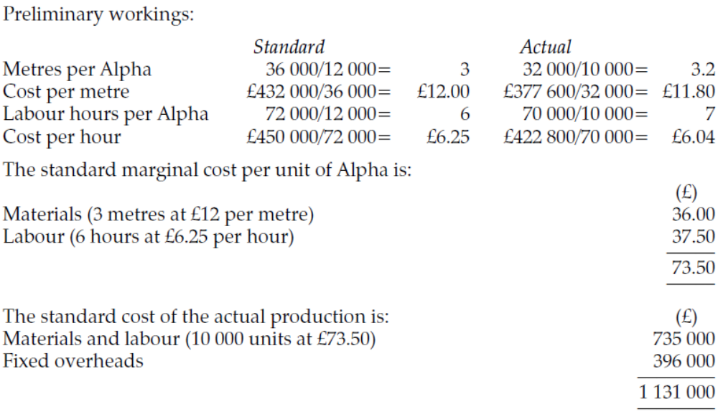

(b)
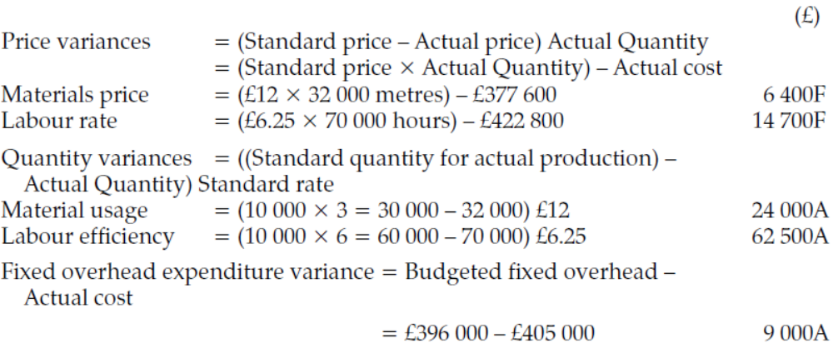
(c)
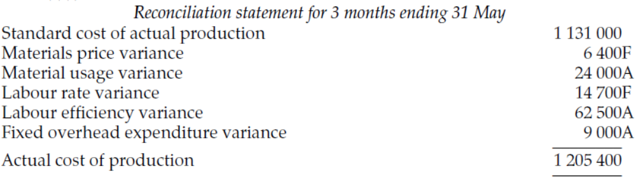
Answer 2
(a)
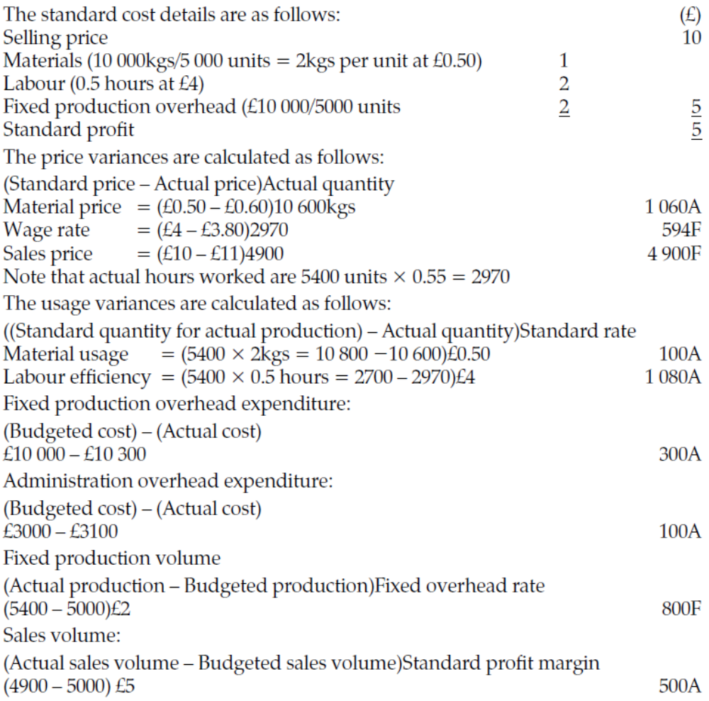

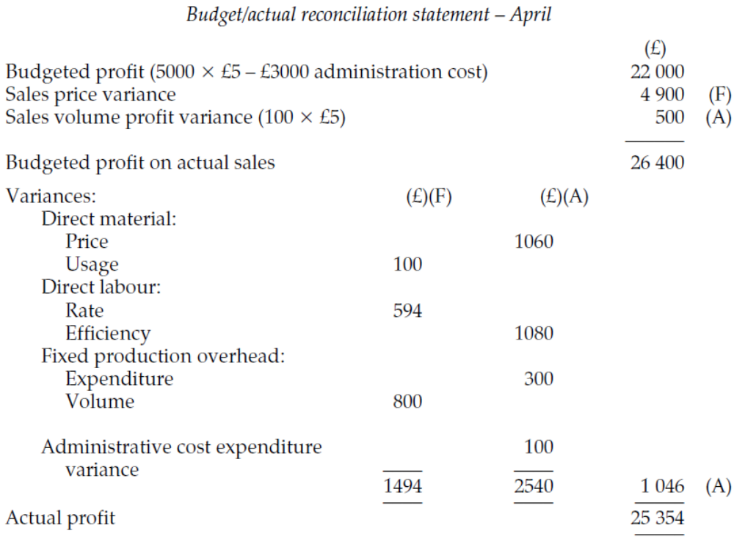

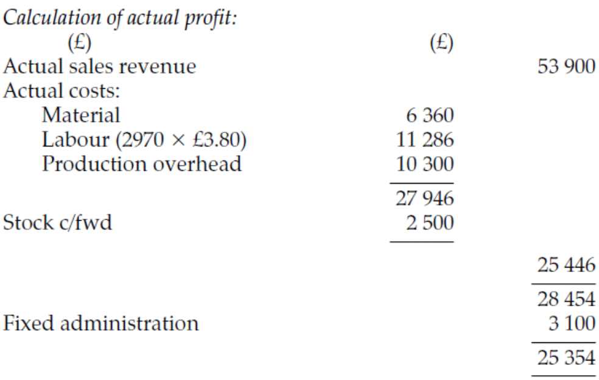

(b)
See relevant variances in Chapter 18 for the answer to this.

(c)
Interdependence occurs when an event has a favourable impact on one variance but an adverse impact on another variance. For example, the purchase of inferior quality materials may account for a favourable material price variance but it may also have a negative impact on the material usage and labour efficiency variances due to the poorer quality causing an increase in usage.

Answer 3
(a)
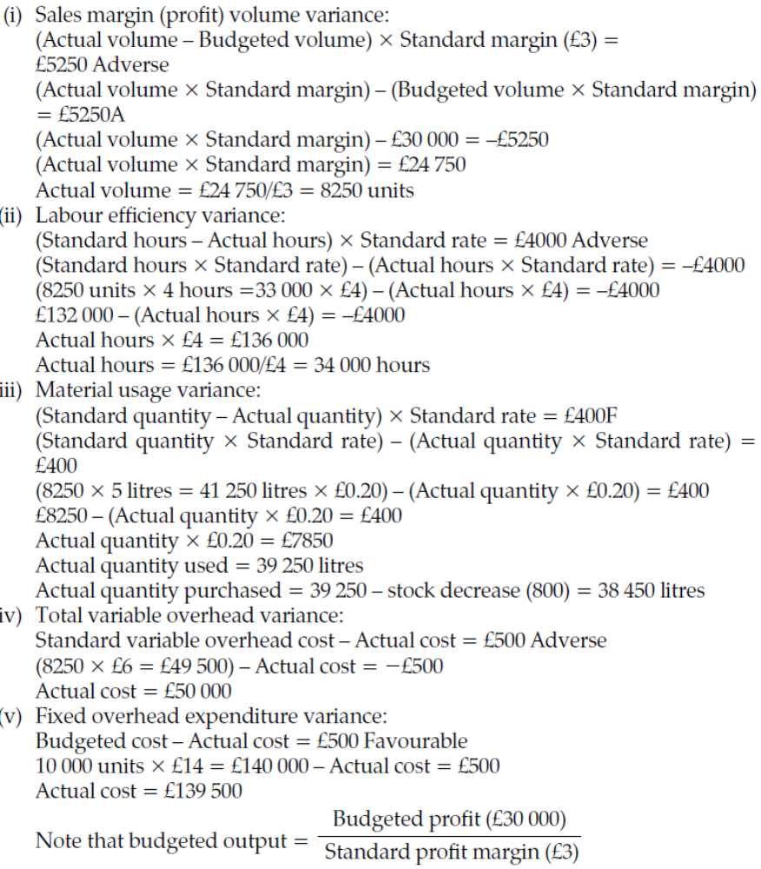

(b)
The answer should draw attention to the fact that standard costing is most suited to an organization whose activities consists of a series of common or repetitive operations. Standard costing procedures cannot easily be applied to non-manufacturing activities where the operations are of a non-repetitive nature, since there is no basis for observing repetitive operations and consequently standards cannot be set.

In those non-manufacturing organizations where routine operations do not exist, standard costing cannot easily be applied. Instead, budgetary control is used to control costs. A budget relates to an entire activity or operation whereas standards can be applied to the units of output and thus provide a basis for the detailed analysis of variances. Therefore budgeting focuses on controlling costs at the aggregate level and does not analyse the difference between actual and budgeted expenditure by price and quantity variances.

Answer 4
(a)
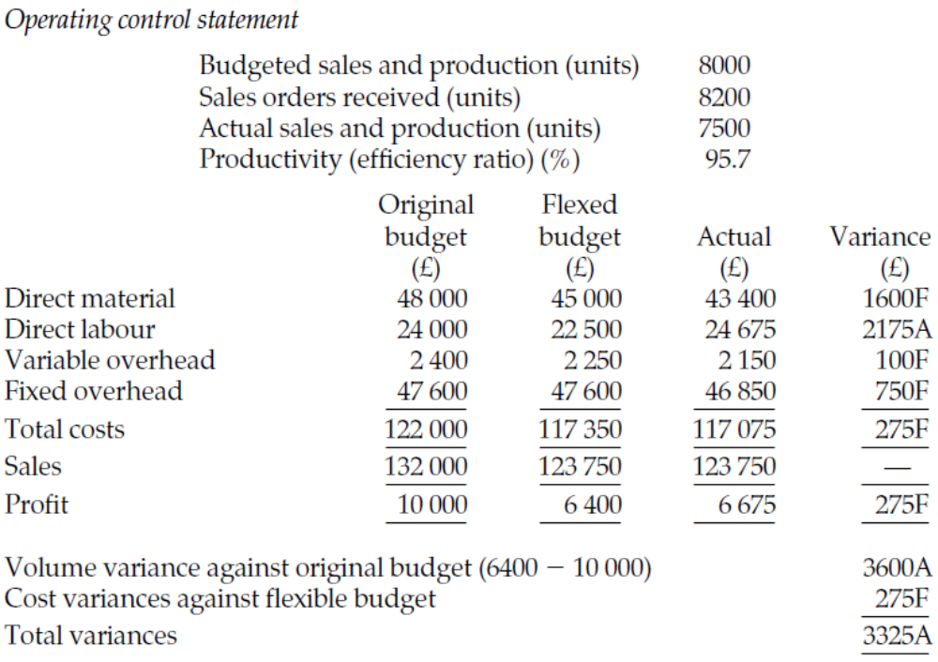

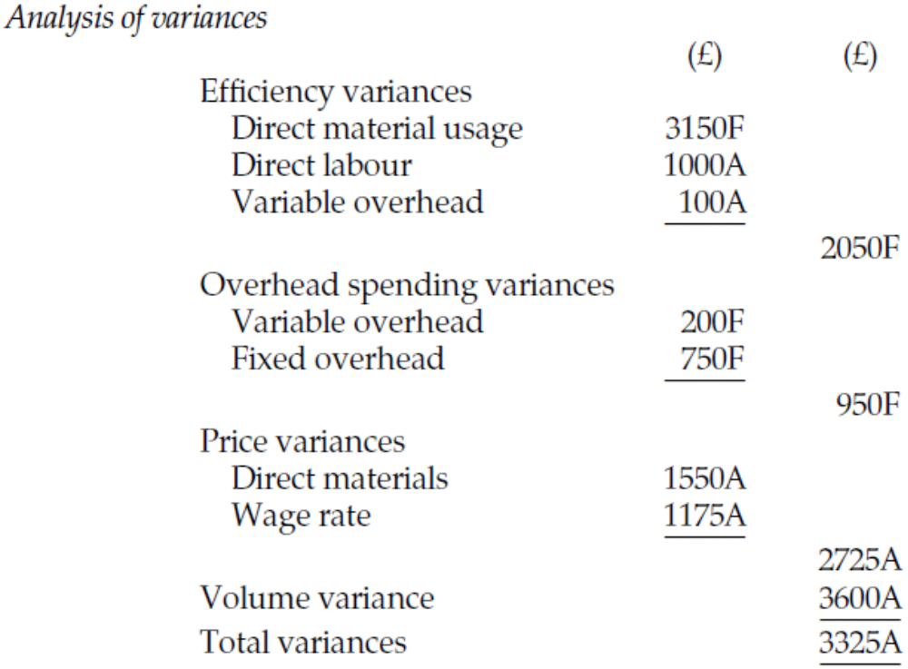

A variable costing approach has been adopted to calculate the above variances. The volume variance is therefore calculated by multiplying the difference between budgeted and actual sales volume (500 units) by the contribution per unit of £7.20. The above presentation categorizes the variances according to operating efficiency, price/spending and volume. The volume variance can be due to either a failure to generate sufficient sales to meet the budgeted sales volume or a failure by production to produce sufficient to meet sales demand.

Answer 5
(a)
The flexed budget will be based on the activity level of 90,000 units rather than the budgeted level of 95,000 units.
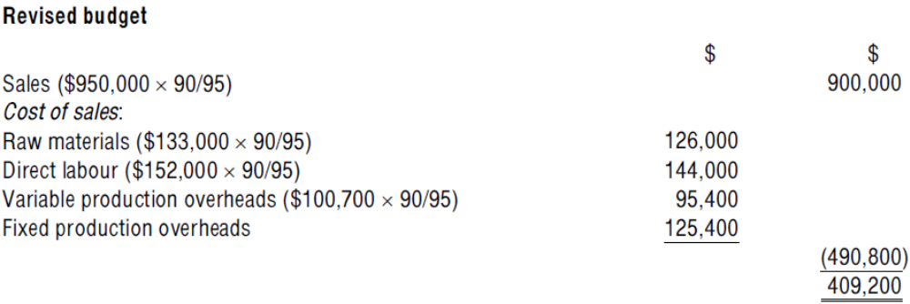
A revised budget should be prepared because budgets are used for control purposes and to assess performance. Only those aspects of performance that are controllable by the managers should be highlighted. Comparing actual results to a fixed budget would result in meaningless variances for control purposes.

(b)
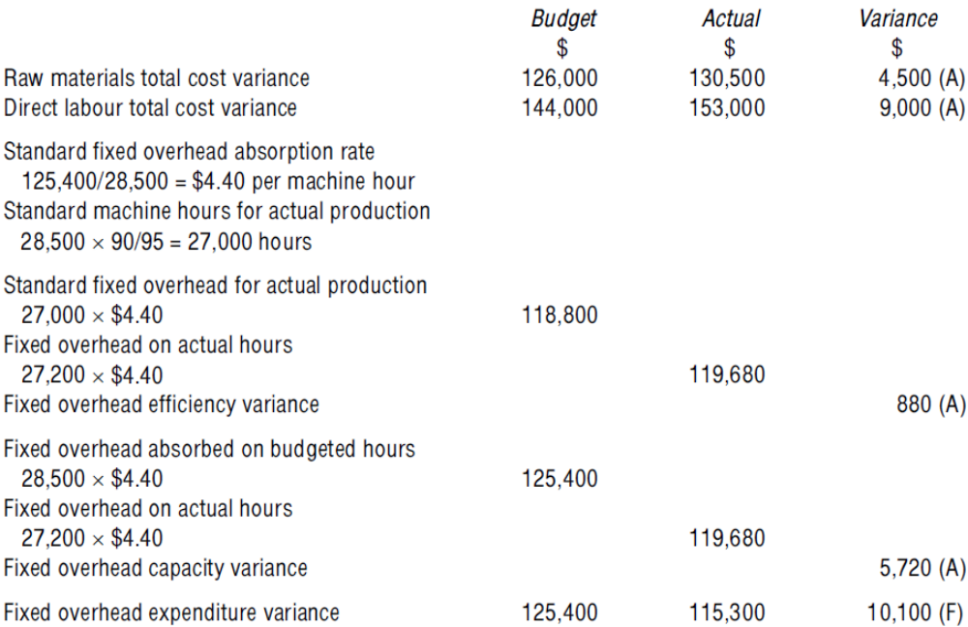

(c)
The raw materials total cost variance of $4,500 adverse has arisen because the budgeted cost per unit of $133,000/95,000 units = $1.40 was overtaken by an actual cost of $130,500/90,000 units = $1.45. This may have been due to a supplier price increase, or an increase in the amount of raw material used per unit.

The fixed overhead efficiency variance is the difference between the number of hours that actual production should have taken, and the number of hours actually taken (that is, worked) multiplied by the standard absorption rate per hour. A total of 200 more hours than expected were used, maybe because of inaccurate initial planning or operational problems (inexperienced staff, machine breakdown).

The fixed overhead expenditure variance is the difference between the budgeted fixed production overhead expenditure and actual fixed production overhead expenditure. The favourable variance could be due to inaccurate budgeting or cost savings being achieved during the period.
Answer 6
(a)
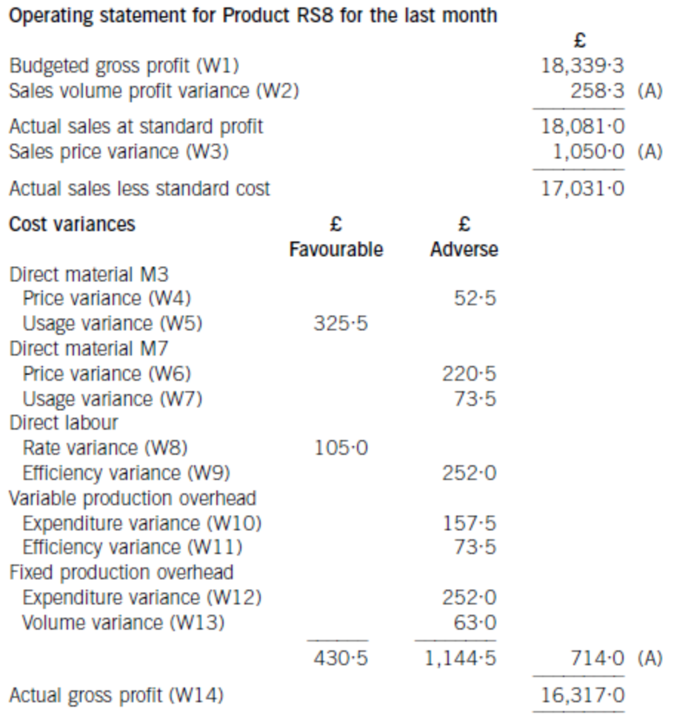
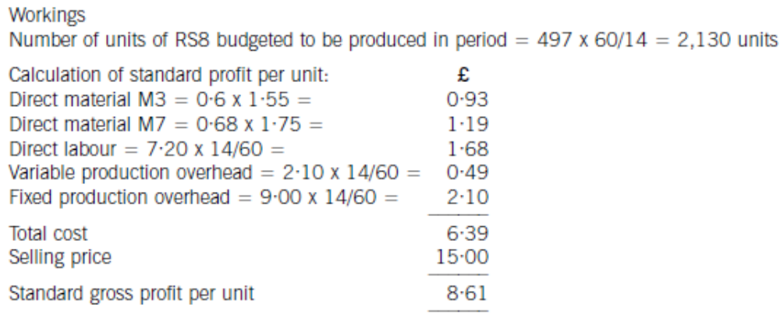

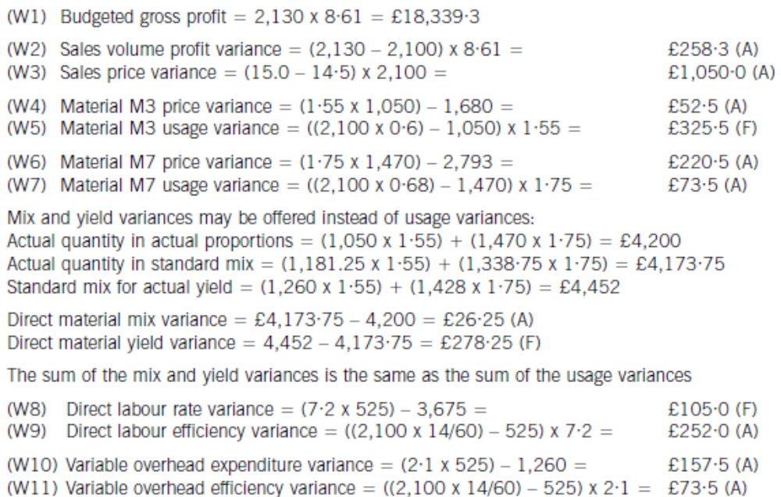

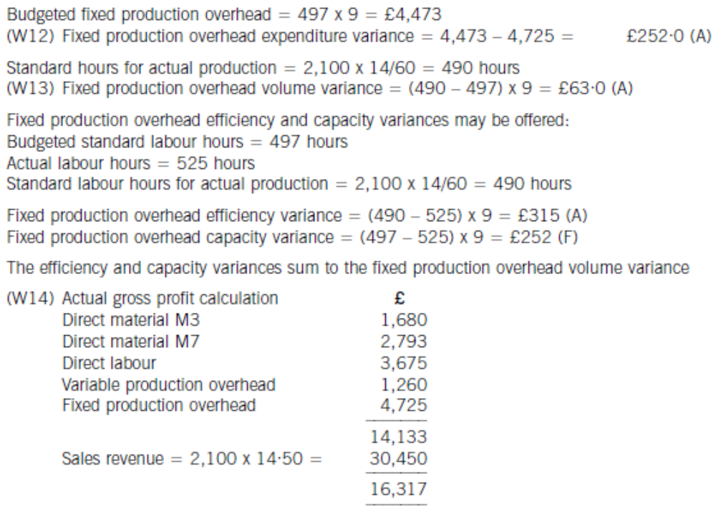

(b)
Controlling variable costs
The first step in the process of controlling costs is to measure actual costs. The second step is to calculate variances that show the difference between actual costs and budgeted or standard costs. These variances then need to be reported to those managers who have responsibility for them. These managers can then decide whether action needs to be taken to bring actual costs back into line with budgeted or standard costs. The operating statement therefore has a role to play in reporting information to management in a way that assists in the decision-making process.

The operating statement quantifies the effect of the volume difference between budgeted and actual sales so that the actual cost of the actual output can be compared with the standard (or budgeted) cost of the actual output. The statement clearly differentiates between adverse and favourable variances so that managers can identify areas where there is a significant difference between actual results and planned performance. This supports management by exception, since managers can focus their efforts on these significant areas in order to obtain the most impact in terms of getting actual operations back in line with planned activity.

In control terms, variable costs can be affected in the short term and so an operating statement for the last month showing variable cost variances will highlight those areas where management action may be effective. In the short term, for example, managers may be able to improve labour efficiency through training, or through reducing or eliminating staff actions which do not assist the production process. In this way the adverse direct labour efficiency variance of £252, which is 7·3% of the standard direct labour cost of the actual output, could be reduced.

Controlling fixed production overhead costs
In the short term, it is unlikely that fixed production overhead costs can be controlled. An operating statement from last month showing fixed production overhead variances may not therefore assist in controlling fixed costs. Managers will not be able to take any action to correct the adverse fixed production overhead expenditure variance, for example, which may in fact simply show the need for improvement in the area of budget planning. Investigation of the component parts of fixed production overhead will show, however, whether any of these are controllable. In general, this is not the case.

Absorption costing gives rise to a fixed production overhead volume variance, which shows the effect of actual production being different from planned production. Since fixed production overheads are a sunk cost, the volume variance shows little more than that the standard hours for actual production were different from budgeted standard hours3. Similarly, the fixed production overhead efficiency variance offers little more in information terms than the direct labour efficiency variance. While fixed production overhead variances assist in reconciling budgeted profit with actual profit, therefore, their reporting in an operating statement is unlikely to assist in controlling fixed costs.

