Chapter 7 Audit Sampling

LEARNING OBJECTIVES

1. Explain the concept of representative sampling.
2. Describe the steps of audit sampling.
3. Distinguish between statistical and non-statistical sampling.
4. Select representative samples.
5. Describe the sample selection methods under statistical and non-statistical sampling

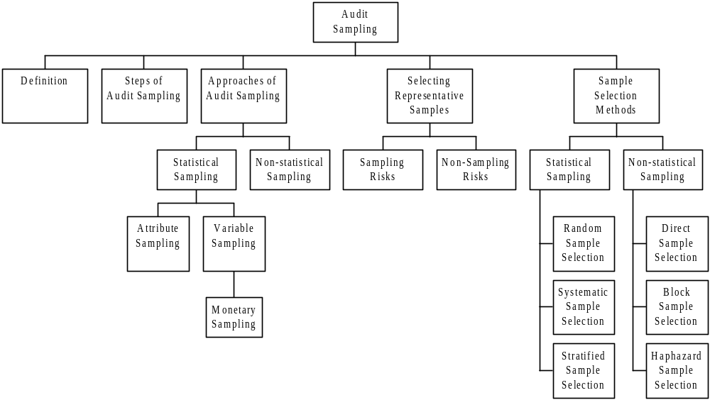

1. Audit Sampling

1.1 | Definition
 | Audit sampling is the subject of HKSA 530. When designing audit procedures, the auditor should determine appropriate means for selecting items for testing so as to gather audit evidence to meet the objectives of audit tests.

1.2 This HKSA is based on the premise (前提) that auditors do not normally examine all the information available to them; it would be impractical to do so and using audit sampling will produce valid conclusions.
1.3 The auditor may select certain items from a population because of specific characteristics they possess. The results of items selected in this way cannot be projected onto the whole population but may be used in conjunction with other audit evidence concerning the rest of the population.
(a) High value or key items. The auditor may select high value items or items that are suspicious, unusual or prone (傾向于) to error.
(b) All items over a certain amount. Selecting items this way may mean a large proportion of the population can be verified by testing a few items.
(c) Items to obtain information about the client’s business, the nature of transactions, or the client’s accounting or control systems.
(d) Items to test procedures, to see whether particular procedures are being performed.

2. Steps of Audit Sampling

2.1 The steps of audit sampling involve the following:
(a) Design the sample:
Auditor should consider the specific audit objectives, the nature of the population from which samples are selected and the sample size when designing an audit sample.
(b) Selection of sample:
Auditor should select sample items that are the representative of the population in respect of characteristics being tested.

For example, the auditor selects specific monetary units from within the accounts receivable balances, the audit effort is directed to the larger value items because they have a greater chance of selection and can reduce the sample size.

Ideally, the auditor should select items for the sample that all sampling units in the population have a chance of being selected.
(c) Evaluation of sample results:
After the appropriate audit procedures have been applied on the samples, the auditor should analyse the errors in the sample and draw conclusions for the population as a whole.

3. Approaches of Audit Sampling

3.1 Two types of audit sampling:
(a) Statistical sampling – uses the laws of probability to select and evaluate the results of an audit sample, therefore, the sampling risk is quantified for drawing the conclusion about the population.
(b) Non-statistical sampling (judgement sampling) – the auditor considers sampling risk without using law of probability to measure it.
3.2 Statistical sampling techniques are broadly categorized into:
(a) Attribute sampling (屬性抽樣)
(i) usually applied in test of controls;
(ii) an attribute is a characteristic that each member of the population either has or does not have (or correct, not correct).
(iii) it can only show the deviations from some benchmark but cannot give the monetary effect of such deviation.
(iv) For example, no initial on the issue of credit notes to customers.
(b) Variable sampling (變量抽樣)
(i) commonly used in substantive procedures;
(ii) a variable is a characteristics that each member of the population has a varying amount or quantity, for example, the amounts owed by debtors.
(c) Monetary unit sampling (貨幣單位抽樣) (Dec 10)
(i) the sampling unit is the individual monetary value (e.g. one dollar).
(ii) it measures whether or not an individual monetary value is in error and by how much.
(iii) the maximum amount of monetary overstatement or understatement error in the population will be expressed.
(iv) it is used as an alternative to variables sampling methods for performing substantive tests.
(v) Advantages of monetary unit sampling are as follows:
1. Audit effort is directed to the larger value items because they have a greater chance of selection.
2. Smaller sample sizes.

4 Selecting the Representative Samples

4.1 The characteristics of a representative sample are that the audit interest of the sample is approximately the same as that of the population.

4.2 Causes of selecting non-representative samples

4.2.1 | Definition (Dec 10, Jun 14)
 | Sampling risks – It is an inherent part of sampling that results from testing less than the entire population. Sampling risk arises from the possibility that the auditor’s conclusion, based on a sample, may be different from that generated from the entire population. (抽樣風險是注冊會計師依據抽樣結果得出的結論，與審計對象總體特徵不相符合的可能性。抽樣風險與樣本量成反比，樣本量越大，抽樣風險越低。)

4.2.2 The way to control the sampling risk may include:
(a) increasing the sample size will reduce sampling risk.
(b) using an appropriate sampling method will reasonably assure representativeness.

4.2.3 | Sampling risks in tests of controls and substantive procedures  (Dec 10, Jun 12, Jun 14)
(a) Tests of control
(i) risk of under reliance (信賴不足風險) – this is the risk that the assessed level of control risk based on the sample is greater than the actual compliance rate of the control.
(ii) risks of over reliance (信賴過度風險) – this is the risk that the assessed level of control risk based on the sample is less than the actual compliance rate of the control.
(b) Substantive procedures
(i) risk of incorrect rejection (誤拒風險) – this is the risk that the sample supports the conclusion that the recorded transaction or account balance is materially misstated when, in fact, it is not materially misstated.
(ii) risk of incorrect acceptance (誤受風險) – this is the risk that the sample supports the conclusion that the recorded transaction or account balance is not materially misstated when, in fact, it is materially misstated.

4.2.4 | Definition
Non-sampling risk – It is the risk of erroneous conclusions being drawn from audit procedures due to any reason other than those which give rise to sampling risk.
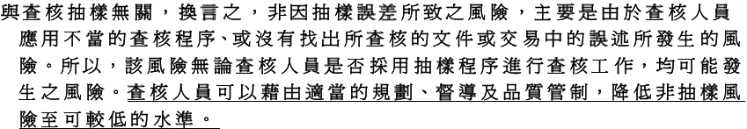

4.2.5 Examples of non-sampling risk include:
(a) the use of inappropriate audit procedures,
(b) misinterpretation of audit evidence, and
(c) failure to recognize a misstatement or deviation.

4.3 Sample size determination

4.3.1 Examples of some factors affecting sample size:
(Jun 14)
Examples of factors influencing sample size for tests of control

 | Conditions leading to
Factors | Smaller sample size | Larger sample size
Reliance on accounting and control systems and hence assessment of control risk | Lower preliminary assessment of control risk | Higher preliminary assessment of control risk
Tolerable error  (可容忍誤差) | Higher acceptable rate of deviation | Lower acceptable rate of deviation
Expected error | Lower expected rate of deviation in population | Higher expected rate of deviation in population
Required confidence level | Smaller degree of confidence | Greater degree of confidence
Number of items in population | Virtually no effect on sample size unless population is small

Examples of factors influencing sample size for substantive procedures

 | Conditions leading to
Factors | Smaller sample size | Larger sample size
Assessment of inherent risk | Lower inherent risk | Higher inherent risk
Assessment of control risk | Lower control risk | Higher control risk
Change in detection risk because of other substantive tests related to the same financial statement assertions | Greater use of other substantive tests | Reduced use of other substantive tests
Tolerable error | Large measure of tolerable error | Smaller measure of tolerable error
Expected error | Smaller errors or lower frequency | Larger errors or higher frequency
Number of items in population | Virtually no effect on sample size unless population is small
Required confidence level/acceptable level of detection risk | Smaller degree of confidence (higher acceptance level of detection risk) | Higher degree of confidence (lower acceptance level of detection risk)
Stratification | Stratification of the population, if appropriate | No stratification of the population

4.3.2 The sample size can be calculated as:

Sample size | = | Reliability factor
Sample size | = | Precision

Where the reliability factor, taken from tables based on the Poisson sampling distribution is associated with the level of assurance the auditors want or need to obtain from the test. Such a table is given below and it shows the relationship between risk levels, and the reliability factor.

Confidence level | Risk level | Reliability factor (R Factor)
 |  | No errors expected | One error expected
99% | 1% | 4.6 | 6.61
95% | 5% | 3.0 | 4.75
90% | 10% | 2.3 | 3.89
85% | 15% | 1.9 | 3.38
80% | 20% | 1.6 | 3.00
70% | 30% | 1.2 | 2.44

4.3.3 Example
Calculate the sample sizes which should be used in tests of control in the following circumstances.
(a) No errors anticipated in the sample, accept 5% risk that four or more items in 100 are incorrect in the population.
(b) One error anticipated in the sample, accept 1% risk that three or more items in 100 are incorrect in the population.

Answer

(a) Sample size = 3.0 / 0.05 = 60 items
(b) Sample size = 6.61 / 0.04 = 165 items

Question 1
An international accounting firm has acquired a local accounting firm. The partners of the local accounting firm are reluctant to adopt the international accounting firm’s sampling technique because they do not feel confident of the results derived from the sampling method used.

The international accounting firm adopts statistical sampling on a number of audit procedures. According to explanations from the international accounting firm, statistical sampling is a method of drawing inferences (推斷) about a large volume of data by examination of a sample. It can be used for either attributes or variables.

The international accounting firms provides the following data to demonstrate the efficiency of its sampling technique:
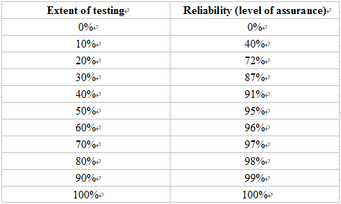
Required:

(a) Identify whether each of the following audit procedures should adopt sampling and, if it should, state whether attribute or variable sampling would typically be used. Organise your answer as follows:

Audit procedures | Involves Sampling?  (Yes or No) | Attribute/Variable  /Not applicable
(i) Interviewing client employees
(ii) Scrutinizing accounting records for usual items
(iii) Test of controls over inventory pricing
(iv) Tests of the amounts of transactions that are not supported by proper approval
(v) Obtaining written representations from management
(vi) Tests of recorded payroll expense
(vii) Observing cash- handling procedures
(viii) Inspecting land and building
(ix) Tests of controls over discounts rates allowed to individual customers
(x) Tests of control over matching suppliers’ invoices with goods receiving note and shipping documents
(10 marks)
(b) Based on the given set of data, discuss the relationship between “extent of testing” and “degree of assurance”. (3 marks)
(c) Explain why “audit risk” cannot be eliminated even if the total population is audited.
(2 marks)
(d) Define the following risks:
(i) inherent risk;
(ii) control risk;
(iii) detection risk;
(iv) sampling risk. (4 marks)
(Total 20 marks)
(Adapted HKIAAT Paper 8 Auditing June 2000)

5. Sample Selection Methods

5.1 Selection methods for statistical sampling:
(a) Random sample selection (隨機抽樣)
ensures that all items in the population have an equal chance of selection, e.g. by use of random number tables (隨機數表(亂數表)) or computerized generator (隨機數產生器).
(b) Systematic sample selection (系統選樣法)
involves selecting items using a constant interval (e.g. every nth item) between selections, the first interval having a random start.

For example, if a population to be sampled is 600 items and the sample size is 50, the sampling interval will be 12 (= 600/50). One of the first 12 items will be selected as the starting point and thereafter every twelfth item will be selected. In determining the starting point each of the first 12 items (in this example) should have a chance of being selected. The starting point may be selected haphazardly or randomly.

Systematic selection is particularly useful when sampling from non-monetary populations, for example dispatch notes.

(c) Stratified sample selection (分層隨機抽樣) (Dec 10)
The objective of stratification is to reduce the variability of items within each stratum and therefore allows sample size to be reduced without increasing sampling risk.

The population is divided into different strata, each of which has similar characteristic, then sampling techniques such as the random selection method can be applied in each stratum.

Example:
Stratum | Composition of stratum | No. of accounts (method of selection used)
1 | Accounts of $10,000 or over | All accounts
2 | Accounts of $5,000 to $9,999.99 | 50 accounts (random number)
3 | Accounts of less than $5,000 | 30 accounts (random number)

5.2 Selection methods for non-statistical sampling:
(a) Directed sample selection (判斷抽樣)
the selection of each item based on some judgemental criteria by the auditor. The criteria used may include:
(i) items most likely to contain misstatements;
(ii) items containing selected population characteristics;
(iii) large dollar coverage.
(b) Block (or sequence) sample selection (區段抽樣)
is the selection of several items in sequence. Once the first item in the block is selected, the remainder of the block is chosen automatically. For example an auditor may use a sample of 50 consecutive cheques to check whether cheques are signed by authorized signatories rather than picking 50 single cheques throughout the year.

Sequence sampling may however produce samples that are not representative of the population as a whole, particularly if errors only occurred during a certain part of the period, and hence the errors found cannot be projected onto the rest of the population.

Nevertheless, block sampling can result in significant cost savings in audit time, and there are some occasions where practical considerations may require the use of block sampling, for example when visiting a branch.

(c) Haphazard sample selection (隨意抽樣)
may be an alternative to random selection provided auditors are satisfied that the sample is representative of the entire population. It is the selection of samples without following a structured techniques regard to their size, source, or other distinguishing characteristics.

5.3 Example of audit sampling procedures

5.3.1 The application of sampling techniques in substantive procedures, illustrated below, involves the following steps:
(a) designing the sample;
(b) selecting a sample;
(c) performing the audit procedures;
(d) evaluating results of the tests; and
(e) summarizing the results.

Sampling | Example of substantive procedures
a. Design the sample | (i) Audit objectives:  Sending debtors’ confirmations to ensure the existence of debtors and the accuracy of their ledger balances.  (ii) Population and sampling units:  Population – total debtors value of $5,525,000, excluding credit balances.  Variability – $130 to $182,000  Sub-population – five accounts over $65,000, totaling $660,000, were considered to be individually material, leaving a population of 1,195 accounts with a value of $4,865,000 to be sampled.  Sampling unit – 1,200 account balances.  (iii) Determining the sample size:  (1) Tolerable error  Amount – $170,000  Internal control – moderate reliable  Substantive test – analytical review and cut-off test provide conclusion of moderate assurance.  (2) Assurance required  Conclude that the required assurance is moderate.  (3) Expected error – few or none.  (4) Calculating the sample size  Sample size = Population value/tolerable error x reliability factor  = $4,865,000 / $170,000 x 2.5 = 72
b. Selection of a sample | The sample was selected by using the systematic sampling method from a debtors list that had been tested to and from the debtors ledger and had been agreed in total to the balance on the control account in the general ledger.
c. Performance of the audit procedures | Replies were received from the 5 large customers and from 67 of those sampled. The accounts of the five customers failing to reply were verified by alternative tests on the subsequent settlement from the customers and it is concluded that the balances of these debtors were correctly stated.
d. Evaluation of results of the tests | (i) Analysis of errors:  The reported errors are summarized in the following table.  (ii) Projected error:  The projected error is calculated by using the ratio method:  $3,900/$234,000 x $4,865,000 = $81,083  The client corrected the 3,900 errors found in the sample but disputed the $1,000 error on the large amount resulting in a net projected population error of:  $81,083 – $3,900 + $1,000 = $78,183
  Population | Sample
  Recorded amount | Recorded amount | Audited amount | Misstatement
  $ | $ | $ | $
  660,000 | 660,000 | 659,000 | 1,000
  4,865,000 | 234,000 | 230,100 | 3,900
  5,525,000 | 894,000 | 889,100 | 4,900
d. Summarise the results | As the projected population error is significantly lower than the tolerable error, we can conclude that the recorded debtors are in existence and the balances are no materially misstated.

Question 2
Grand Ltd and Petit Ltd are garments manufacturing companies, both of them are the audit clients of King & Kong. Both audit teams have identified overstatements in debtor balances from the testing results.

 | Grand Ltd | Petit Ltd
Tolerable misstatement for debtors | $40,000 | $40,000
Expected misstatement | $16,000 | $16,000
Book value of total debtors | $1,600,000 | $1,600,000
Book values of samples | $896,000 | $258,000
Audit value of samples | $890,000 | $252,000

Required:

Calculate the projected misstatements for Grand Ltd and Petit Ltd respectively. Based on the projected misstatements, draw conclusions on the debtor balances of Grand Ltd and Petit Ltd.
(5 marks)
(Adapted HKIAAT Paper 8 Auditing December 2004 B6(e))

